Test Issue Log |  |  |  |  | Issue ID#: TPMS_Prod065
Project Name: | Trade Promotion Management System (TPMS)
Test Stage: | Unit Functionality Integration System Interface  Performance Regression Acceptance Pilot
Test Case Number: | Support #5981 |  |  | Test Started Date: |  | 29/1/2016
Test Title: | Remove repeated header at generate excel report
Test Description: | To test on remove repeated header at generate with excel report
Test Functionality: | Post Event > JPPPA Report
Test Procedure: | - Click on Post Event > JPPPA Report
Test Result: | Pass: Fail: Conditional Pass: |  | Tested by: |  | Siti Norahayu
Reason for Failed / Conditional Pass:
TEST DESCRIPTION
Click on Post Event > JPPPA Report
Result:
System displays Generated excel report without repeating header.

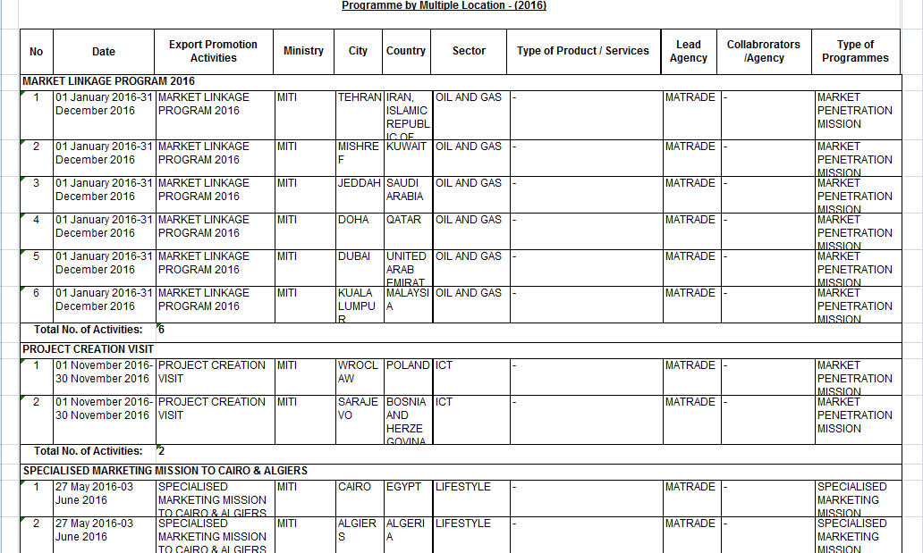

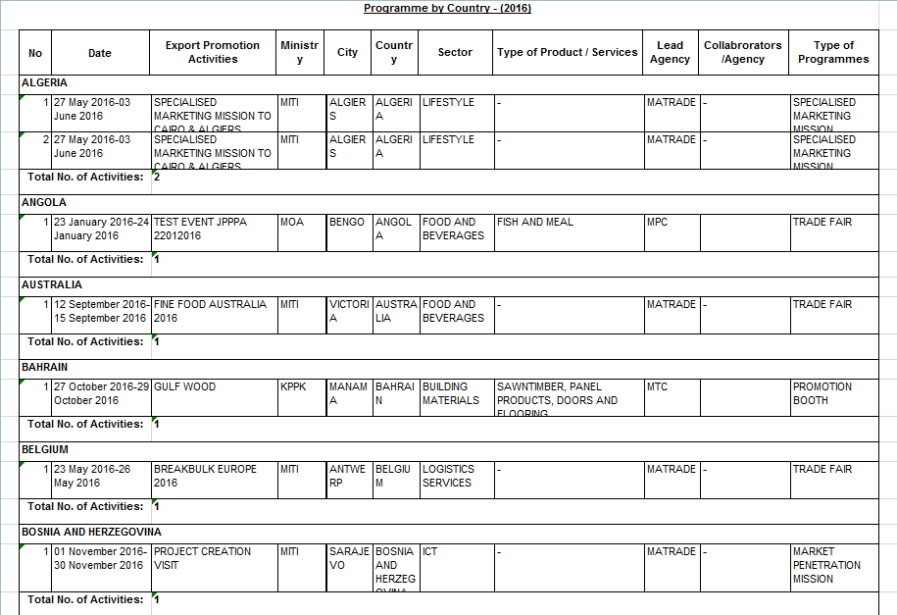

Reviewed By: (PMO)
 |  | Name/Position : NorhaidahBintiMdDasuki / Senior Manager, Quality Assurance and Support  Date : 29/1/2016

