Test Issue Log |  |  |  |  |  | Issue ID# : TPMS_Prod063
Project Name: | Trade Promotion Management System (TPMS)
Test Stage: | Unit Functionality Integration System Interface  Performance Regression Acceptance Pilot
Test Case Number: | Support # 5979 |  |  | Test Started Date: |  |  | 25/02/2016
Test Title: | To check stability of performance of import company.
Test Description: | System shall able to import company from csv file
Test Functionality: | TPMS>Promotion>Registration>Import Company
Test Procedure: | Issue:  To import company record and to display summary of import company
Test Result: | Pass: Fail:  Conditional Pass: : |  | Tested by: |  | Siti Aishah Ibrahim
Reason for Failure:
TEST DESCRIPTION
Issue :

Login as Administrator (Tester5)
Select Promotion
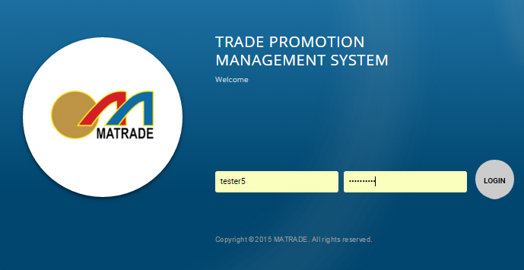

- Select “Promotion” from the sub menu drop down list
- Choose “Test Import Company 25022016” and click on View button
- Select “Registration” from the sub navigation drop down list
- Click on “Import Company” button
- Upload csv file

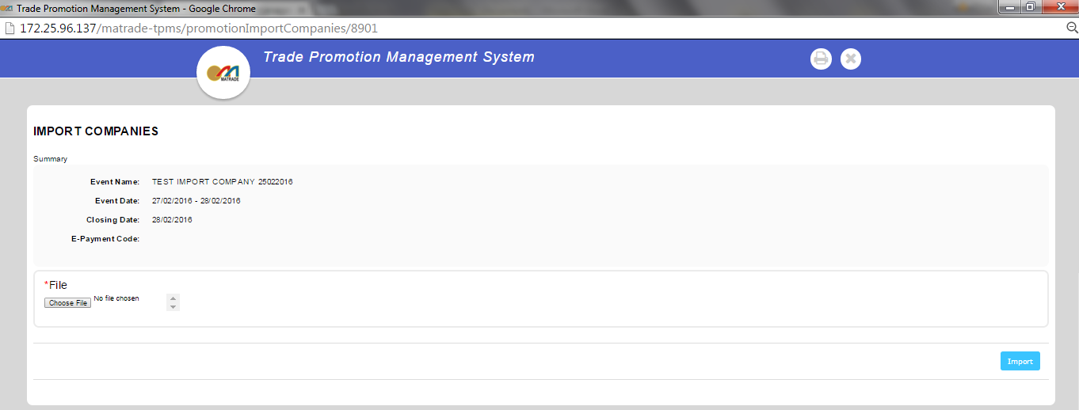

Result :

TPMS able to upload companies data from csv file within 50 seconds.
- Total Company from csv : 99
- Total success import : 33
- Local : 31
- Foreign : 2

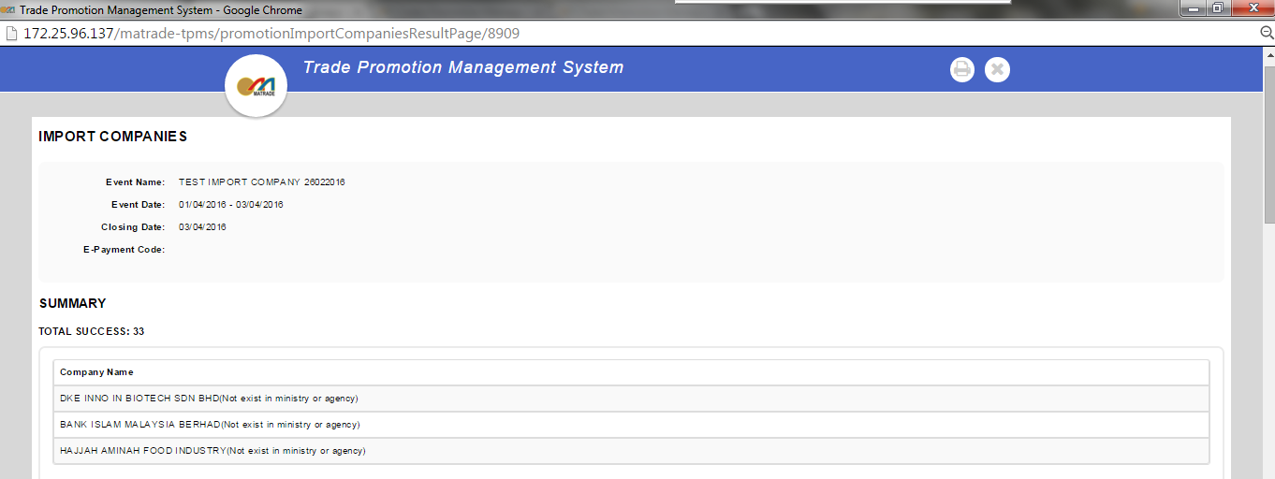

Malaysian Company

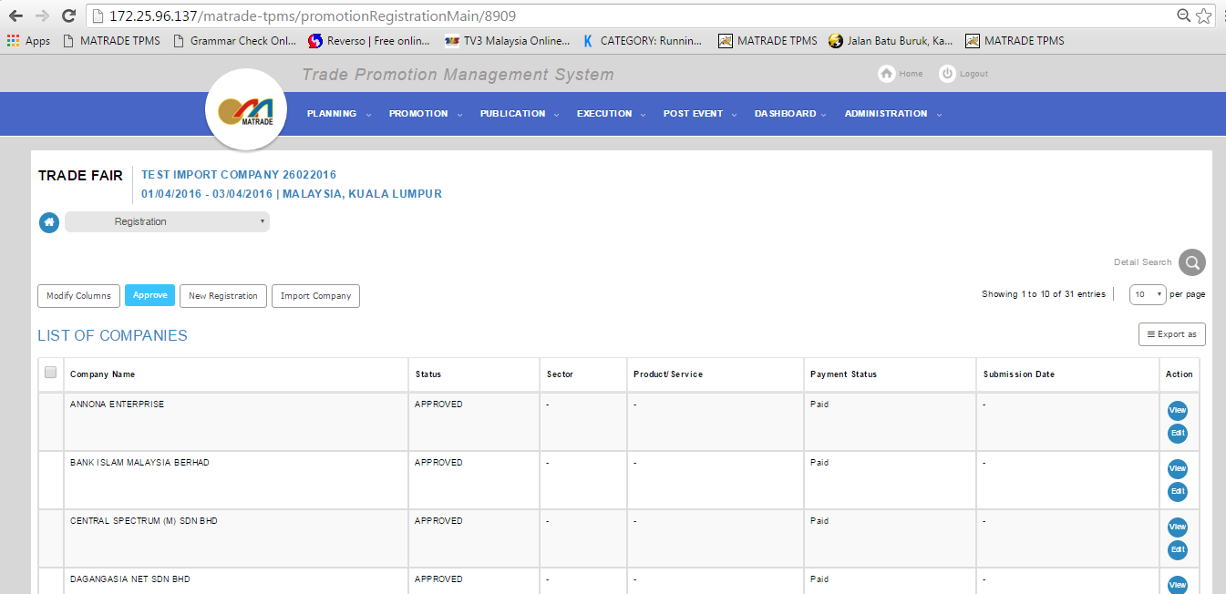

Foreign

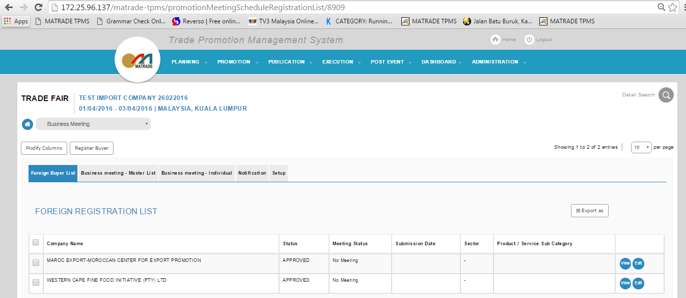

- Total Failed import : 66
- Failed to save company : 60
- Failed to save company (Malaysian Company Without ROC) : 6

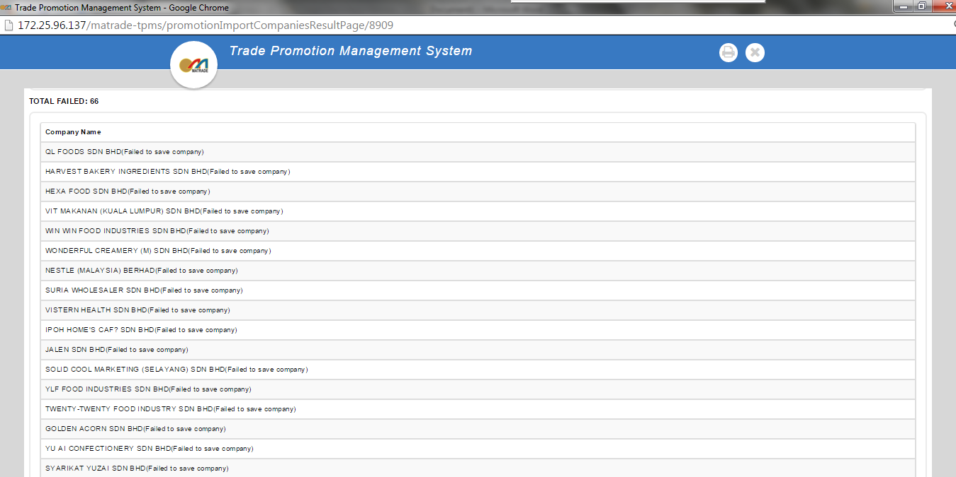
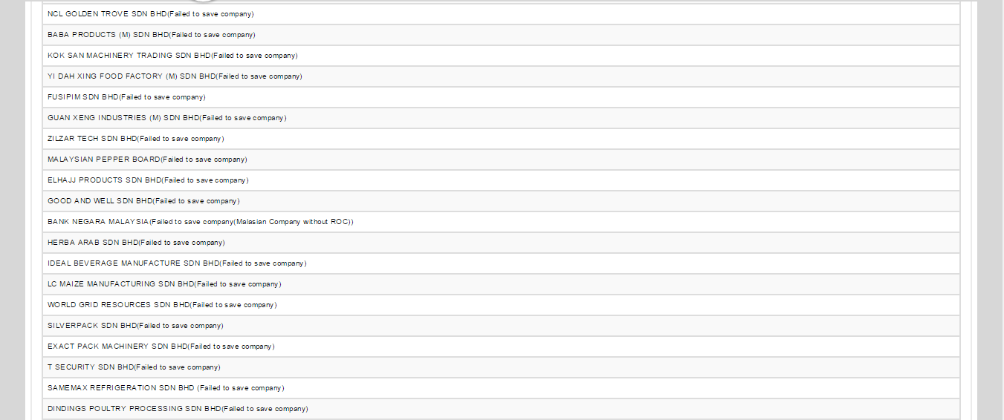
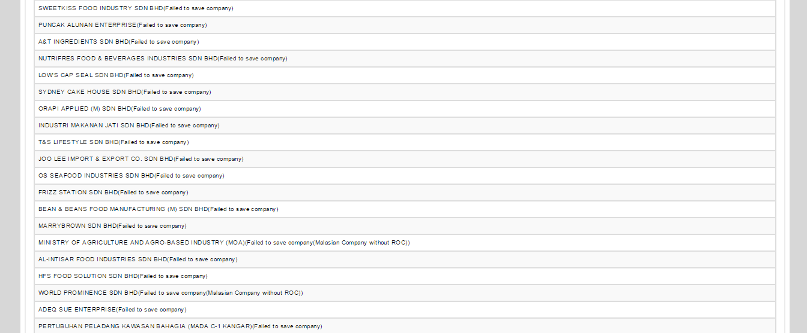
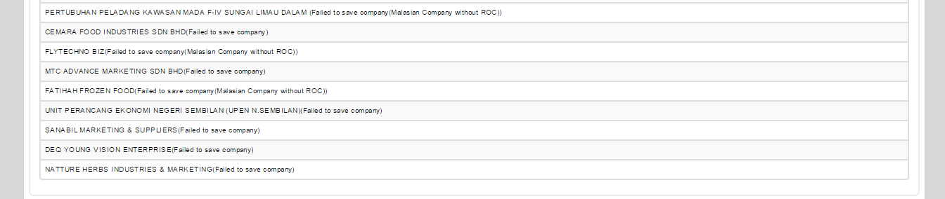

Total Failed Findings/Root Caused

- Please check back csv file before import the data into the system because there are some company data in csv incomplete. Some columns are missing the data and TPMS cannot import the data during the import process. Example: column ROC number blank.
- For column Address & Representative, suggest not to enter the data as double line (enter / new line) in csv because the system cannot read the data during import process. If there are data Address & Representative exceed 1 per company, proposed to insert a (,) symbol after the first and subsequent new representative is included a representative second.

Reviewed By: (PMO)
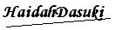 |  | Name/Position : Norhaidah Binti Md Dasuki / Senior Manager, Quality Assurance and Support  Date : 30/12/2015

