***Issue Form (PROD)***

|  |  |
| --- | --- |
| **Originator's Name:** Azliza Husain  **Project:** Trade Promotion Management System (TPMS)  **Project Manager:** Norharizal Ishak  **Module :** Promotion Report  **Date Raised: 29**/02/2016  **Phase :** Module3 - 8  **Functional Area:**  Main Report – Company Details – Foreign Buyers.  Sub-report :  – Number of buyers by country & participant   * Summary of Foreign Buyers by TC * No. of buyers by product & service | **Issue ID Number:** TPMS_Prod075  **Related Issue ID Number:** Redmine #6014 & #6018 & #6019  **Classification:**  **Priority:** Critical/High/Medium/Low  **Assigned to: Vendor / IT / PMO SA / UPA**  **Actual Closed Date:** |
| **Status:** Open/Assigned/Investigated/Resolved/Approved/Deferred/No Action  *(Circle one)* | |
| **Description :**  *Please refer to file attached for further details.* | **Impact:** |
| **Findings/Root Caused (Description):** | **Resolution:** |
| **Estimated Impact :** |  |
| **Recommendation:** | |
| **Accepted :**  **(Vendor / IT / PMO SA / UPA)**  **Date: 29/2/2016** | **Accepted (MATRADE Tester):**  **Date:** |

**PROMOTION REPORT: INSP MIHAS 2016 (TPMS – LOG ISSUE 75)**

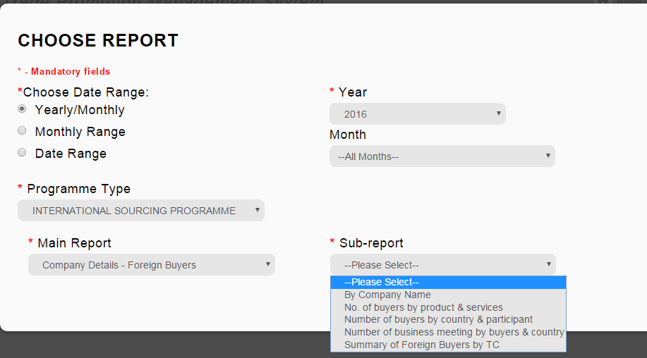.

Number of buyers by country & participant

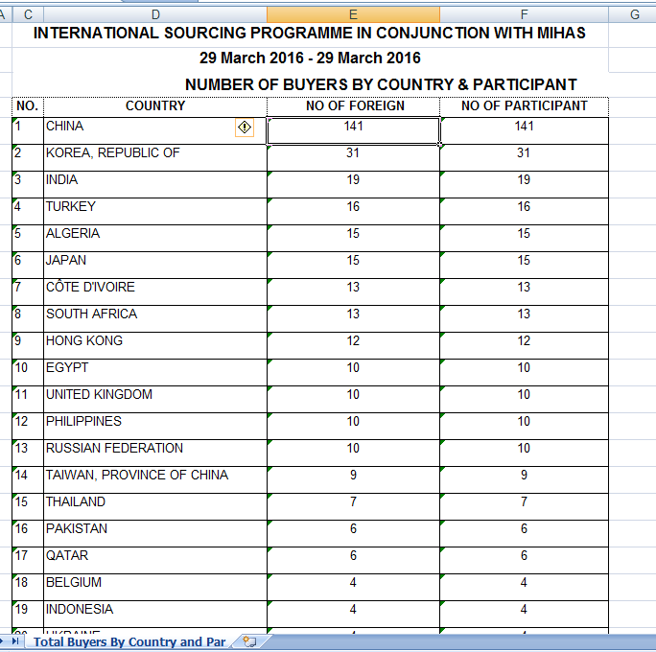

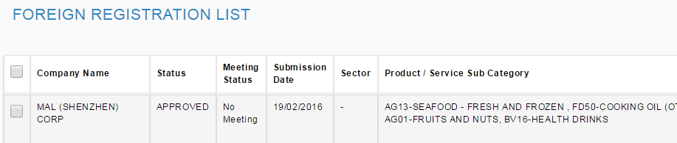

**Contoh Foreign Buyer:**

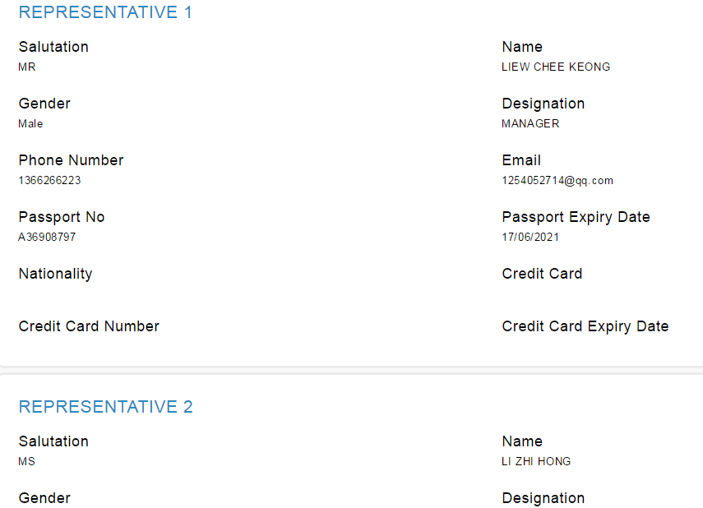

No. of buyers by product & service

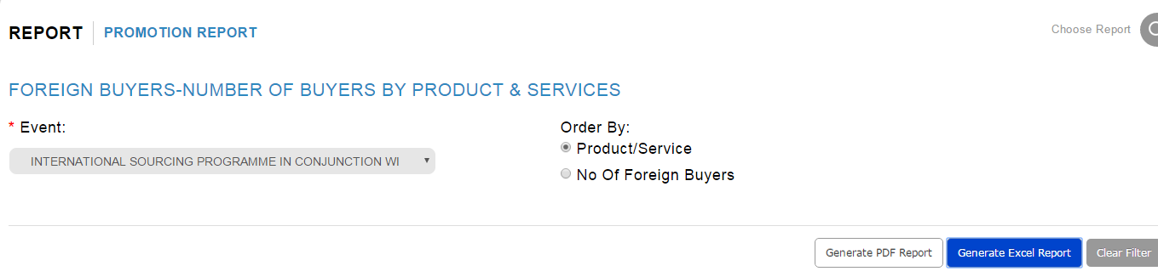

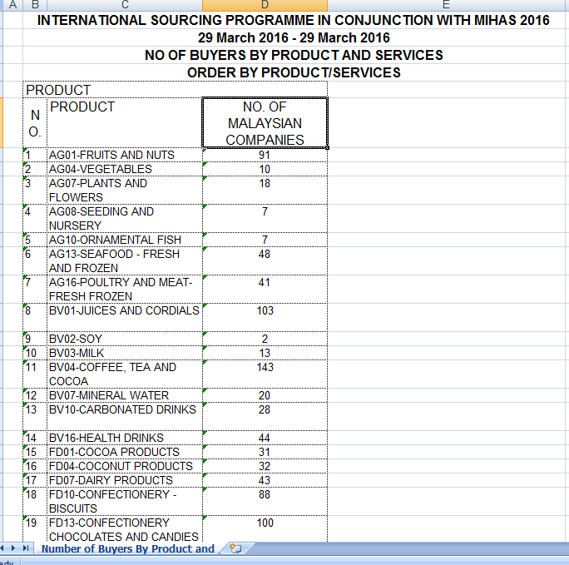

To change -> NO OF FOREIGN BUYERS

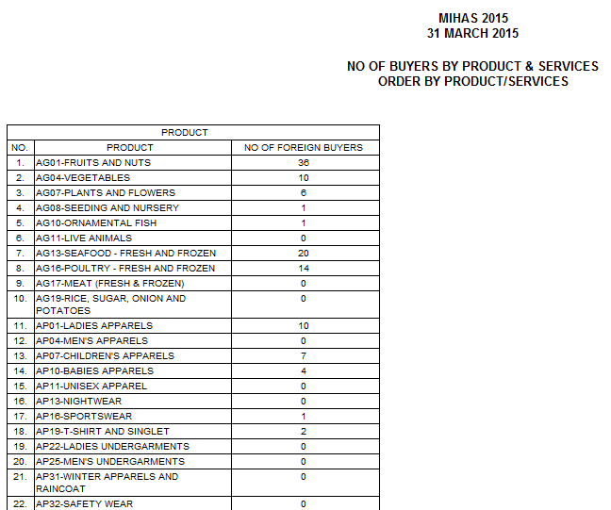 **Old system**

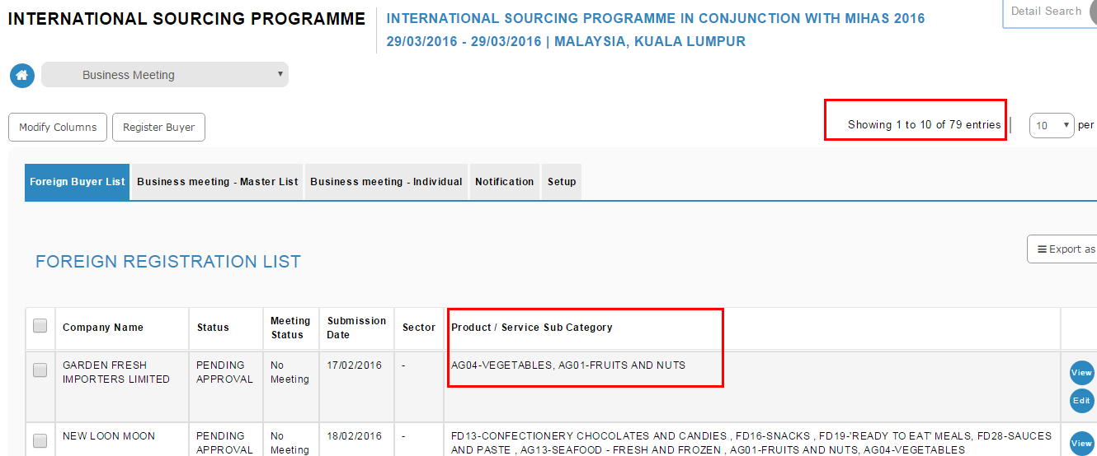

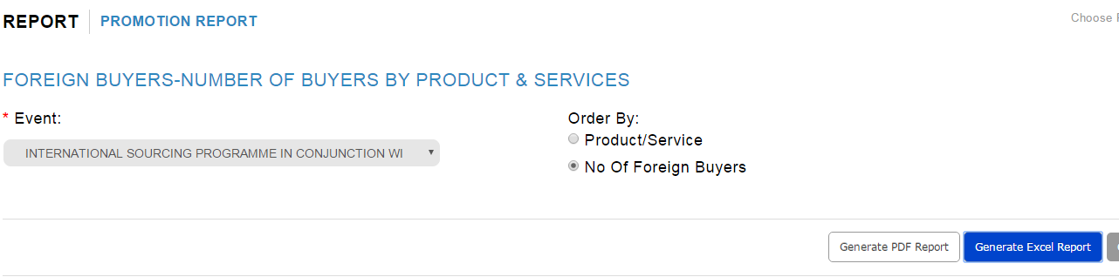

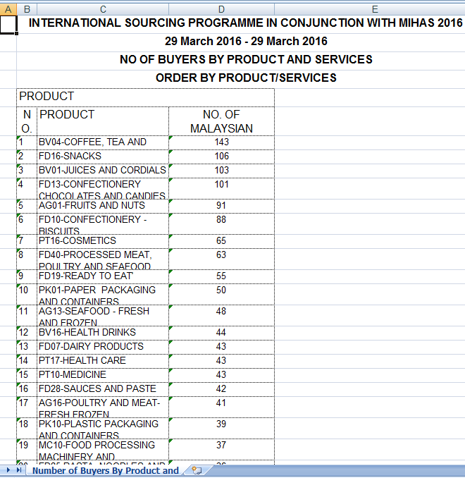

To change-> NO OF FOREIGN BUYERS

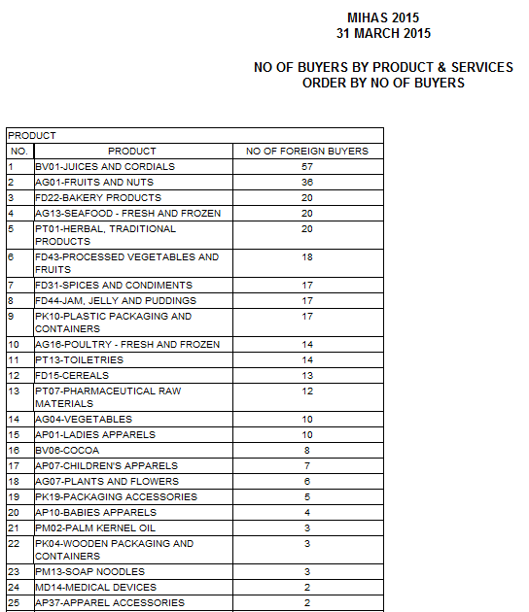

* **Old System**

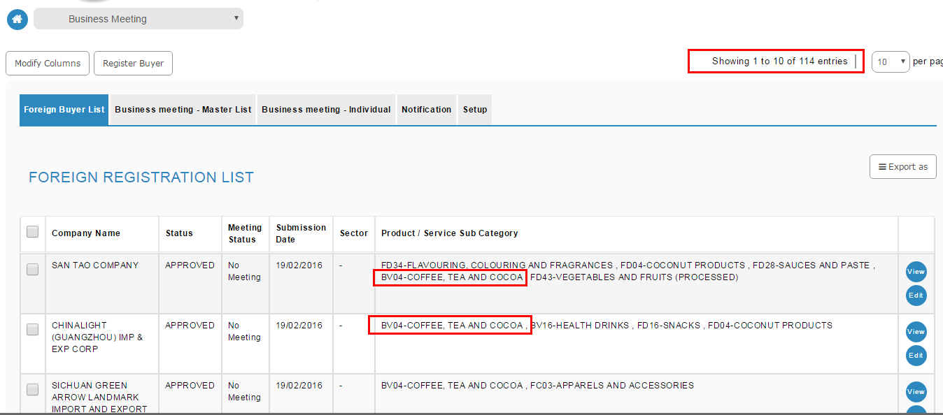

Summary of Foreign Buyers by TC

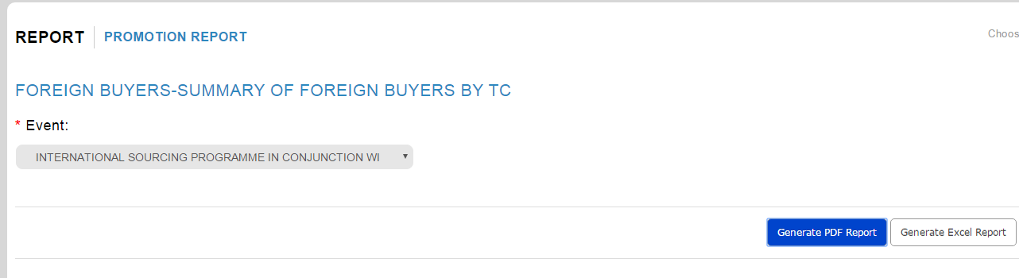

**Country - THAILAND:**

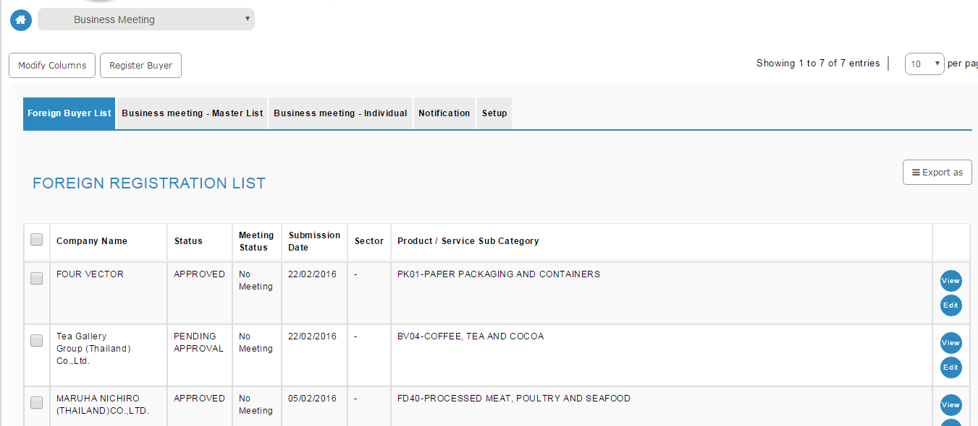

**Country – CHINA:**

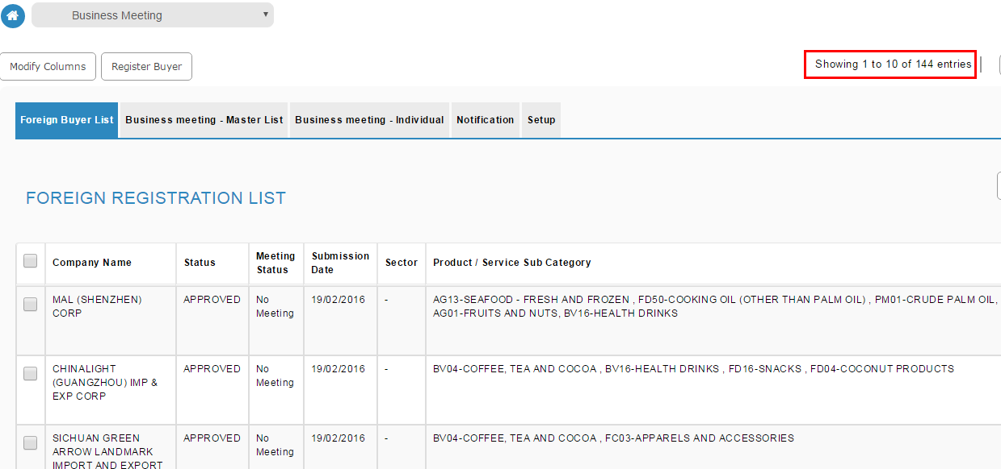

**Generate pdf:**

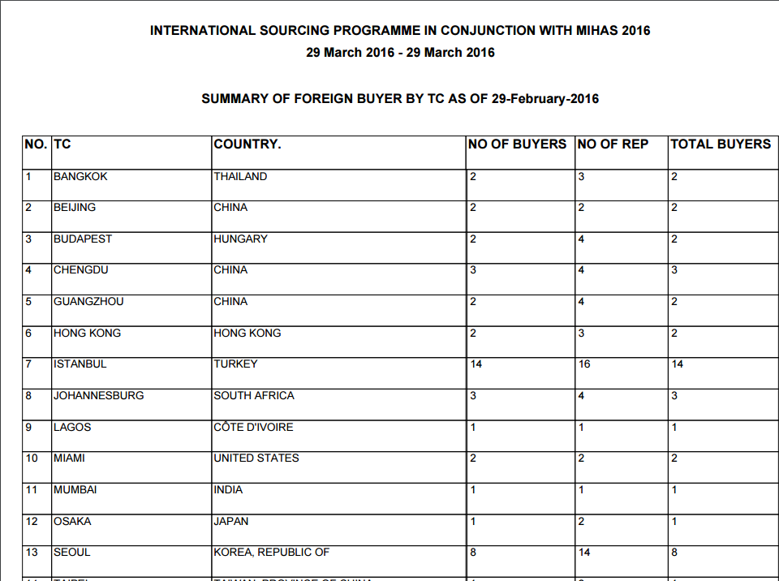

**Generate excel:**

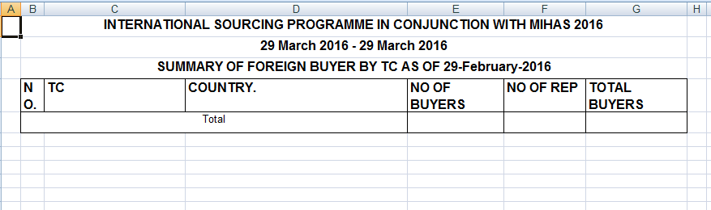

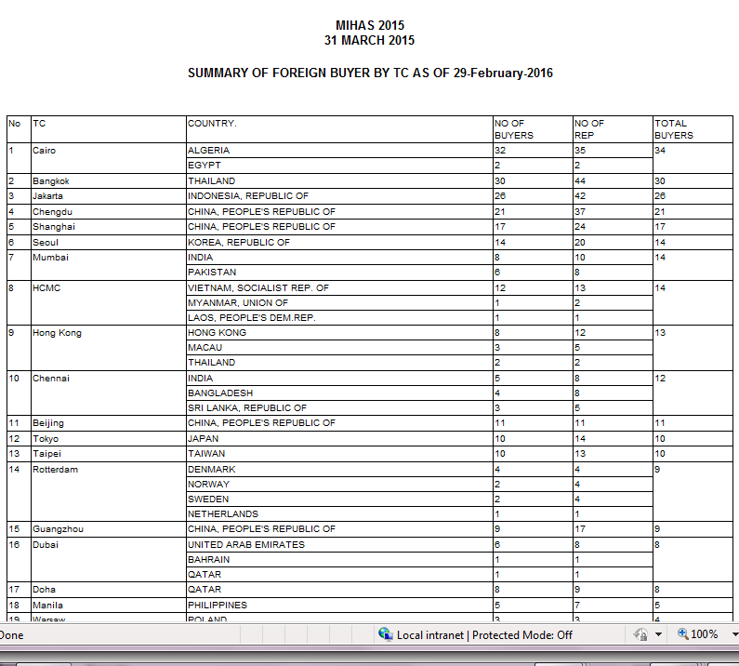

Old System: