***Issue Form (PROD)***

|  |  |
| --- | --- |
| **Originator's Name:** Azliza Husain  **Project:** Trade Promotion Management System (TPMS)  **Project Manager:** Norharizal Ishak  **Module :** Promotion Report  **Date Raised: 3**/03/2016  **Phase :** Module3 - 8  **Functional Area:** Choose report –> Programme Type (International Sourcing Programme) -> Main Report (Company Details-Foreign Buyer) -> Sub Report (By Company Name) | **Issue ID Number:** TPMS_Prod077  **Related Issue ID Number:** Redmine #60  **Classification:**  **Priority:** Critical/High/Medium/Low  **Assigned to: Vendor / IT / PMO SA / UPA**  **Actual Closed Date:** |
| **Status:** Open/Assigned/Investigated/Resolved/Approved/Deferred/No Action  *(Circle one)* | |
| **Description :**  Total companies not tally in the report.  *Please refer to file attached for further details.* | **Impact:** |
| **Findings/Root Caused (Description):** | **Resolution:** |
| **Estimated Impact :** |  |
| **Recommendation:** | |
| **Accepted :**  **(Vendor / IT / PMO SA / UPA)**  **Date: 02/03/2016** | **Accepted (MATRADE Tester):**  **Date:** |

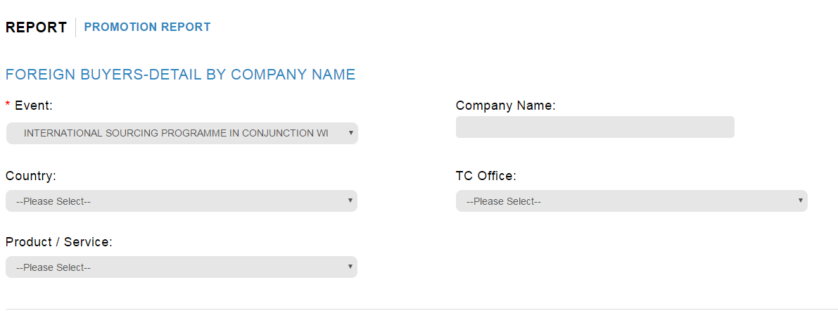

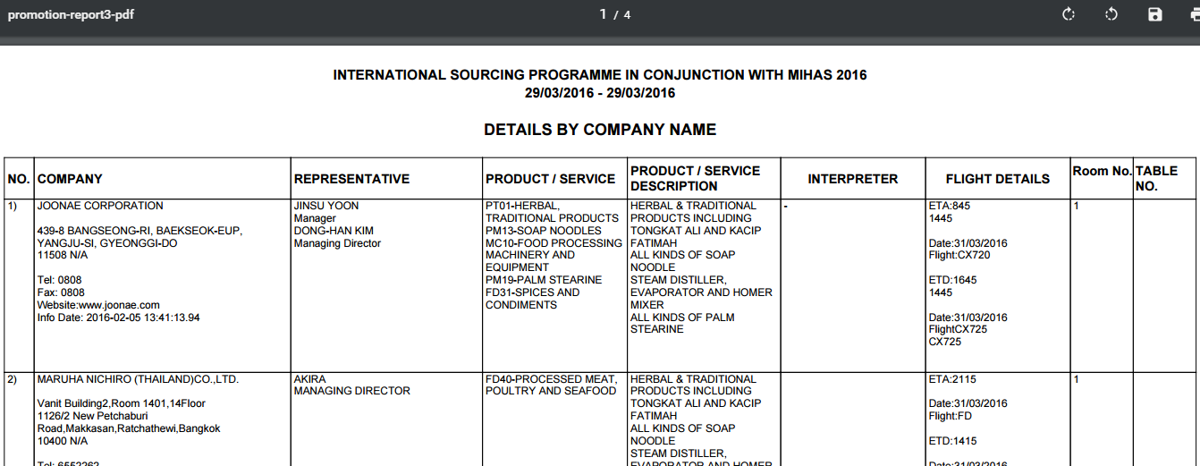

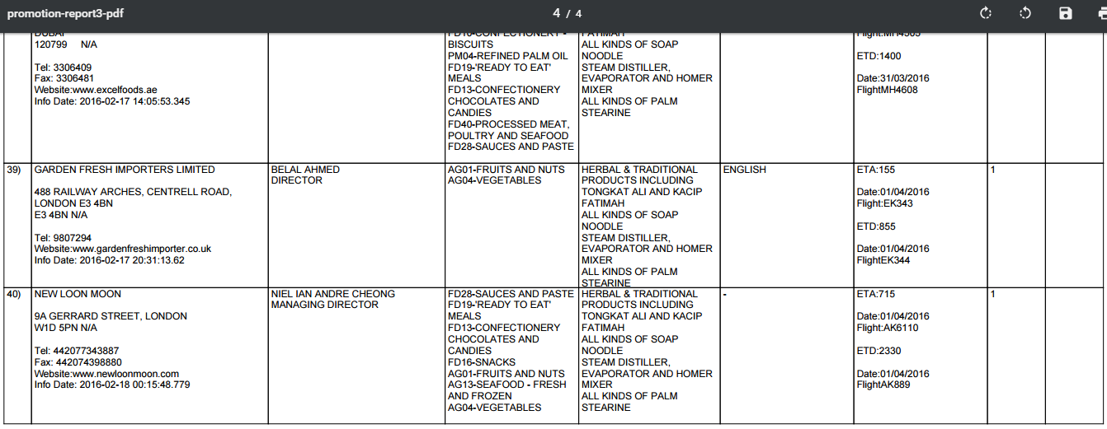

* Only 40 companies listed pdf
* To sort in alphabetical order

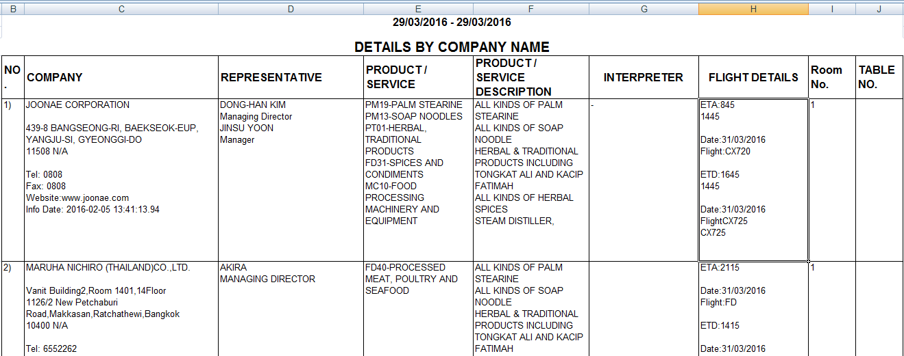

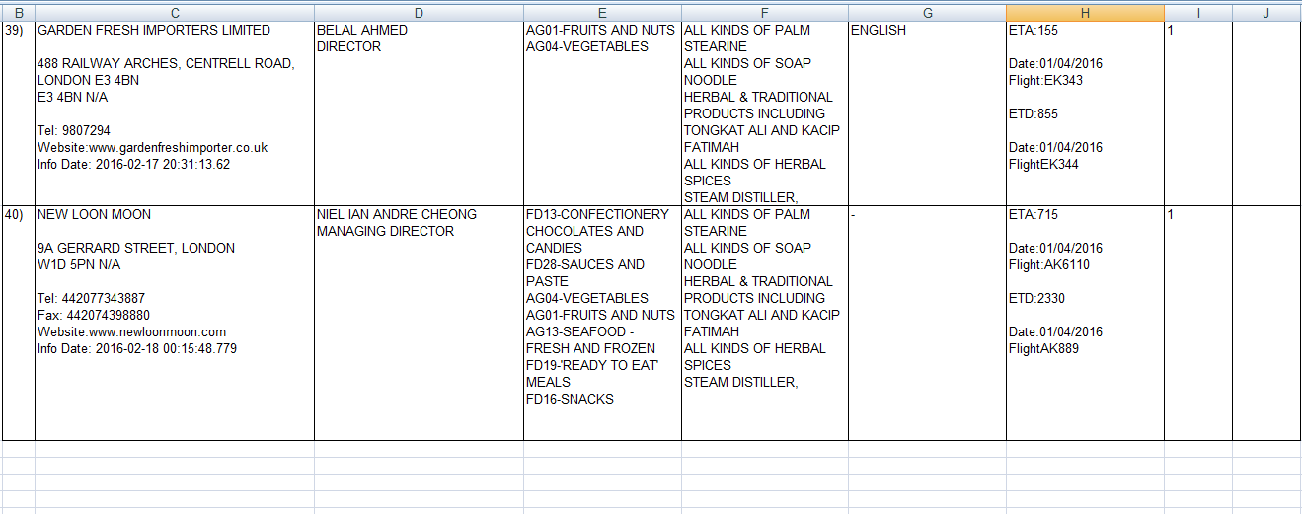

* Only 40 companies listed in excel
* To add title same as in pdf
* To sort in alphabetical order