**Malaysia Company:-**

1. Sort Company Name alphabetically
2. Product & Service column change to Product / Service Sub Category
3. Value for “Previous trade promotion sale performance”

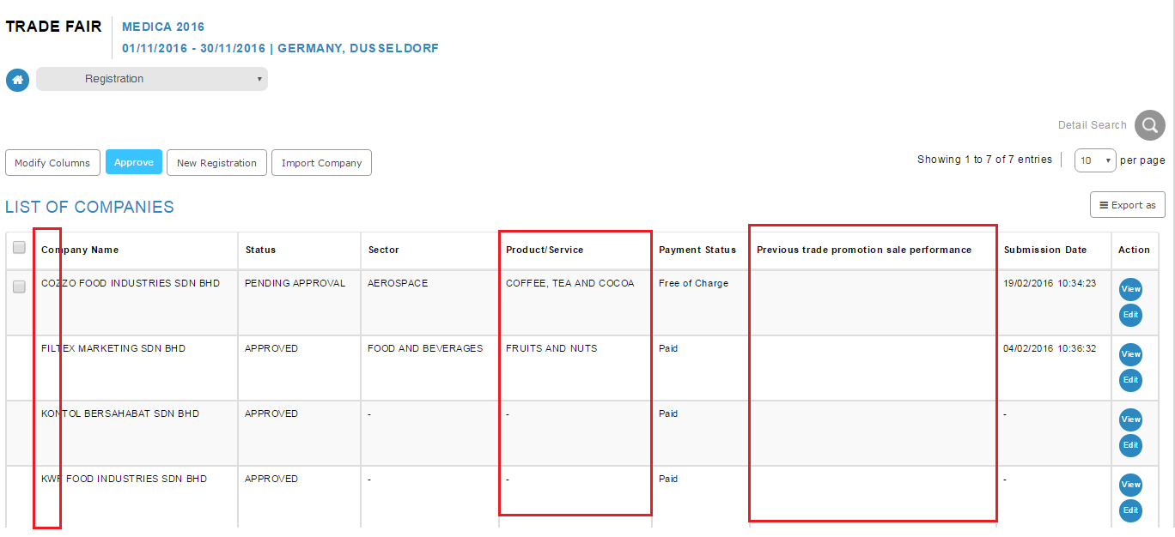

**Foreign Buyer**

1. Sort Company Name alphabetically
2. Add Registration Status field at Details Search

