Test Issue Log |  |  |  |  | Issue ID#: TPMS_Prod075iii
Project Name: | Trade Promotion Management System (TPMS)
Test Stage: | Unit Functionality Integration System Interface  Performance Regression Acceptance Pilot
Test Case Number: | Support #6019 |  |  | Test Started Date: |  | 4/3/2016
Test Title: | Generate report for Number of buyers by country & participant
Test Description: | To test on “Number of buyers by country & participant” report data is tally with the system.
Test Functionality: | Promotion > Promotion Report > Company Details - Foreign Buyer -->> Number of buyers by country & participant
Test Procedure: | - Click on Promotion > Select related Event > Select on Business Meeting  - Click on “Detail Search” and search for Indonesia under Country dropdown.  - Click on Promotion > Promotion Report > Selection Committee Report – Listing by Companies  - Click on Promotion > Promotion Report > Companies Details – Foreign Buyers – By Company Name  - Select event name and company.
Test Result: | Pass: Fail: Conditional Pass: |  | Tested by: |  | Siti Norahayu
Reason for Failed / Conditional Pass:
TEST DESCRIPTION
- Click on Promotion > Select related Event > Select on Business Meeting
Result:
System display Foreign Registration List

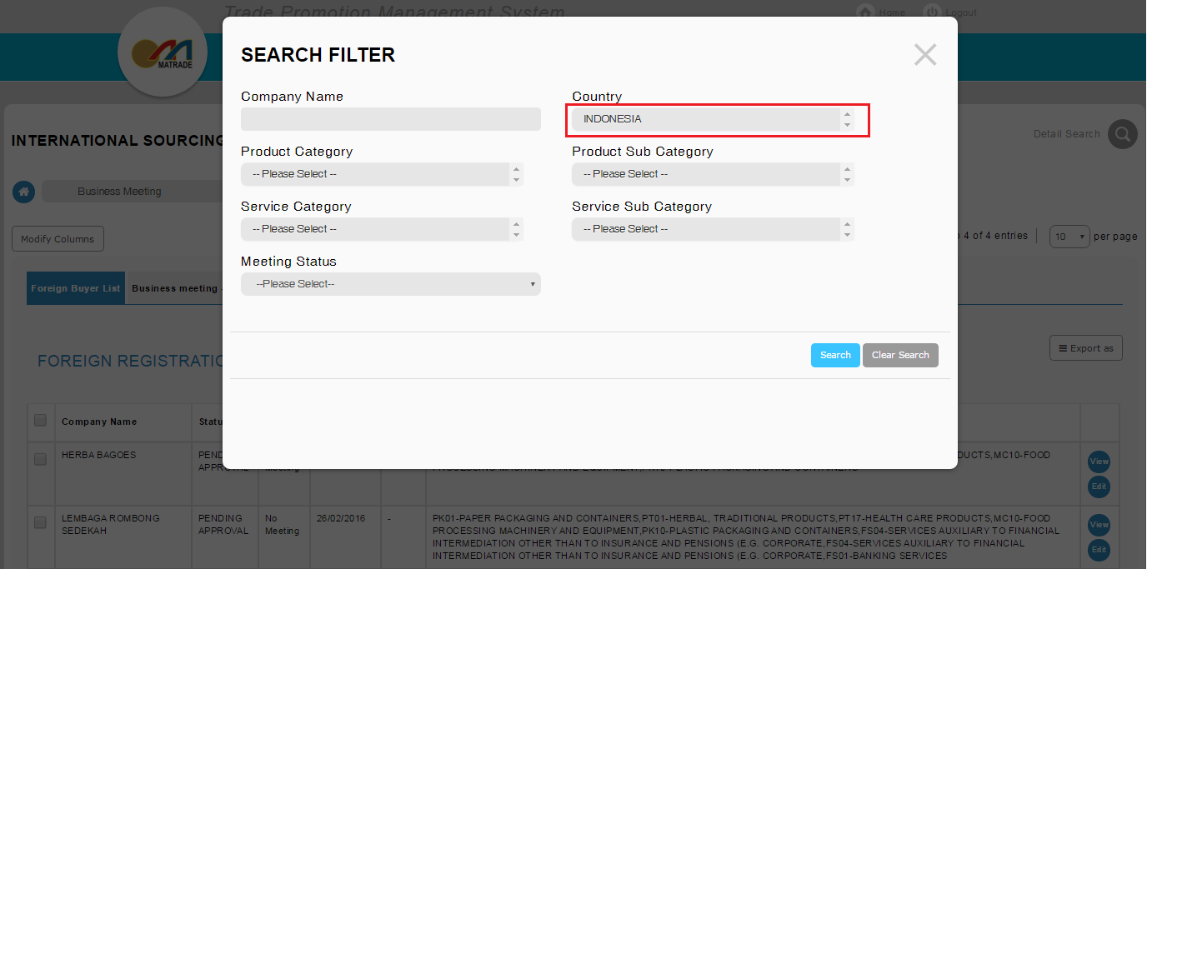
Search Foreign Company - INDONESIA

- Click on “Detail Search” and search for Indonesia under Country dropdown.
Result:
System display Foreign Registration List
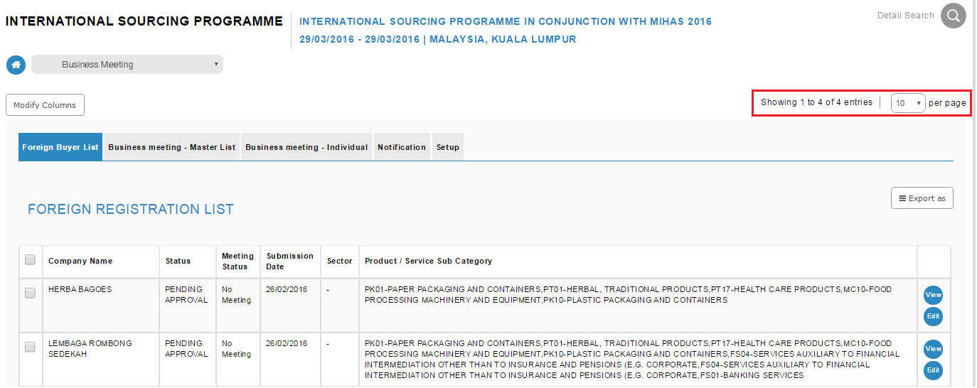
Search Result for INDONESIA – 4 entries

- Click on Promotion > Promotion Report > Selection Committee Report – Listing by Companies
Result:
System display “Selection Committee Report” with value for INDONESIA is 4 and No of Participant is 8.
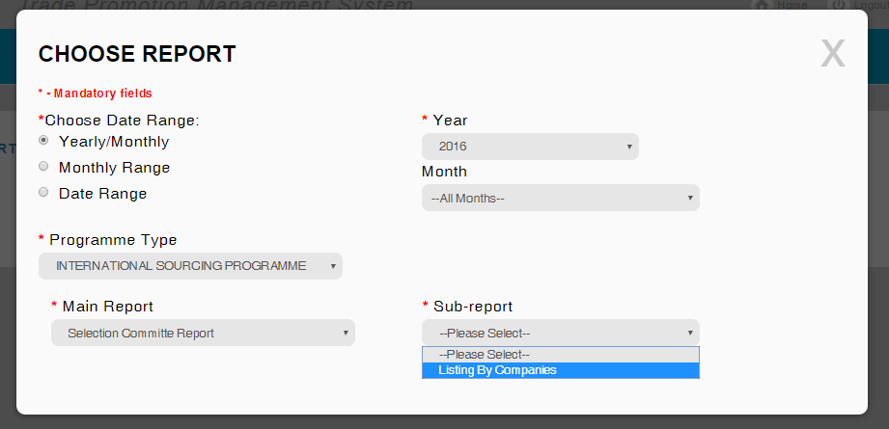
Generate PDF report for “Selection Committee Report”

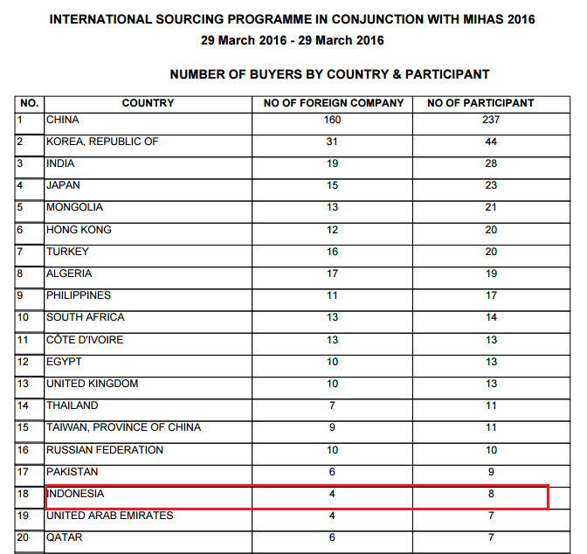

- Click on Promotion > Promotion Report > Companies Details – Foreign Buyers – By Company Name
- Select event name and company.
Result:
This report will show the participant (representative) details for INDONESIA.
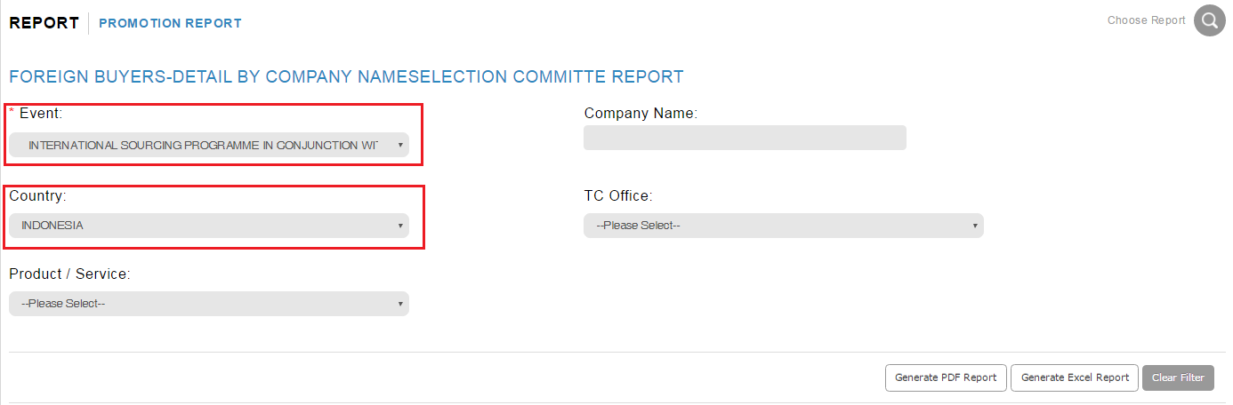
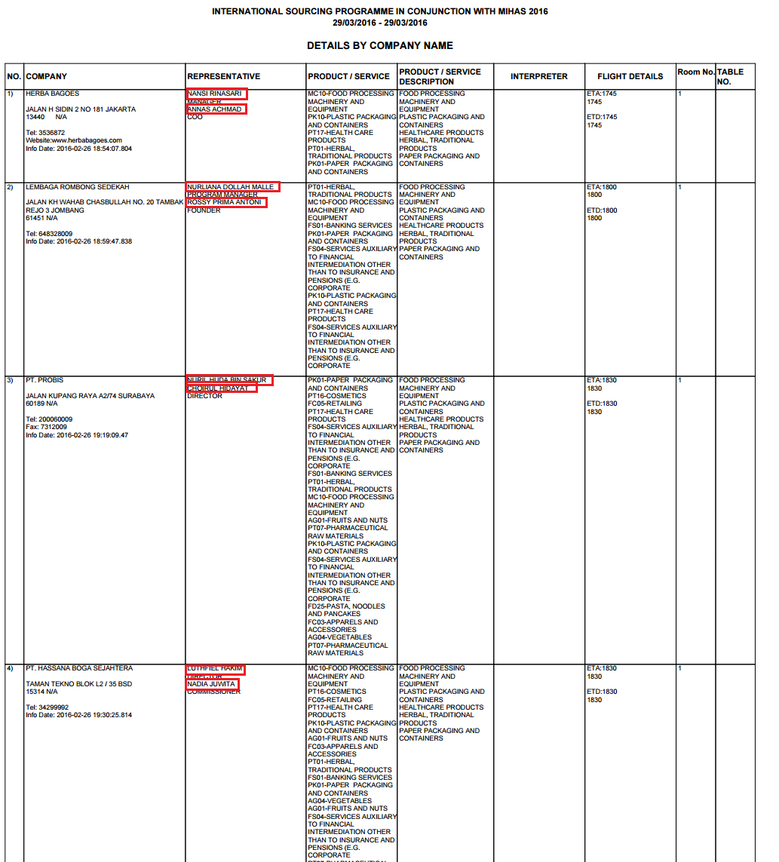

Reviewed By: (PMO)
 |  | Name/Position : NorhaidahBintiMdDasuki / Senior Manager, Quality Assurance and Support  Date : 4/3/2016

