Test Issue Log |  |  |  |  | Issue ID#: TPMS_Prod075ii
Project Name: | Trade Promotion Management System (TPMS)
Test Stage: | Unit Functionality Integration System Interface  Performance Regression Acceptance Pilot
Test Case Number: | Support #6018 |  |  | Test Started Date: |  | 4/3/2016
Test Title: | Generate report for Summary of Foreign Buyer by TC
Test Description: | To test on “Summary of Foreign Buyer by TC” report data is tally with the system.
Test Functionality: | Promotion > Promotion Report > Company Details - Foreign Buyer -->> Summary of Foreign Buyer by TC
Test Procedure: | Generate Report  - Click on Promotion > Promotion Report > Companies Details – Foreign Buyers – Summary of Foreign Buyer by TC  - Select event name and click on “Generate PDF or Excel Report” button.  To verify Data  - Click on Promotion > Select related Event > Select on Business Meeting  - Click on “Detail Search” and select Country field to search.
Test Result: | Pass: Fail: Conditional Pass: |  | Tested by: |  | Siti Norahayu
Reason for Failed / Conditional Pass:
TEST DESCRIPTION
- Click on Promotion > Promotion Report > Companies Details – Foreign Buyers – No of buyers by product & services.
Result:
System display choose report screen
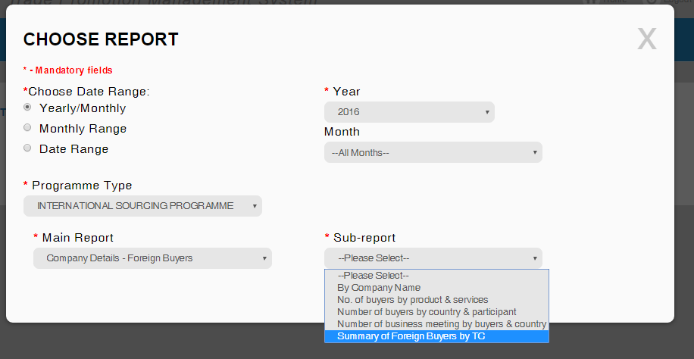

- Select event name and click on “Generate PDF or Excel Report” button.
Result:
System display choose Event screen
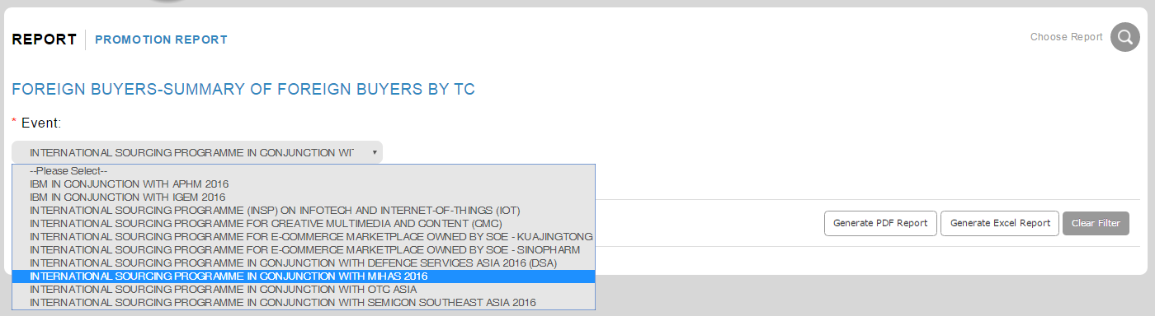

- Select click on “Generate PDF or Excel Report” button
Result:
System display “Summary of Foreign Buyer by TC” Report
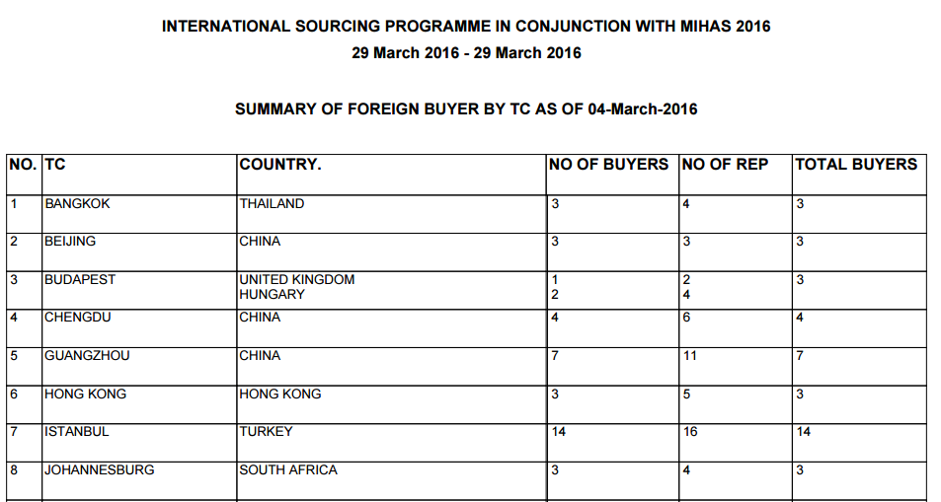

To Verify Data
- Click on Promotion > Select related Event > Select on Business Meeting
- Click on “Details Search” and select Country field to search.
Result:
System display selected Foreign Registration List. Number of entries MUST same with the report.
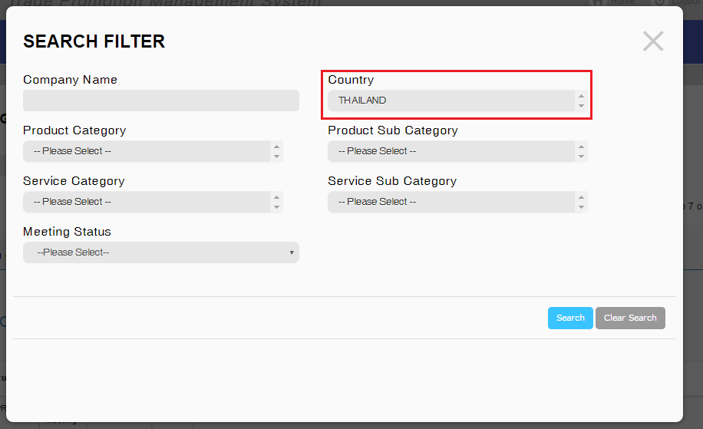
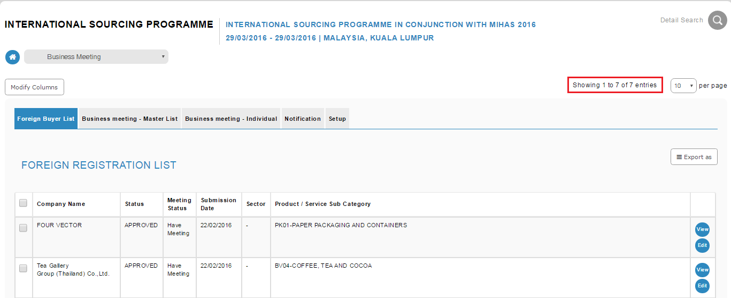
System display 3companies with APPROVED status for THAILAND

Reviewed By: (PMO)
 |  | Name/Position : NorhaidahBintiMdDasuki / Senior Manager, Quality Assurance and Support  Date : 4/3/2016

