Test Issue Log |  |  |  |  | Issue ID#: TPMS_Prod060
Project Name: | Trade Promotion Management System (TPMS)
Test Stage: | Unit Functionality Integration System Interface  Performance Regression Acceptance Pilot
Test Case Number: | Support #6034 |  |  | Test Started Date: |  | 04/03/2016
Test Title: | Add Company Name field in search filter.
Test Description: | To test on “Company Name” filter at Malaysian Companies & Foreign Buyer
Test Functionality: | Promotion >List of event > Registration > List of companies  Promotion >List of event > Business Meeting > Foreign Registration List
Test Procedure: | - Promotion >List of event > List of companies  - Promotion >List of event > Business Meeting > Foreign Registration List
Test Result: | Pass: Fail: Conditional Pass: |  | Tested by: |  | Siti Norahayu
Reason for Failed / Conditional Pass:
TEST DESCRIPTION
Click on Promotion > List of event > Registration > List of companies
Result:
System display List of companies

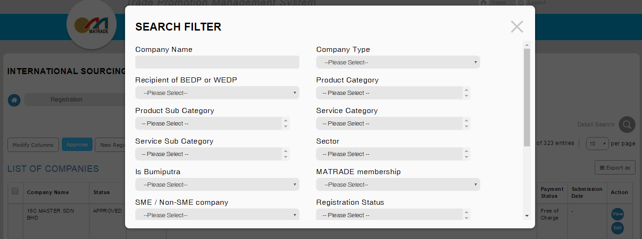

Click on Promotion > List of event >Business Meeting > Foreign Registration List
Result:
System display Foreign Registration List

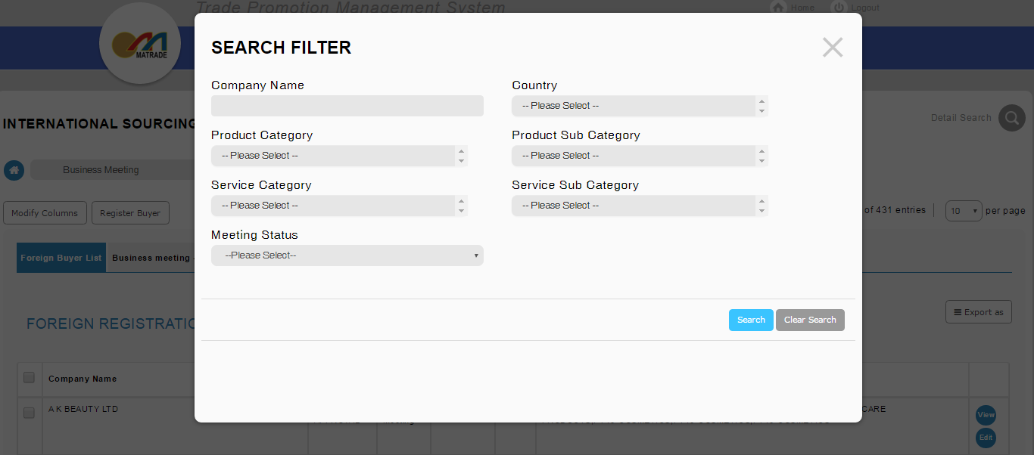

Reviewed By: (PMO)
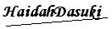 |  | Name/Position : NorhaidahBintiMdDasuki / Senior Manager, Quality Assurance and Support  Date : 04/03/2016

