Add meaningful label for attendance list. For example attendance list for main event. Apply to all attendance lists.

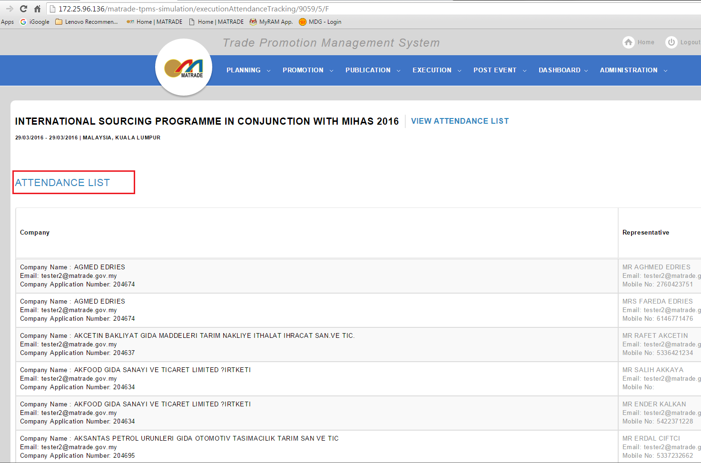

Change wording filter to Detail search. Follow standard wording for searching in other module.

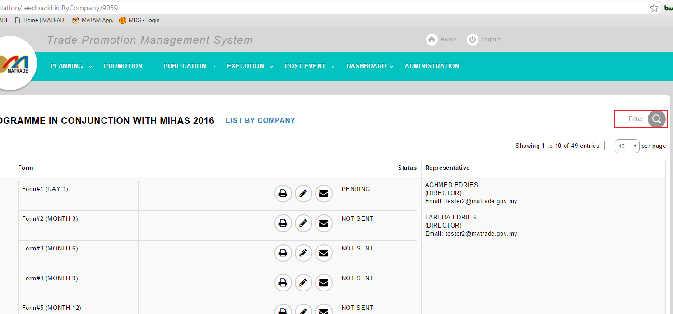

Add company name in detail search

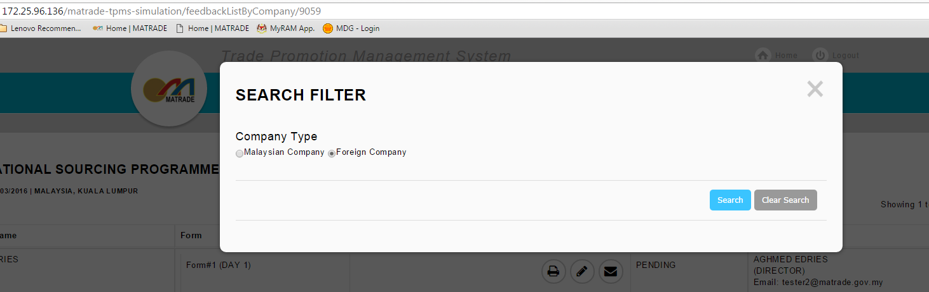

If user click ‘X’ button, system will refresh main page and default value for Company Type will change to Foreign Company.

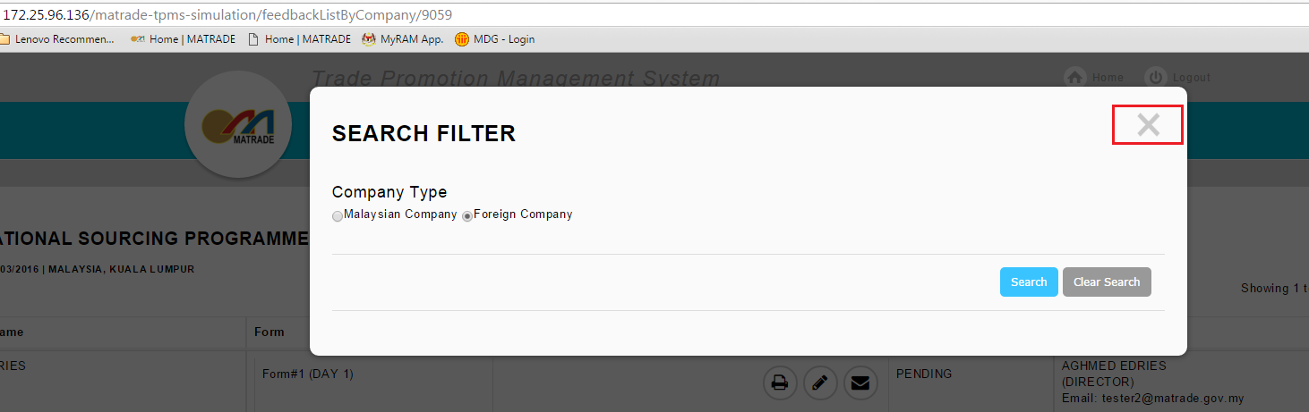

Remove repeating header in list of company.[Execution Report -> Malaysian Company Attendance]

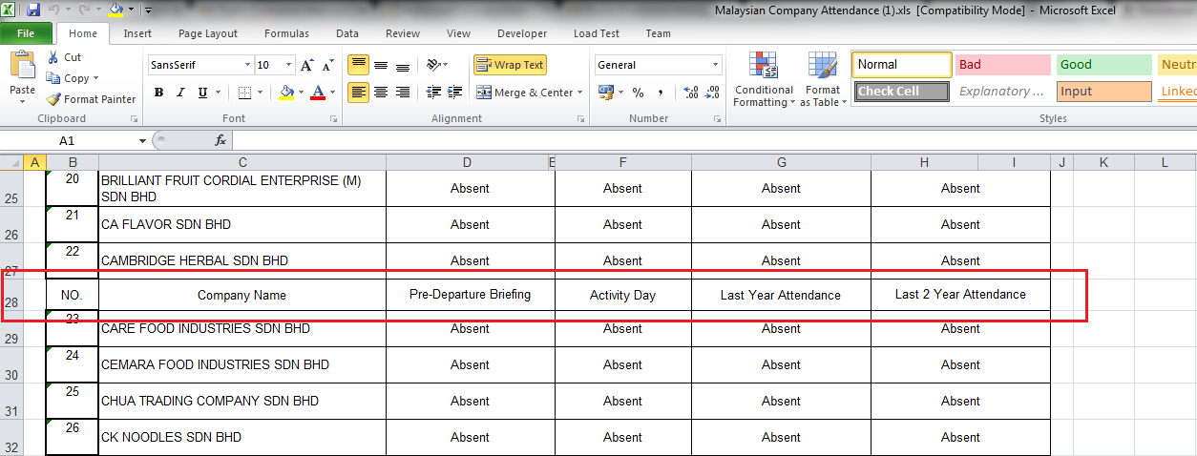

Product/Services Description not upper case. [Feedback]

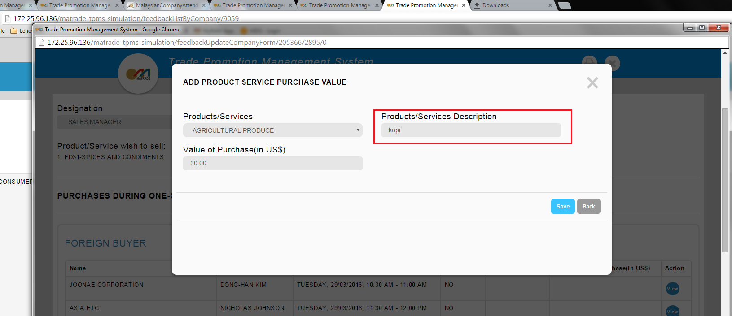

Business meeting – Master List attendance and feedback foreign and feedback Malaysian company not tally.

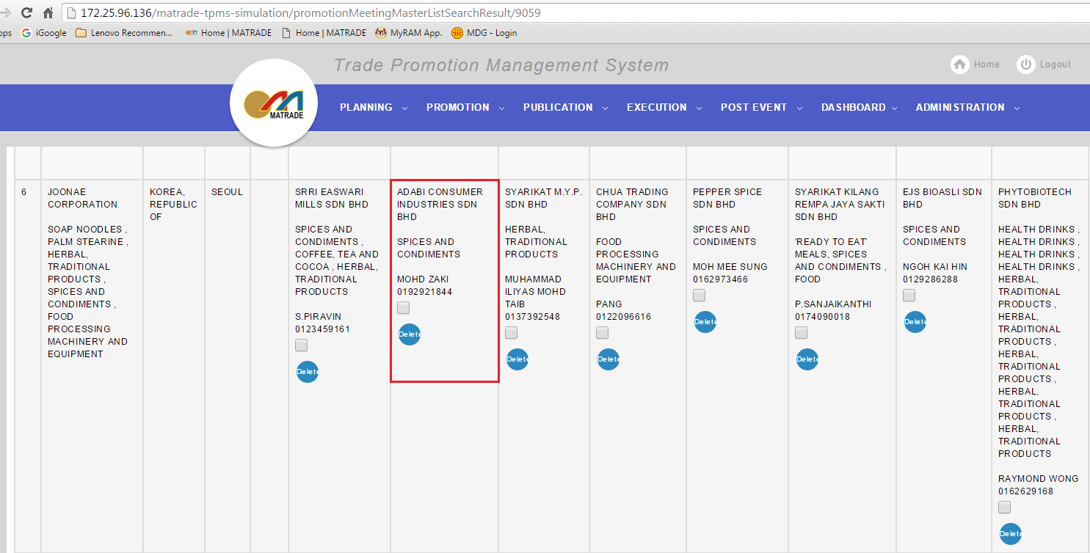

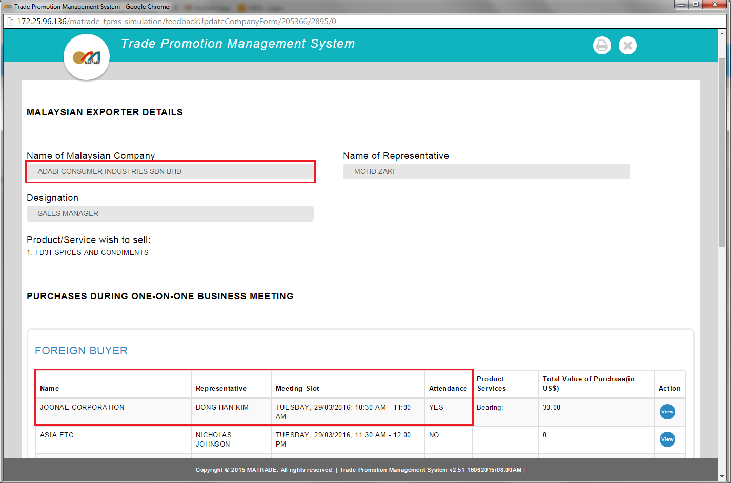

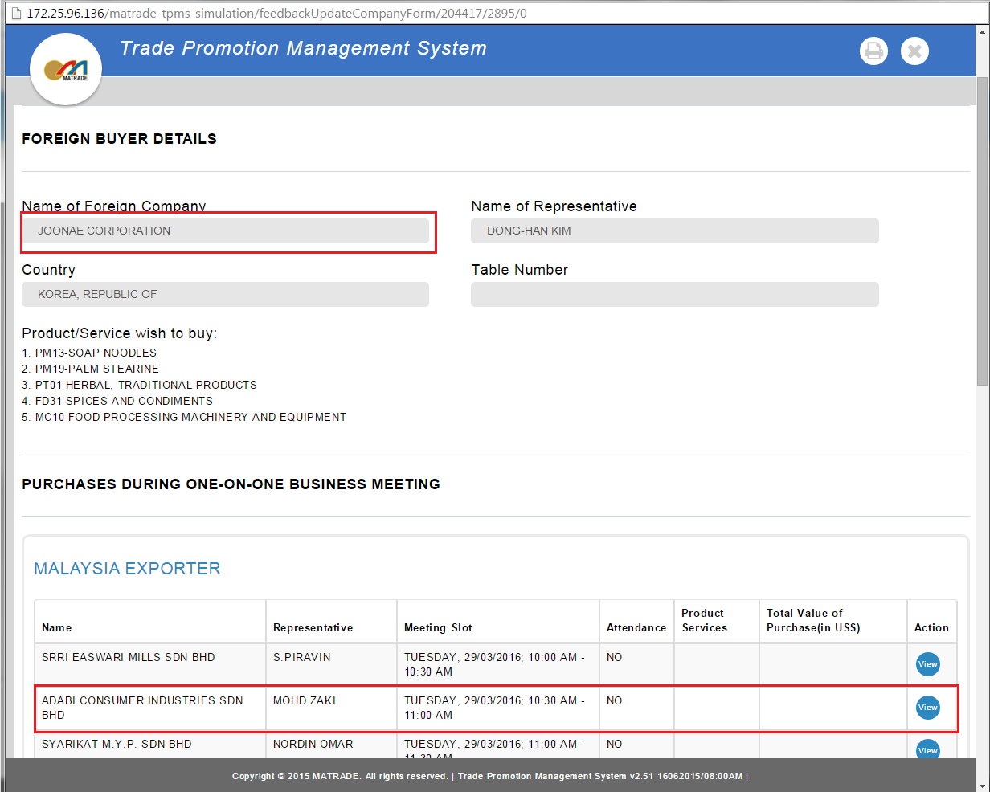

Load foreign buyer list take too long.

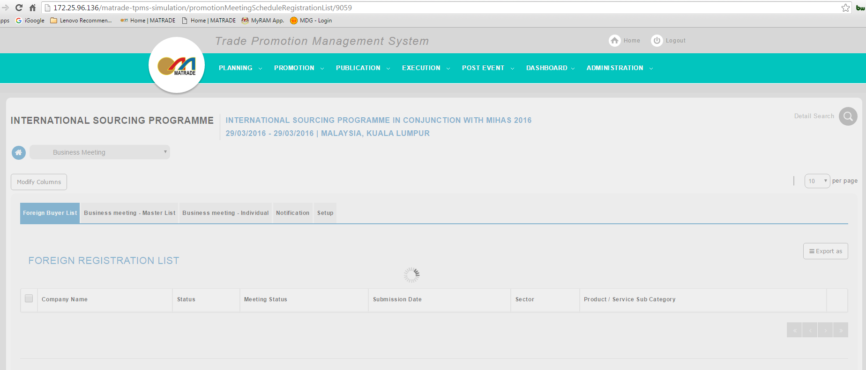

Load too long to view business meeting-master list

