**SIMULATION INPS MIHAS 2016**

**Foreign Registration List**

* To sort Foreign buyer name in alphabetical order

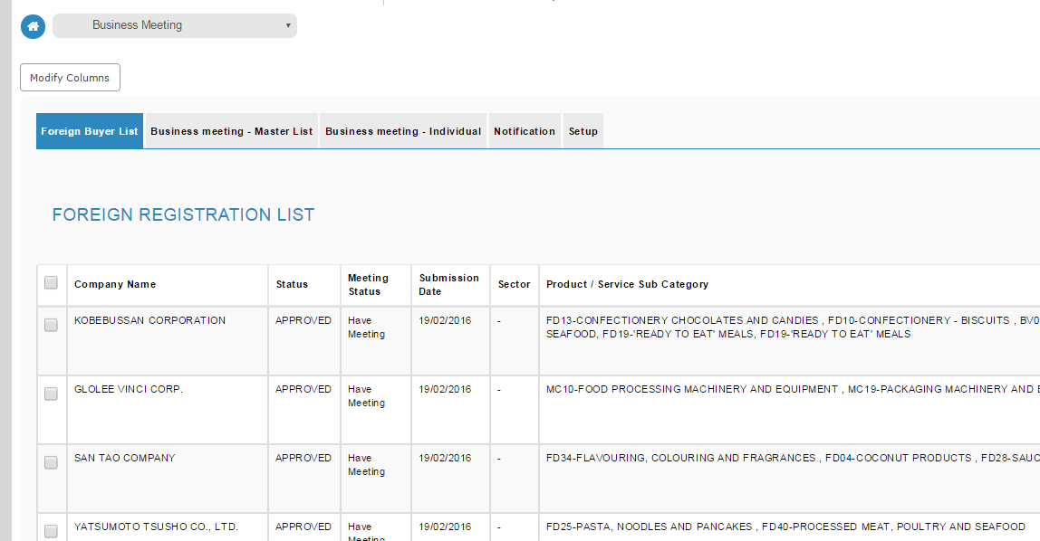

Bila click Business Meeting – Master list tab, ianya mengambil masa yang lama untuk memaparkan result business meeting master list. Ada ketikanya mengambil masa 40 second and ada masanya mengambil masa more than 4 minutes.

Ada juga display screen biru iaitu -> the system has encountered an error…….. bila try to refresh.

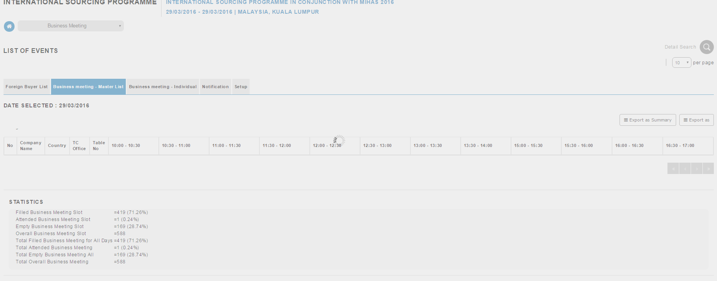

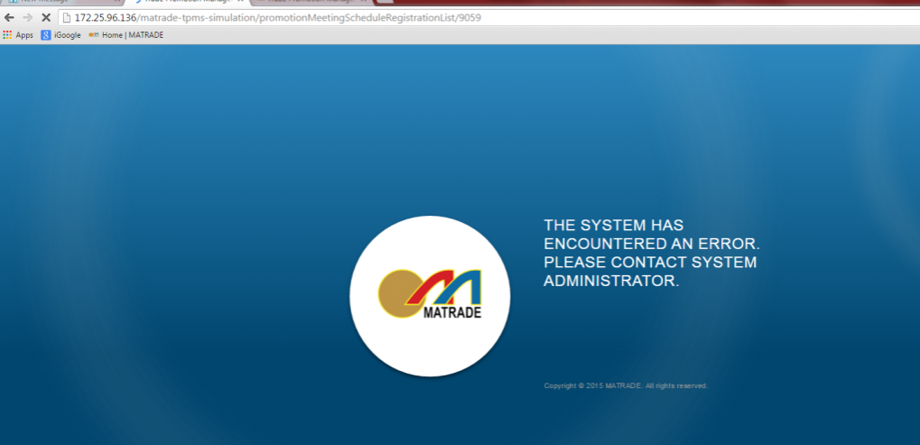

Edit business meeting:

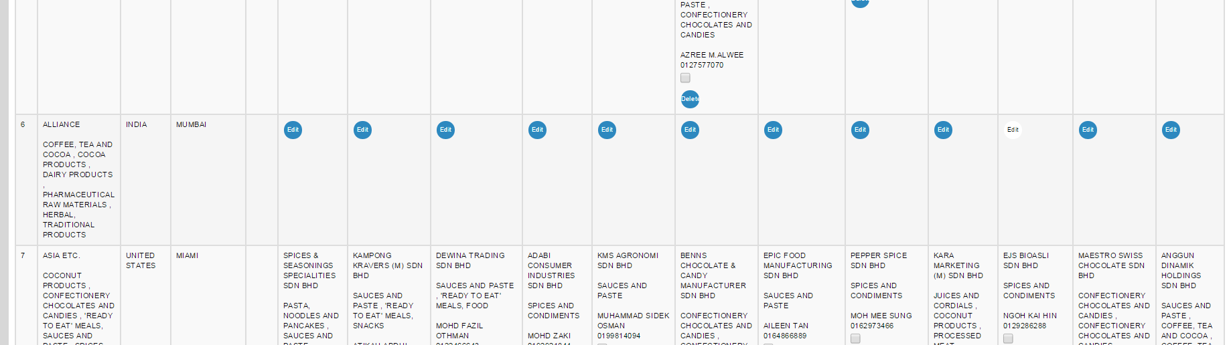

Click Edit icon-> didapati tiada icon loading dipaparkan selepas clik Edit icon menyebabkan tak nampak samada proses Edit itu berjalan atau tidak.

Selepas beberapa second, keluar error -> An error occurred while edit meeting slot. Please try again

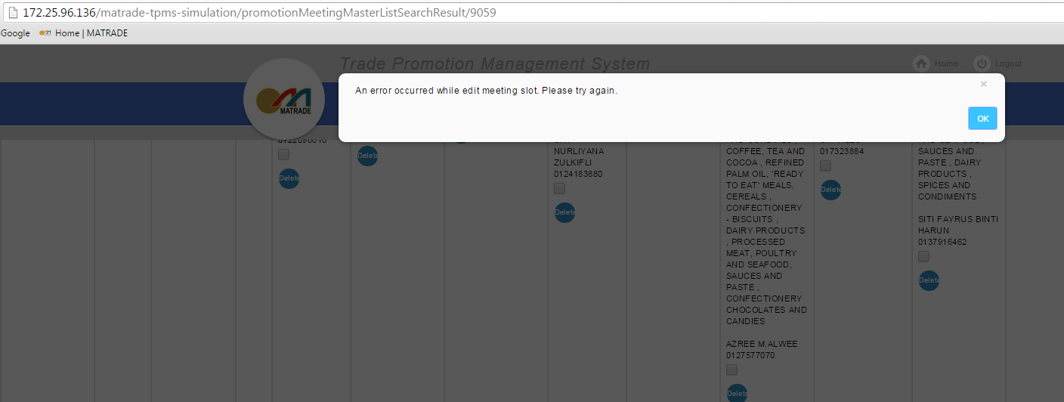

**Business meeting – Individual**

* To sort the Foreign Buyer and Malaysian company list in the alphabetical order

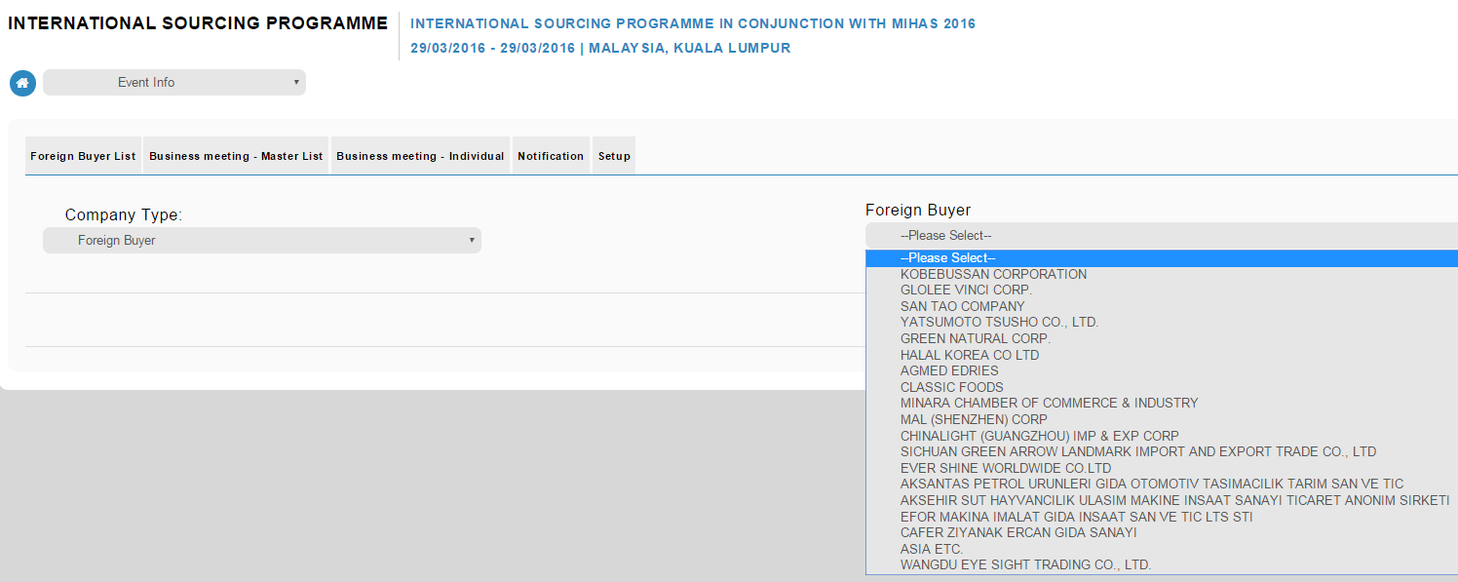

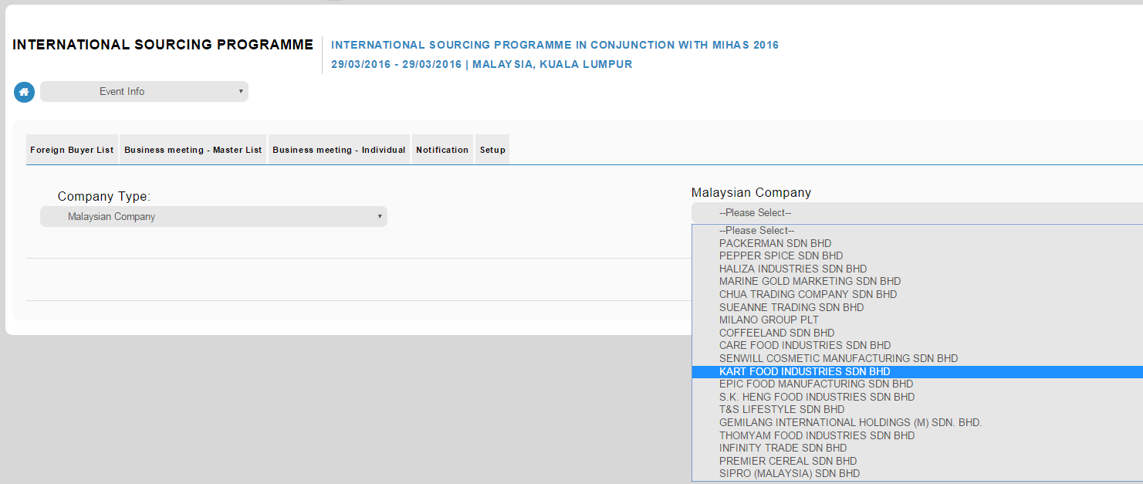

* To bold :

Event Name:

Company:

Country:

TC Office:

Product & Service:

Product & Service Description:

Total Business Meeting:

* Field for TC Office and Country only available for Foreign Buyer not For Malaysian company.

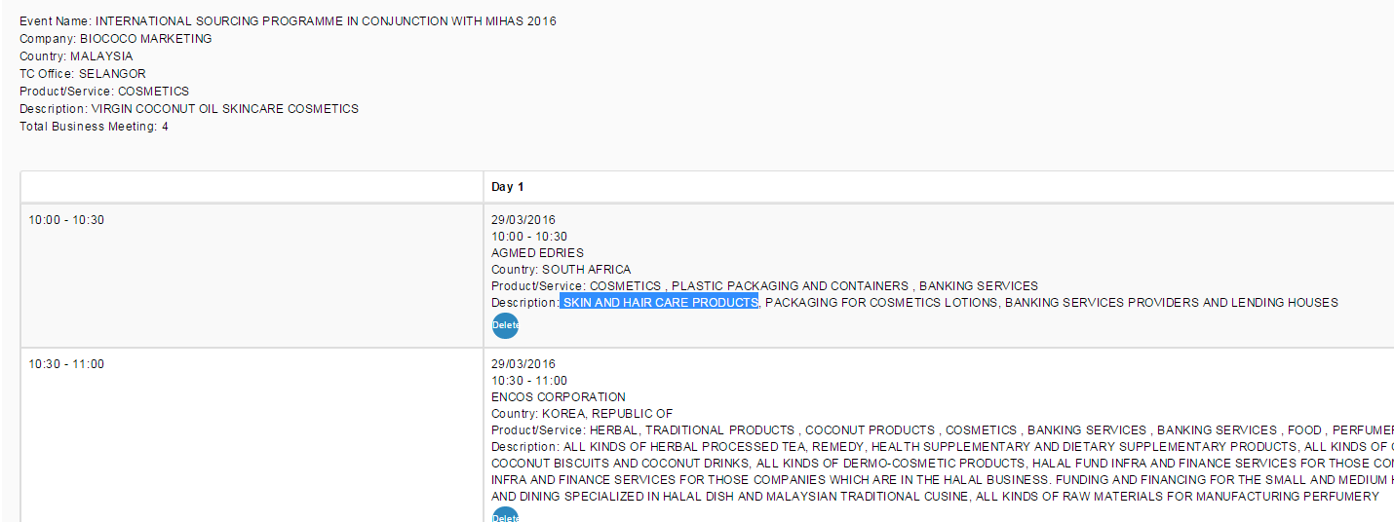

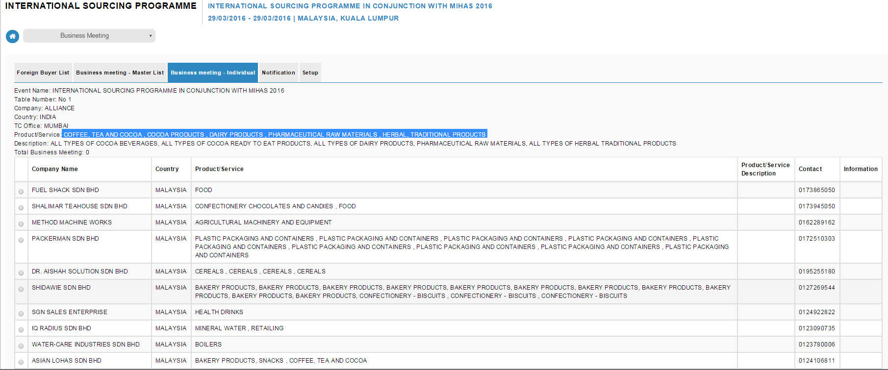

Maklumat Product/Service Description tidak dipaparkan.

Ada certain company tak boleh Edit – display error -> Server Error with Status code

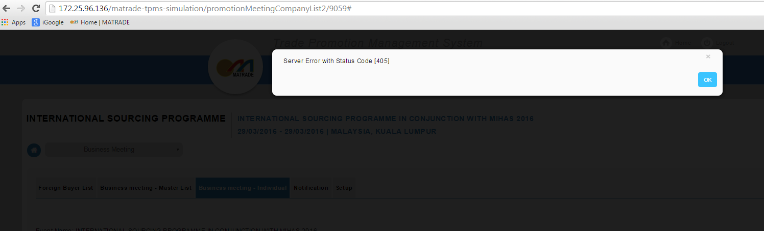

**Business meeting – Individual:**

Bila perlu pilih company lain, need to used button back browser, system need to default back Company Type to Please Select…

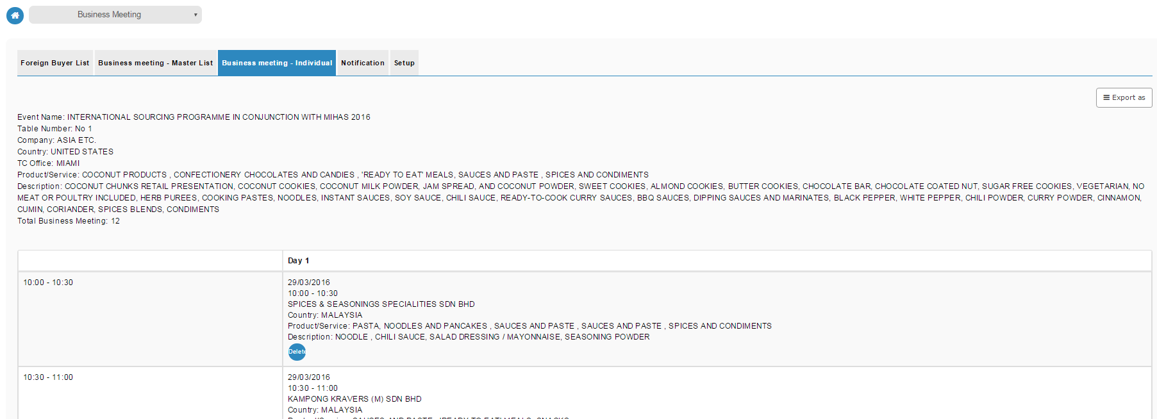

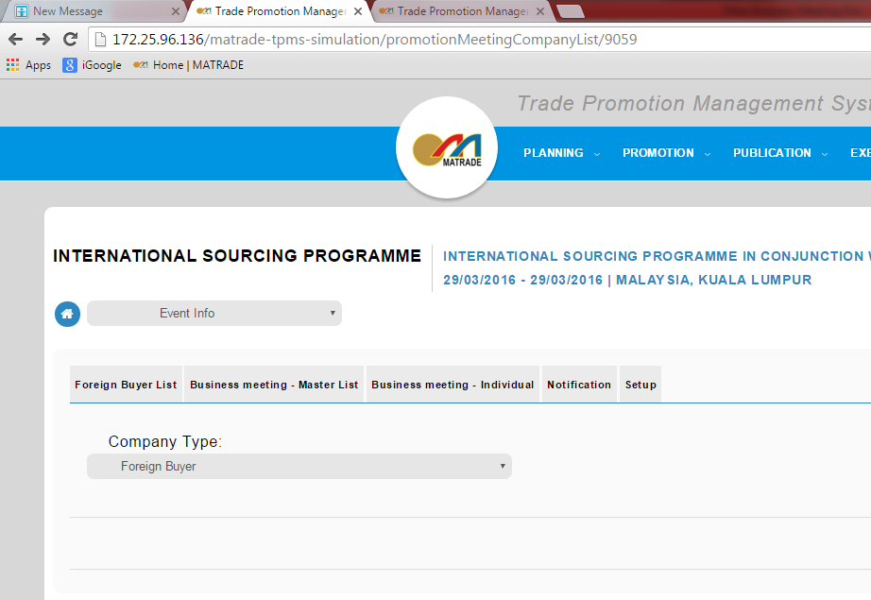

**Business meeting – master list:**

Export as summary to excel and pdf

* Total buyer in the master list not tally with total buyer in Foreign Buyer list