Change Request Form

Project Name | PERKHIDMATAN PEMBANGUNAN TRADE PROMOTION MANAGEMENT SYSTEM (TPMS)  NO. TENDER: MATRADE NO. 1/2014
Reference number | CR/MATRADE/TPMS/003
Name of Requestor
Date of Request | 12 Aug 2015

Change Request Detail
Change Description | Issue No. TPMS_UAT_098  Report Planning >> Details of Work Programme  To add summary of activity in the end of report  Sample Summary :  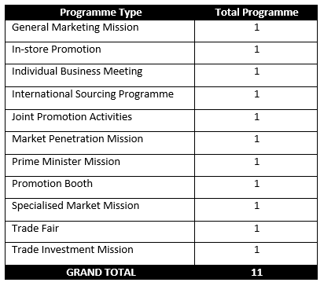  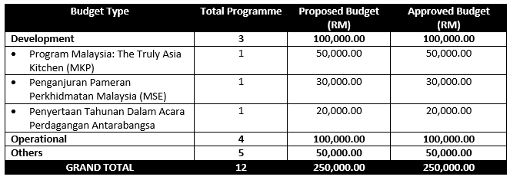
Reason of Change
Implication
Impact of Change | Summary of Activity will be added to Details of Word Programme report.
Financial Impact (RM)
Schedule Impact (days) | Module Man days Remarks  Planning Report >> Details of Work Programme 3 Need sample of summary of activity  Total

Change Approval Response

Inteksoft’s Decision |  | Approved
 |  | Rejected
 |  | KIV
Authorizing Signature & Chop | _________________________  En. Benny Yeo,  Project Director |  | Date:
MATRADE’s Decision |  | Approved
 |  | Rejected
 |  | KIV
Authorizing Signature & Chop | _________________________  En. Jamaluddin Abdullah,  Project Director |  | Date:

