**Requirement for Issue No. TPMS_UAT_122**

**CR/MATRADE/TPMS/010**

1. To add column Total Generated Sales (RM) and Total Approved Participants and display the accurate information in the screen as below:
2. Planning>Activity List – List of Activity (refer correct sequence required by En Rizal Redmine ID #5865

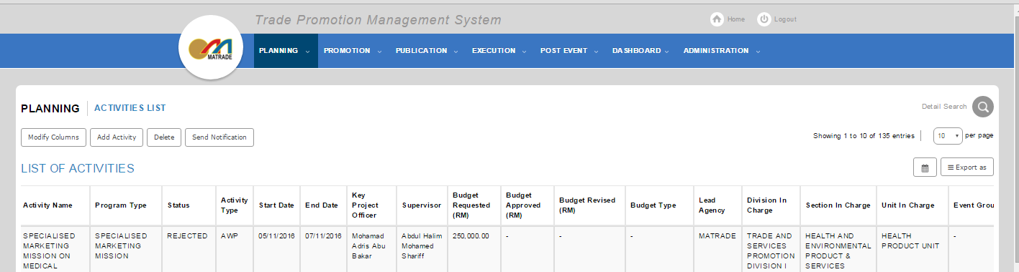

|  |  |  |  |  |  |  |  |  |
| --- | --- | --- | --- | --- | --- | --- | --- | --- |
| Activity Name | Program Type | Activity Type | Status | Location (s) | TC (s) | Regional Offices (RO) | Sector | Lead Agency |
|  |  |  |  |  |  |  |  |  |

|  |  |  |  |  |  |  |
| --- | --- | --- | --- | --- | --- | --- |
| Co Organiser (s) | Collaborator (s) | Section in Charge | Unit in Charge | Division in Charge | Start Date | End Date |
|  |  |  |  |  |  |  |

|  |  |  |  |  |  |
| --- | --- | --- | --- | --- | --- |
| Budget Requested | Budget Approved | Budget Revised | Budget Type | Total Target Sales (RM) | Total Target Participants |
|  |  |  |  |  |  |

|  |  |  |  |  |
| --- | --- | --- | --- | --- |
| **Total Generated Sales (RM)** | **Total Approved Participant** | Key Project Officer | Supervisor | Event Group |
|  |  |  |  |  |

1. Planning>Activity List – Modify Column (sequence as below :-)

Top of Form

Top of Form

**SELECT FIELDS**

|  |  |
| --- | --- |
| * Activity Name * Activity Type * Location(s) * Regional Offices (RO) * Lead Agency * Collaborator(s) * Unit In Charge * Start Date * Budget Approved (RM) * Budget Type * Total Target Sales (RM) * Total Generated Sales (RM) * Supervisor * Event Group | * Program Type * Status * TC (s) * Sector * Co Organizer(s) * Section In Charge * Division In Charge * End Date * Budget Requested (RM) * Budget Revised (RM) * Total Target Participants * Total Approved Participants * Key Project Officer |

1. Planning>Activity List – <Activity Name> - View

Step 1: Click on related <Activity Name> “View” button

To add new column and display information of Total Generated Sales (RM) and Total Approved Participants

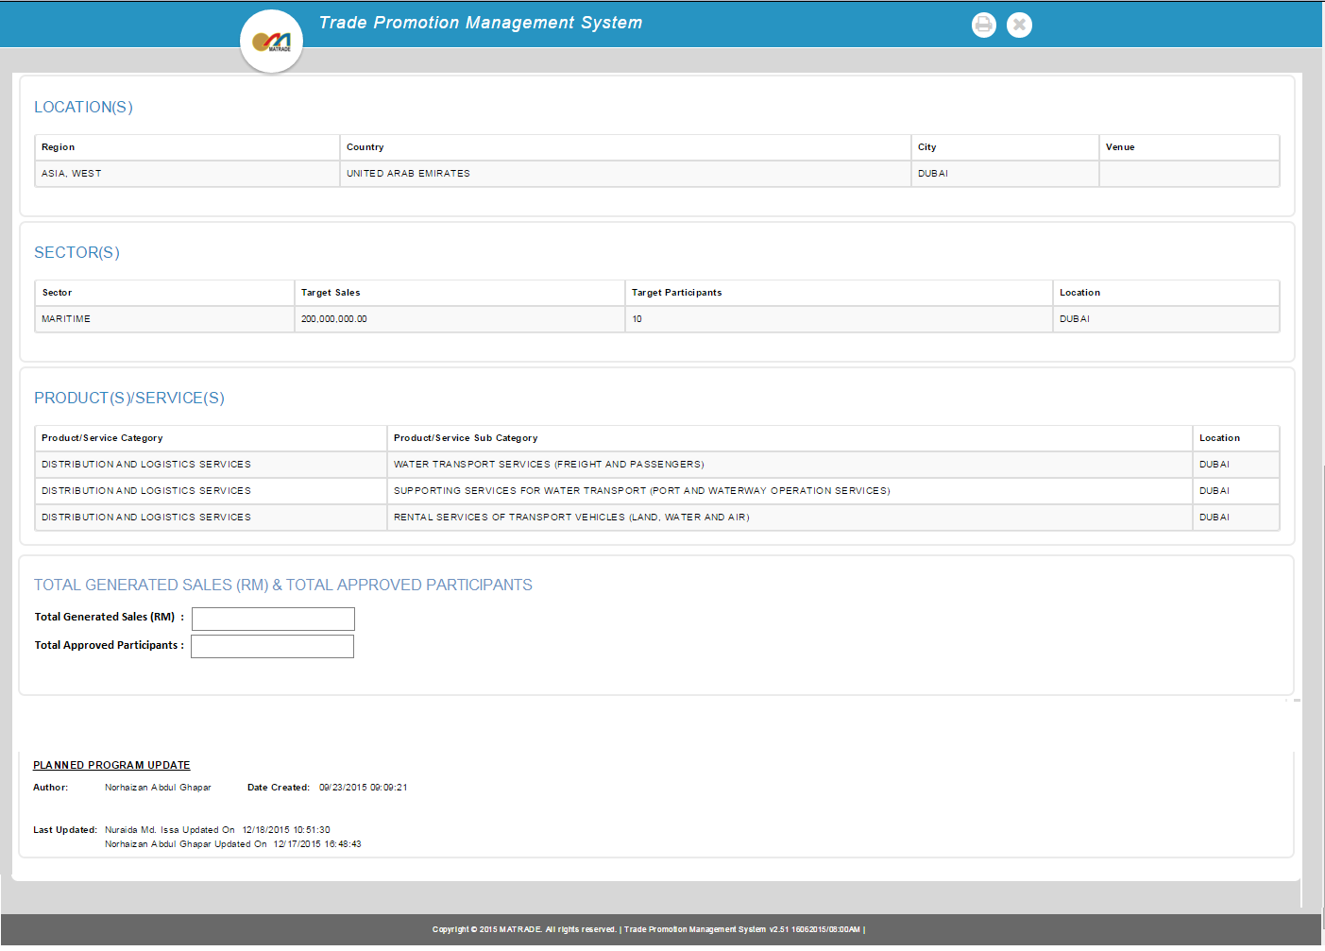

1. Planning>Activity List – <Activity Name> - Add or Edit

Step 1: Click on related <Activity Name> “Edit” or “Add” button

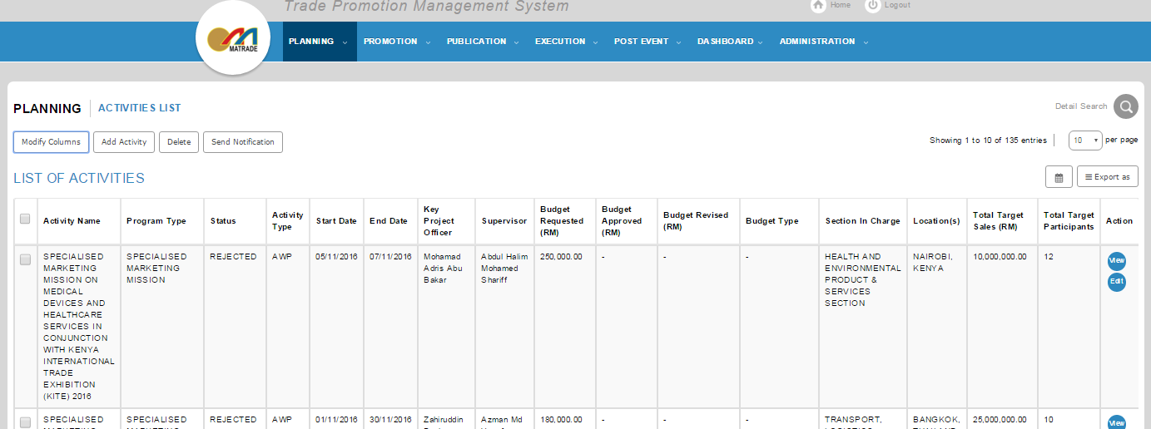

To add new column and display information of Total Generated Sales (RM) and Total Approved Participants (read only)

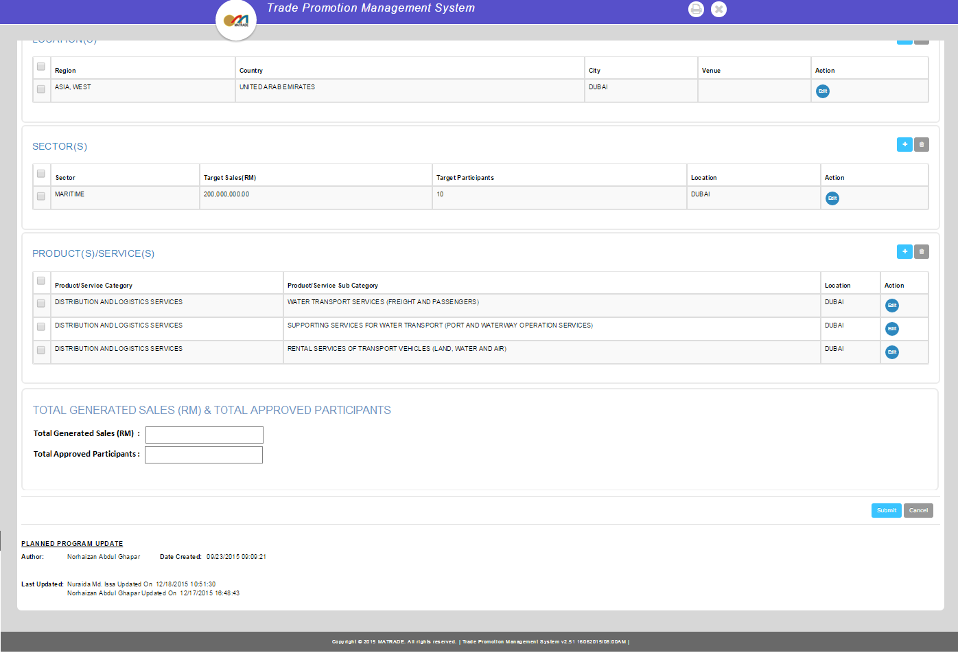

Step 2: Click on “Search Historical Data” button

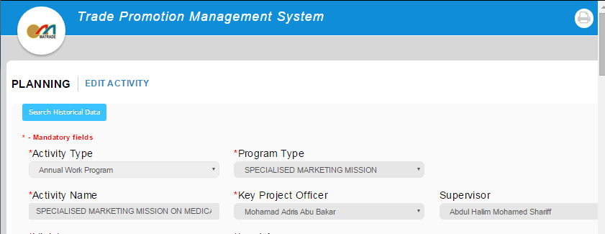

To add column Total Generated Sales (RM) and Total Approved Participants

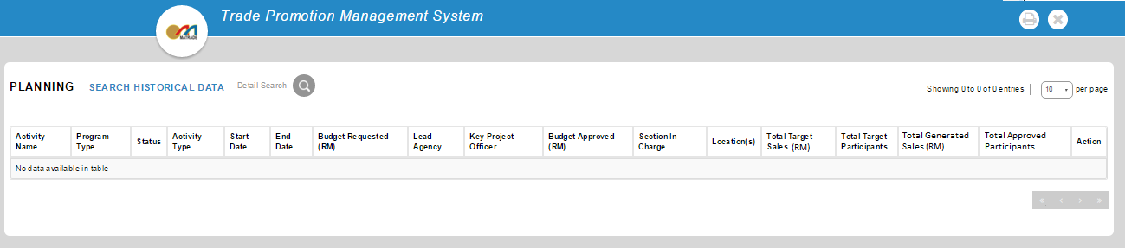

Step 3: Click on “Detail Search” button to search by field criteria

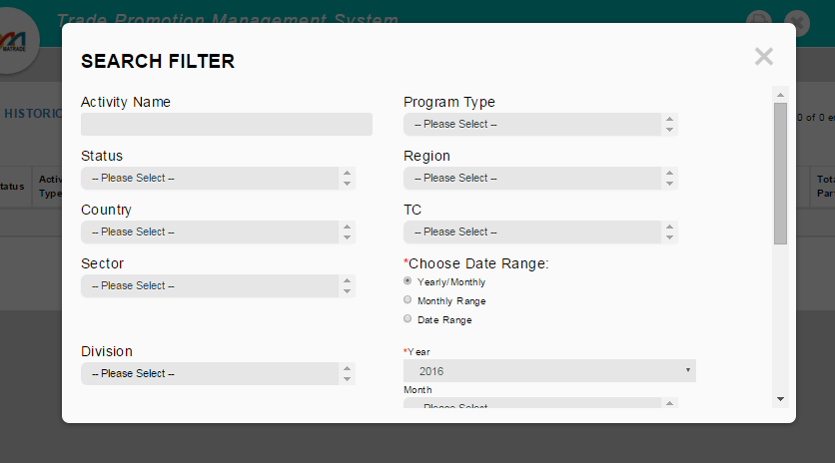

To add new column and display information of Total Generated Sales (RM) and Total Approved Participants

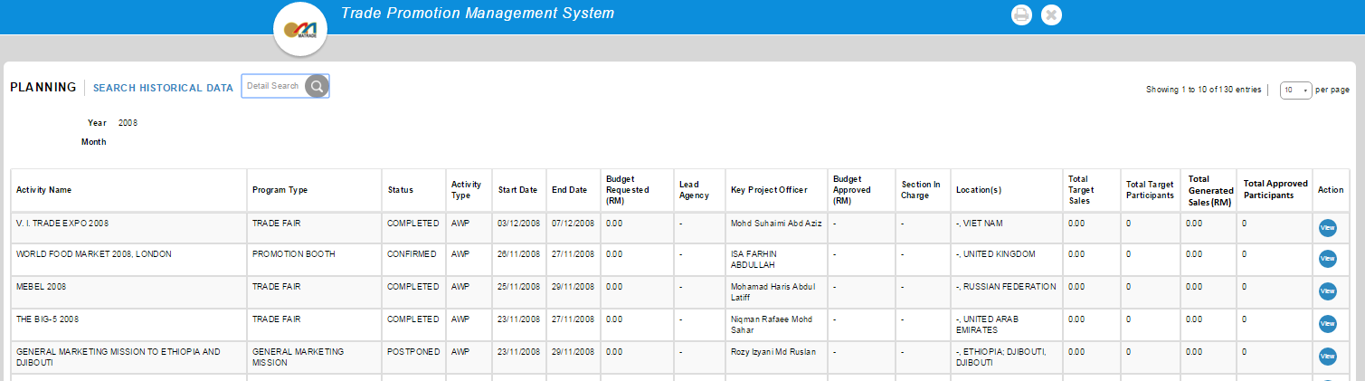

When click “View” button, it shall display as below:-



Notes: Both additional column shall also be displayed in “Export As” (Excel & PDF screen)