***Issue Form (PROD)***

|  |  |
| --- | --- |
| **Originator's Name:** Azliza Husain  **Project:** Trade Promotion Management System (TPMS)  **Project Manager:** Norharizal Ishak  **Module :** Promotion  **Date Raised: 9**/03/2016  **Phase :** Module3 - 8  **Functional Area: Business Meeting – Master List** | **Issue ID Number:** TPMS_Prod085  **Related Issue ID Number:** Redmine #6062  **Classification:**  **Priority:** Critical/High/Medium/Low  **Assigned to: Vendor / IT / PMO SA / UPA**  **Actual Closed Date:** |
| **Status:** Open/Assigned/Investigated/Resolved/Approved/Deferred/No Action  *(Circle one)* | |
| **Description :**   1. Tidak boleh filter by TC Office -> loading lama dan tidak keluar result. 2. Edit Business Meeting yang empty slot, tidak berjaya dilakukan walaupun sudah pilih company yang dikehendaki.   Memaparkan error message “Please select a   company” apabila tekan butang Select.  *Please refer to file attached for further details.* | **Impact:** |
| **Findings/Root Caused (Description):** | **Resolution:** |
| **Estimated Impact :** |  |
| **Recommendation:** | |
| **Accepted :**  **(Vendor / IT / PMO SA / UPA)**  **Date: 9/3/2016** | **Accepted (KFHMB Tester):**  **Date:** |

Business Meeting – Master List - > Search Filter by TC

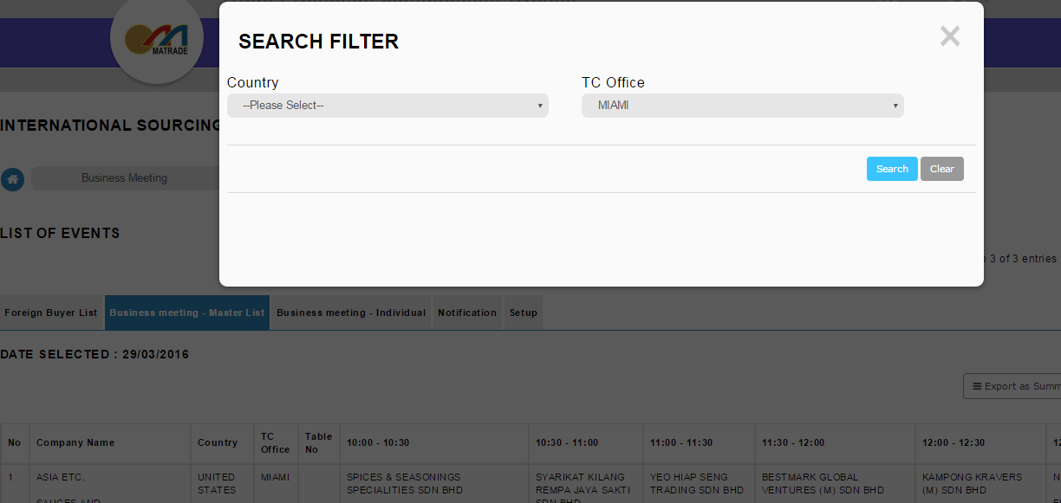

Loading terlalu lama, result not display.

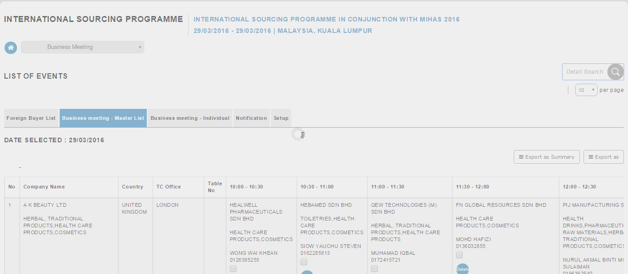

* Dalam TPMS Simulation, search by TC , result display dalam masa yang singkat.

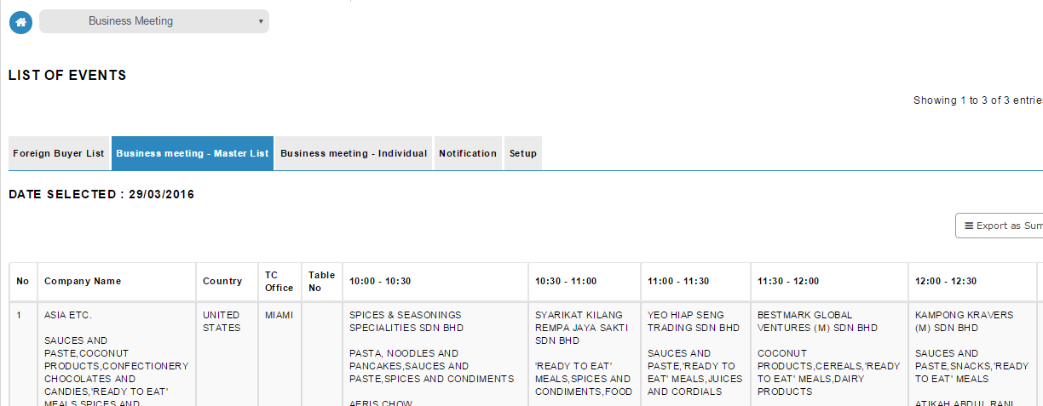

Business Meeting – Master List -> Edit

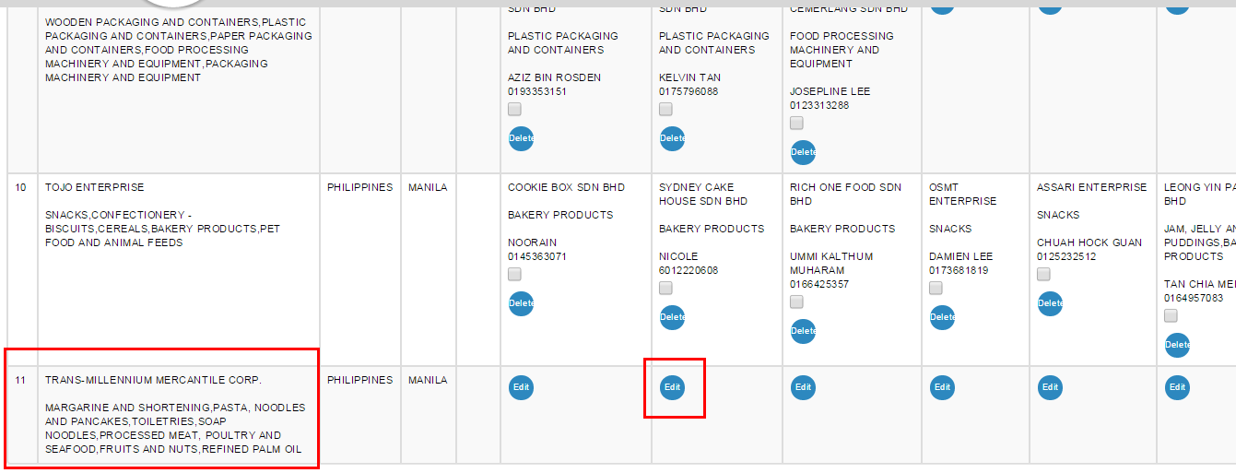

Screen di bawah akan dipaparkan. Sudah pilih Malaysian company yang sesuai, then klik butang Select, keluar pop up message – “Please select a company”

