Test Issue Log |  |  |  |  | Issue ID#: TPMS_Prod085
Project Name: | Trade Promotion Management System (TPMS)
Test Stage: | Unit Functionality Integration System Interface  Performance Regression Acceptance Pilot
Test Case Number: | Support #6062 |  |  | Test Started Date: |  | 10/3/2016
Test Title:
Test Description: | To test on details search for country & TC Office.  To test on select company for manual matching slot.
Test Functionality: | Promotion > Business Meeting – Master List
Test Procedure: | - Click on Promotion > Business Meeting – Master List > Detail search
Test Result: | Pass: Fail: Conditional Pass: |  | Tested by: |  | Siti Norahayu
Reason for Failed / Conditional Pass:
TEST DESCRIPTION
Click on Promotion > Business Meeting – Master List > Detail search
Result:
System display details search screen & search result

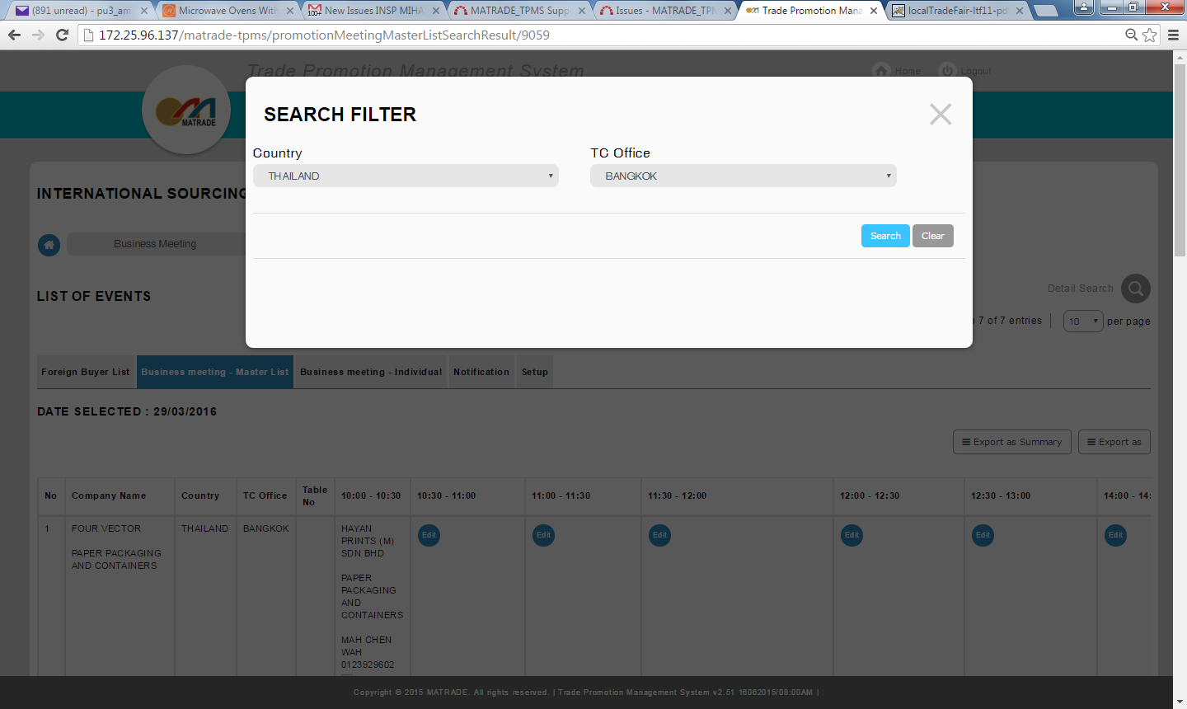
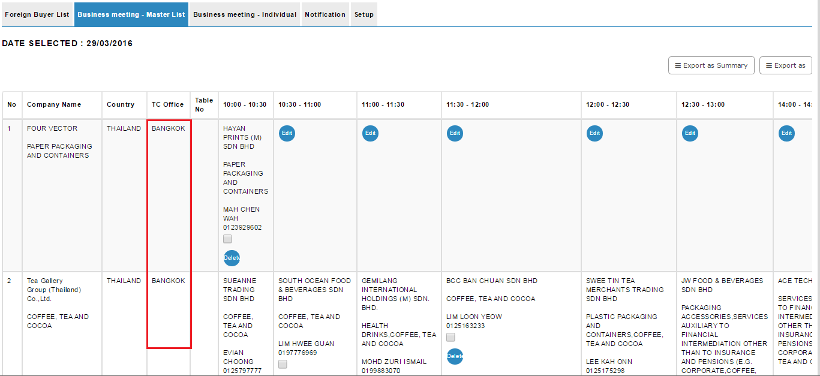

Click on Edit button to do manual match.
Result:
System display company with empty slot to be insert.

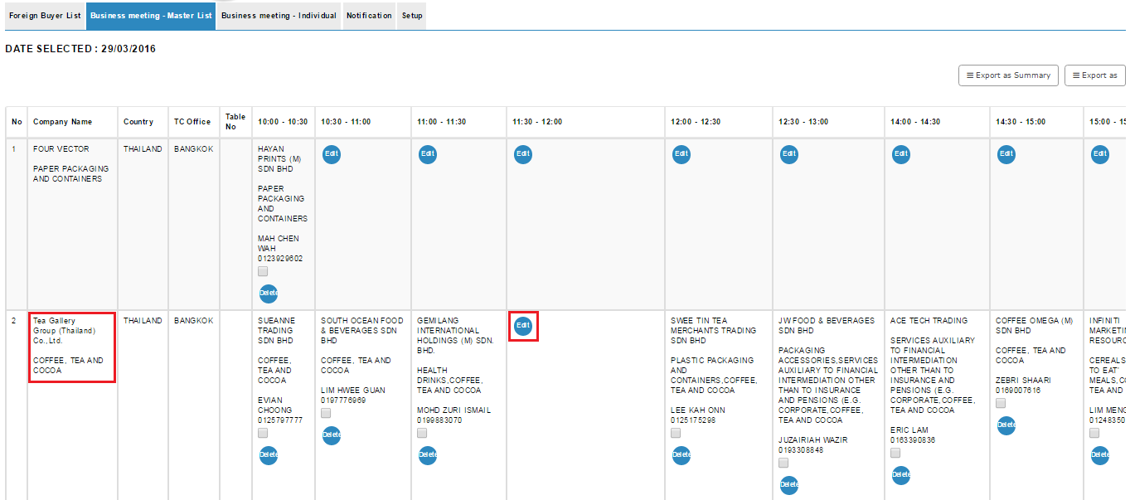
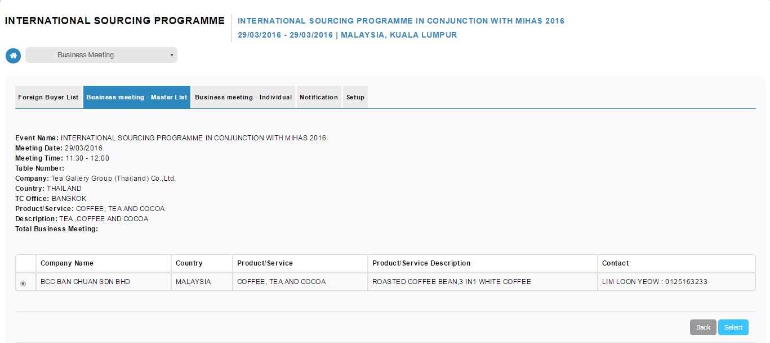
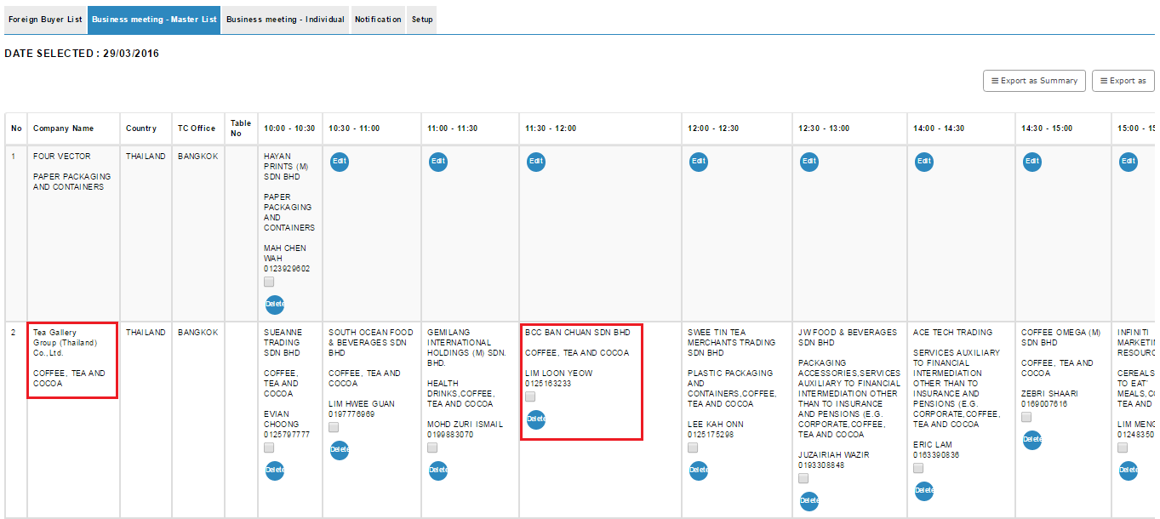

Reviewed By: (PMO)
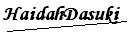 |  | Name/Position : NorhaidahBintiMdDasuki / Senior Manager, Quality Assurance and Support  Date : 10/3/2016

