Test Issue Log |  |  |  |  | Issue ID#: TPMS_Prod084
Project Name: | Trade Promotion Management System (TPMS)
Test Stage: | Unit Functionality Integration System Interface  Performance Regression Acceptance Pilot
Test Case Number: | Support #6061 |  |  | Test Started Date: |  | 11/3/2016
Test Title: | End date at view planning details
Test Description: | To test on End date at view planning details(popup window)
Test Functionality: | Planning > Activities List
Test Procedure: | - Click on Planning > Activities List
Test Result: | Pass: Fail: Conditional Pass: |  | Tested by: |  | Siti Norahayu
Reason for Failed / Conditional Pass:
TEST DESCRIPTION
Click on Planning > Activities List > View button
Result:
System display List of Activities

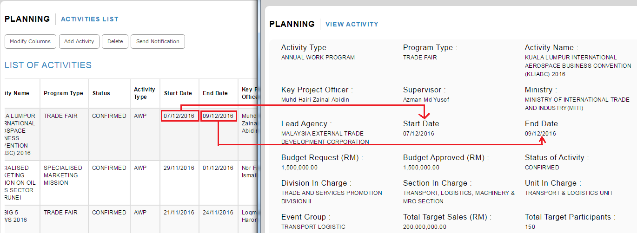

Reviewed By: (PMO)
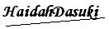 |  | Name/Position : NorhaidahBintiMdDasuki / Senior Manager, Quality Assurance and Support  Date : 11/3/2016

