Test Issue Log |  |  |  |  | Issue ID#: TPMS_Prod088
Project Name: | Trade Promotion Management System (TPMS)
Test Stage: | Unit Functionality Integration System Interface  Performance Regression Acceptance Pilot
Test Case Number: | Support #6065 |  |  | Test Started Date: |  | 11/3/2016
Test Title: | Name of product or service category not displayed in full
Test Description: | To test on name of product or service category not displayed in full
Test Functionality: | Post Event > Report > Local Trade Fair > General - All Sale by Products & Services Category
Test Procedure: | Click on Post Event > Report > Local Trade Fair > General - All Sale by Products & Services Category
Test Result: | Pass: Fail: Conditional Pass: |  | Tested by: |  | Siti Norahayu
Reason for Failed / Conditional Pass:
TEST DESCRIPTION
Click on Post Event > Report > Local Trade Fair > General - All Sale by Products & Services Category
Result:
System display All Sale by Products & Services Category Report.
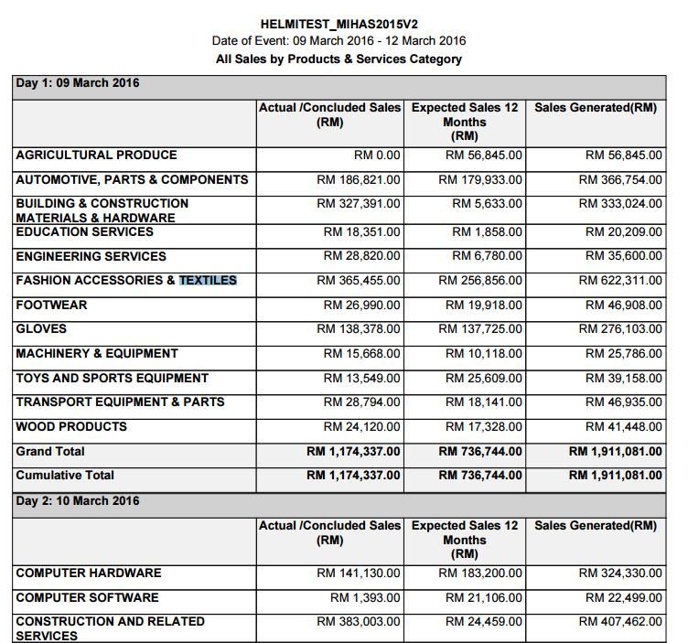

Reviewed By: (PMO)
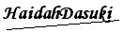 |  | Name/Position : NorhaidahBintiMdDasuki / Senior Manager, Quality Assurance and Support  Date : 11/3/2016

