Test Issue Log |  |  |  |  | Issue ID#: TPMS_Prod086
Project Name: | Trade Promotion Management System (TPMS)
Test Stage: | Unit Functionality Integration System Interface  Performance Regression Acceptance Pilot
Test Case Number: | Support #6063 |  |  | Test Started Date: |  | 15/3/2016
Test Title: | Continues Date for each day.
Test Description: | To test on continues date for each day.
Test Functionality: | Post Event > Report > Local Trade Fair > General - All Sale by hall
Test Procedure: | Click on Post Event > Report > Local Trade Fair > General - All Sale by hall
Test Result: | Pass: Fail: Conditional Pass: |  | Tested by: |  | Siti Norahayu
Reason for Failed / Conditional Pass:
TEST DESCRIPTION
Click on Post Event > Report > Local Trade Fair > General - All Sale by Hall
Result:
System display All Sale by Hall with continues date.
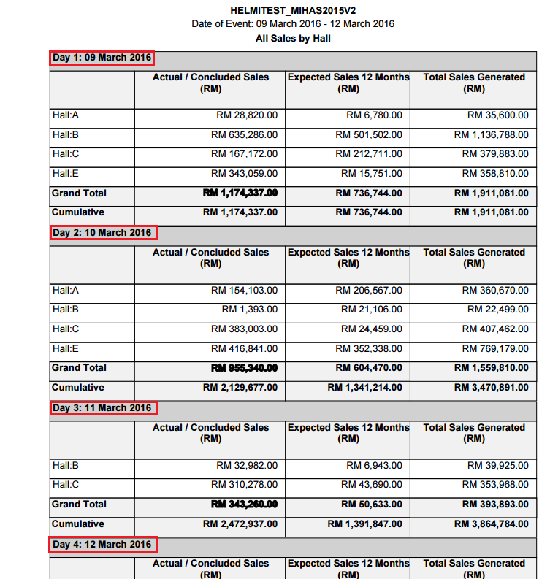

Reviewed By: (PMO)
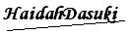 |  | Name/Position : NorhaidahBintiMdDasuki / Senior Manager, Quality Assurance and Support  Date : 11/3/2016

