Test Issue Log |  |  |  |  |  | SCP ID# : 5994
Project Name: | BIB CMS Enhancement Release 1
Test Stage: | Unit Functionality Integration System Interface  Performance Regression Acceptance Pilot
Test Case Number: | 5994 |  |  | Test Started Date: |  |  | 11/03/2016
Test Title: | Transaction History Filter for RIB
Test Description: | - Transaction History : http://10.6.6.20:9081/rib.sit.cms/  - Agronet Transaction History : http://10.6.6.20:9081/rib.sit.cms/
Test Functionality: | Transaction History  - Print  - Download as CSV  - Download as Text  Agronet Transaction History  - Transaction Details  - Status
Test Procedure: | Transaction History  - Check on the Print button function.  - Check on the Download as CSV button function.  - Check on the Download as Text button function.  Agronet Transaction History  - Check the result with selected Transaction Details and Status.
Test Result: | Pass: Fail: | Tested by: |  |  | Erni Suhaireen binti Zulkifli
Reason for Failure:
TEST DESCRIPTION

Account and Banking

Deposit Account

Transaction History
Choose on Start Date and End Date then click on Go to display all the transaction on selected date.
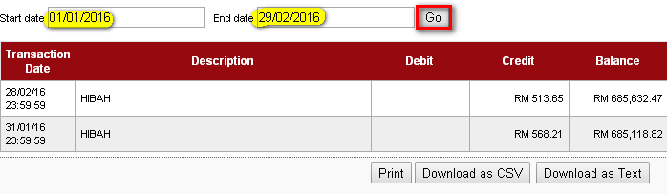

Print
Click on Print to print out the transaction details.
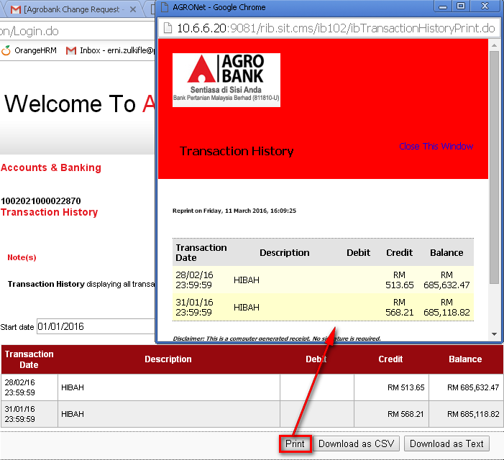

Download as CSV
Click on Download as CSV to download the transaction history on CSV format.
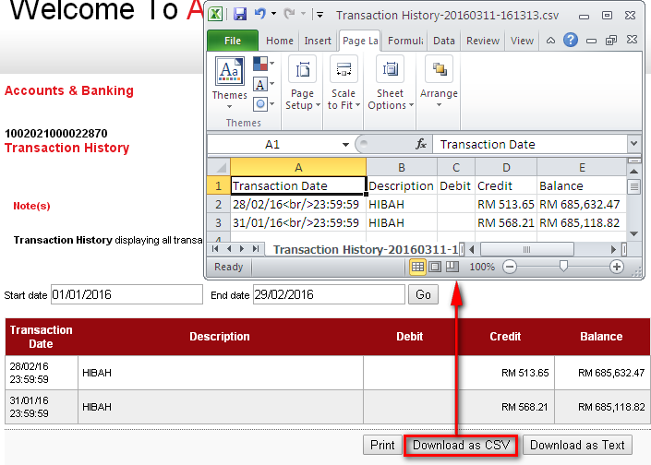

Download as Text
Click on Download as Text to download the transaction history on Text format.

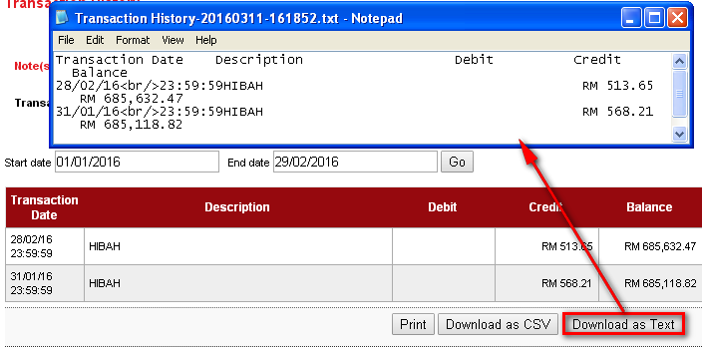

Agronet Transaction History
On this page, choose on Start Date and End Date to display all the transaction on selected date.
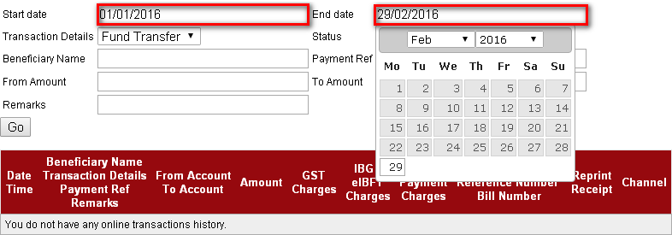

Transaction Details (All) + Status (All)
To find all kind of transaction details with all kind of status, click on All at Transaction Details drop down navigation and also click on All at Status drop down navigation. Then click Go to display.
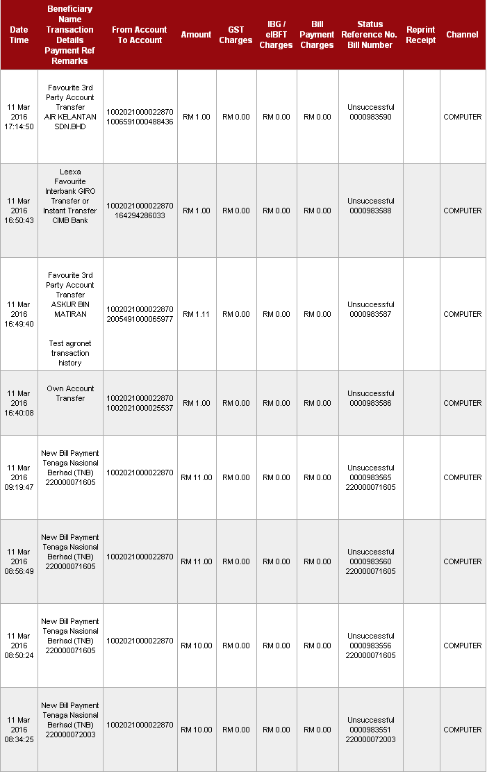

Transaction Details (All) + Status (Successful)
To find all kind of transaction details with successful status only, click on All at Transaction Details drop down navigation and click on Successful at Status drop down navigation. Then click Go to display. It will display “You do not have any online transactions history” if there is no successful transaction status.
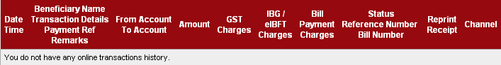

Transaction Details (All) + Status (Unsuccessful)
To find all kind of transaction details with unsuccessful status only, click on All at Transaction Details drop down navigation and click on Unsuccessful at Status drop down navigation. Then click Go to display.
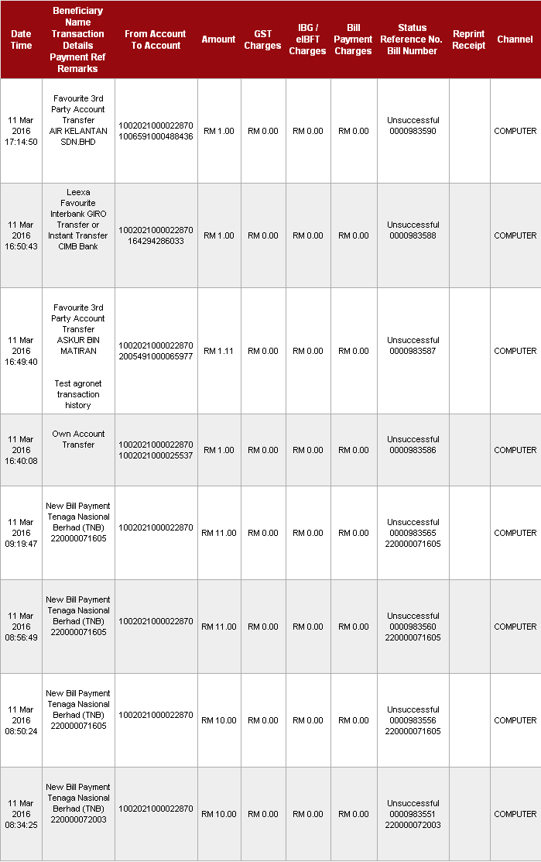

Transaction Details (All) + Status (Accepted)
To find all kind of transaction details with Accepted status only, click on All at Transaction Details drop down navigation and click on Accepted at Status drop down navigation. Then click Go to display. It will display “You do not have any online transactions history” if there is no accepted transaction status.

Transaction Details (Fund Transfer) + Status (All)
To find fund transfer details with all kind of status, click on Fund Transfer at Transaction Details drop down navigation and click on All at Status drop down navigation. Then click Go to display.
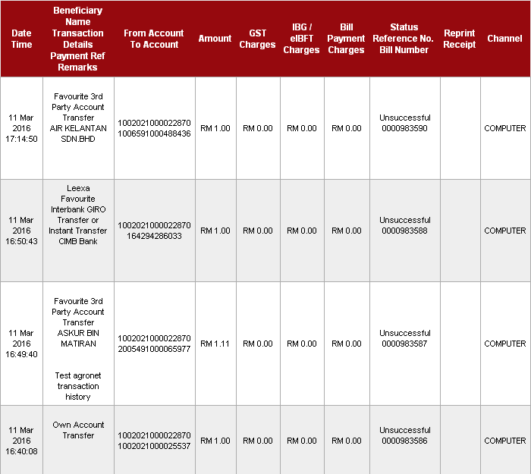

Transaction Details (Fund Transfer) + Status (Successful)
To find fund transfer details with successful status, click on Fund Transfer at Transaction Details drop down navigation and click on Successful at Status drop down navigation. Then click Go to display. It will display “You do not have any online transactions history” if there is no accepted transaction status.

Transaction Detail (Fund Transfer) + Status (Unsuccessful)
To find fund transfer transaction details with unsuccessful status only, click on All at Transaction Details drop down navigation and click on Successful at Status drop down navigation. Then click Go to display.
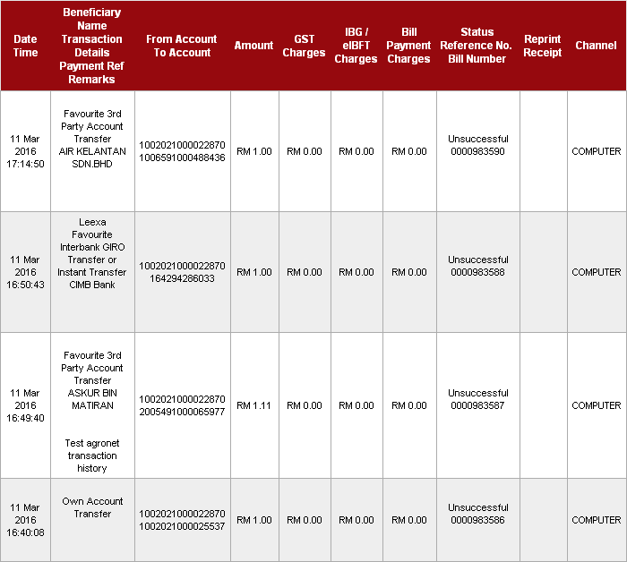

Transaction Detail (Fund Transfer) + Status (Accepted)
To find fund transfer transaction details with accepted status only, click on Fund Transfer at Transaction Details drop down navigation and click on Accepted at Status drop down navigation. Then click Go to display. It will display “You do not have any online transactions history” if there is no accepted transaction status.
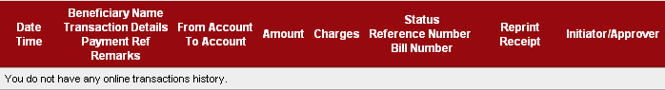

Transaction Details (Bill Payment) + Status (All)
To find bill payment transaction details with all kind of status, click on Bill Payment at Transaction Details drop down navigation and click on All at Status drop down navigation. Then click Go to display.
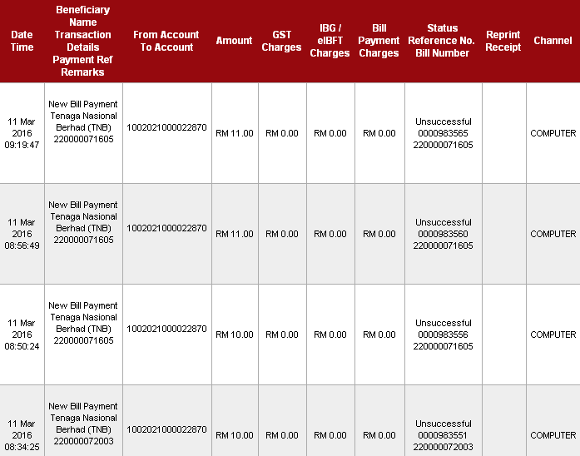

Transaction Details (Bill Payment) + Status (Successful)
To find bill payment transaction details with successful status, click on Bill Payment at Transaction Details drop down navigation and click Successful at Status drop down navigation. Then click Go to display. It will display “You do not have any online transactions history” if there is no transaction.

Transaction Details (Bill Payment) + Status (Unsuccessful)
To find bill payment transaction details with unsuccessful status, click on Bill Payment at Transaction Details drop down navigation and click on Unsuccessful at Status drop down navigation. Then click Go to display.
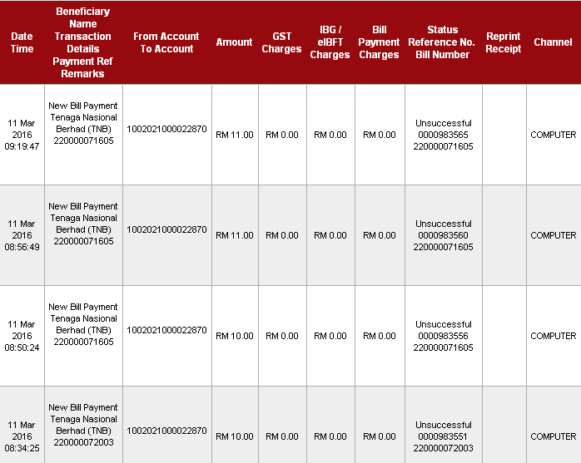

Transaction Details (Bill Payment) + Status (Accepted)
To find bill payment transaction details with accepted status, click on Bill Payment at Transaction Details drop down navigation and click on Accepted at Status drop down navigation. Then click Go to display. It will display “You do not have any online transactions history” if there is no transaction.

Transaction Details (JomPAY) + Status (All)
To find JomPAY transaction details with all kind of status, click on JomPAY at Transaction Details drop down navigation and click on All at Status drop down navigation. Then click Go to display. It will display “You do not have any online transactions history” if there is no transaction.

Transaction Details (JomPAY) + Status (Successful)
To find JomPAY transaction details with successful status, click on JomPAY at Transaction Details drop down navigation and click on Successful at Status drop down navigation. Then click Go to display. It will display “You do not have any online transactions history” if there is no transaction.

Transaction Details (JomPAY) + Status (Unsuccessful)
To find JomPAY transaction details with unsuccessful status, click on JomPAY at Transaction Details drop down navigation and click on Unsuccessful at Status drop down navigation. Then click Go to display. It will display “You do not have any online transactions history” if there is no transaction.

Transaction Details (JomPAY) + Status (Accepted)
To find JomPAY transaction details with accepted status, click on JomPAY at Transaction Details drop down navigation and click on Accepted at Status drop down navigation. Then click Go to display. It will display “You do not have any online transactions history” if there is no transaction.

Transaction Details (Mobile Reload) + Status (All)
To find Mobile Reload transaction details with all kind of status, click on Mobile Reload at Transaction Details drop down navigation and click on All at Status drop down navigation. Then click Go to display. It will display “You do not have any online transactions history” if there is no transaction.

Transaction Details (Mobile Reload) + Status (Successful)
To find Mobile Reload transaction details with successful status, click on Mobile Reload at Transaction Details drop down navigation and click on Successful at Status drop down navigation. Then click Go to display. It will display “You do not have any online transactions history” if there is no transaction.

Transaction Details (Mobile Reload) + Status (Unsuccessful)
To find Mobile Reload transaction details with unsuccessful status, click on Mobile Reload at Transaction Details drop down navigation and click on Unsuccessful at Status drop down navigation. Then click Go to display. It will display “You do not have any online transactions history” if there is no transaction.

Transaction Details (Mobile Reload) + Status (Accepted)
To find Mobile Reload transaction details with accepted status, click on Mobile Reload at Transaction Details drop down navigation and click on accepted at Status drop down navigation. Then click Go to display. It will display “You do not have any online transactions history” if there is no transaction.

Reviewed By: (PMO)
Lizahwati |  |  | Name/Position : Lizahwati binti Basirun  Date : 15/03/2016

