Screen – Business Meeting > Individual Master List

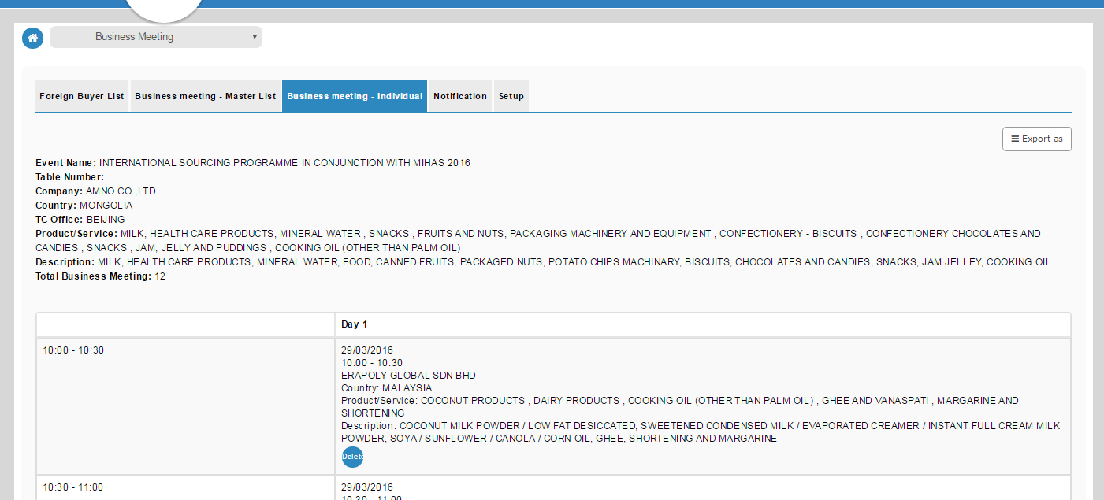

Export as PDF

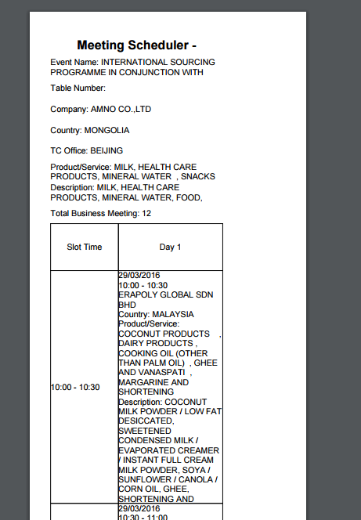

To adjust the column in other to display the information as per screen.

Information for Event Name; Product/Service and Description not full display as per screen.

Export as Excel

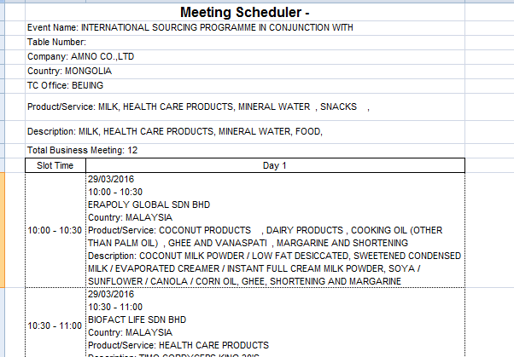

Information for Event Name; Product/Service and Description not full display as per screen.

And remove repeatable header.