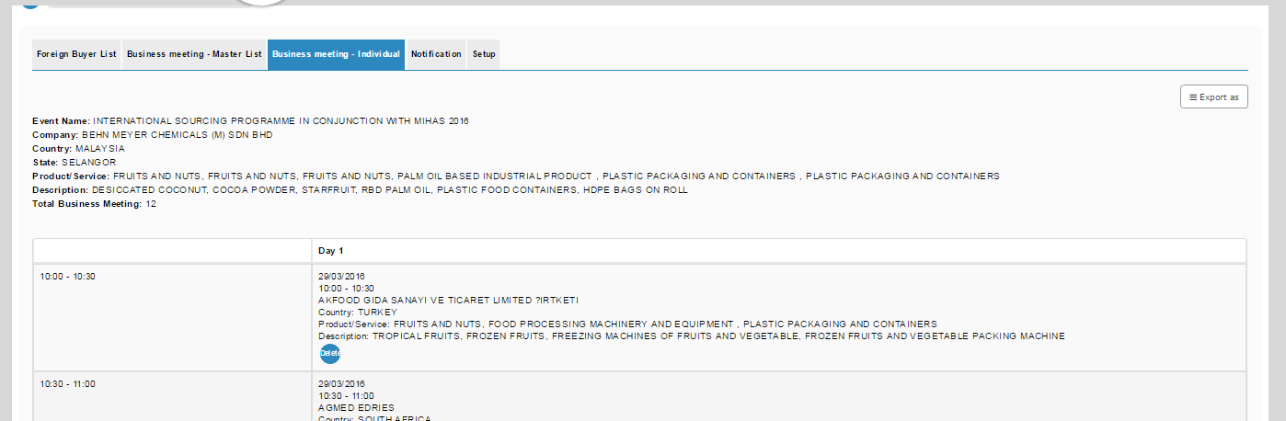

PDF:-

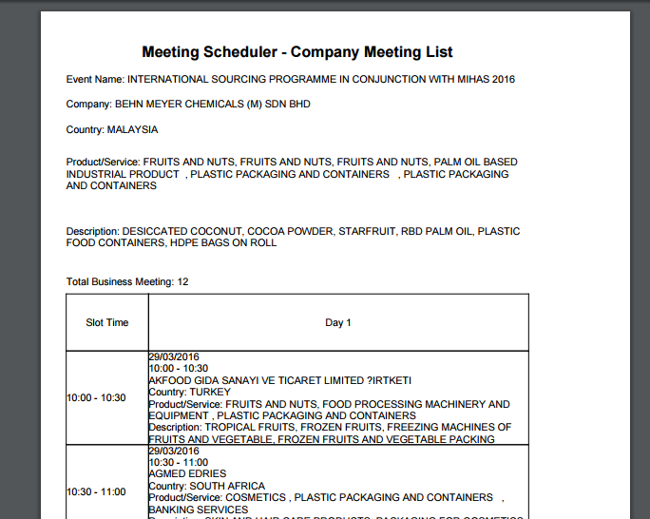

1. Need only to repeat table header.
2. Fix the cell border

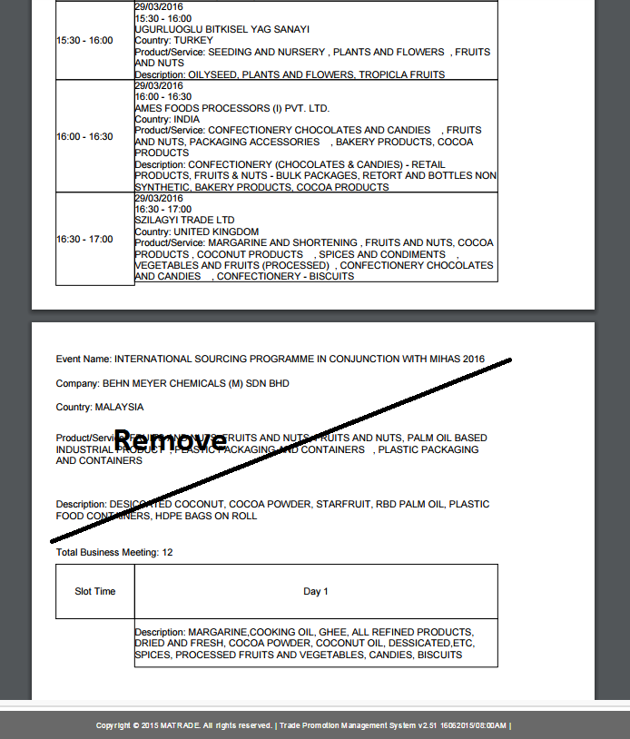

EXCEL:-

Remove repeating title and table header

