***Issue Form (PROD)***

|  |  |
| --- | --- |
| **Originator's Name:** Azliza Husain  **Project:** Trade Promotion Management System (TPMS)  **Project Manager:** Norharizal Ishak  **Module :** Promotion  **Date Raised:** 18/03/2016  **Phase :** Module 3 - 8  **Functional Area:** Post Event -> Feedback | **Issue ID Number:** TPMS_Prod0107  **Related Issue ID Number:** Redmine #6103  **Classification:**  **Priority:** Critical/High/Medium/Low  **Assigned to: Vendor / IT / PMO SA / UPA**  **Actual Closed Date:** |
| **Status:** Open/Assigned/Investigated/Resolved/Approved/Deferred/No Action  *(Circle one)* | |
| **Description :**     1. Feedback form-> when to print ->product/service and Malaysian companies met not display in the form 2. The Name of Representative display company name, not representative name. 3. To widen the product/service column .   *Please refer to file attached for further details.* | **Impact:** |
| **Findings/Root Caused (Description):** | **Resolution:** |
| **Estimated Impact :** |  |
| **Recommendation:** | |
| **Accepted :**  **(Vendor / IT / PMO SA / UPA)**  **Date: 18/03/2016** | **Accepted (MATRADE Tester):**  **Date:** |

Feedback – print out feedback form

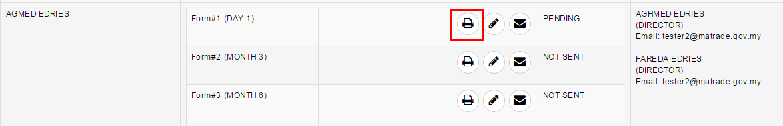

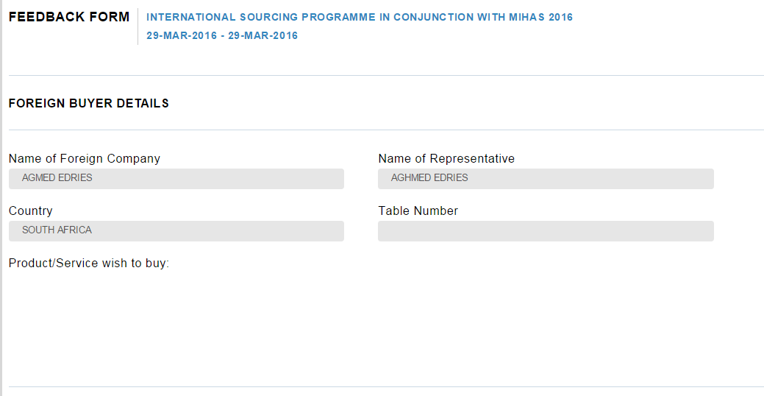

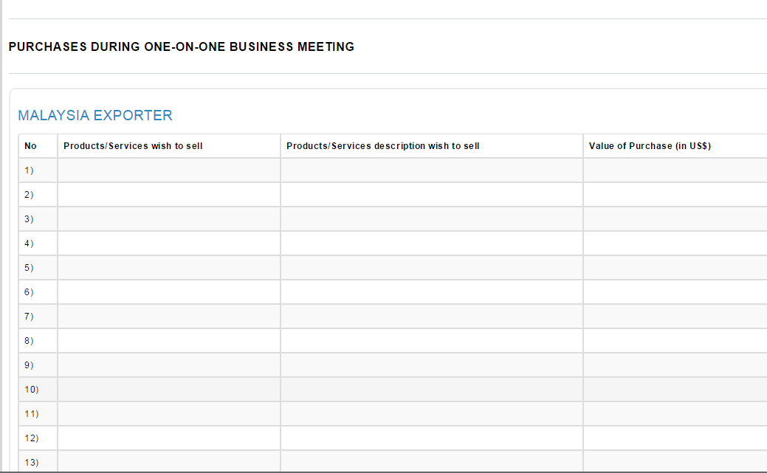

Edit feedback form:

