***Issue Form (PROD)***

|  |  |
| --- | --- |
| **Originator's Name:** Azliza Husain  **Project:** Trade Promotion Management System (TPMS)  **Project Manager:** Norharizal Ishak  **Module :** Promotion  **Date Raised:** 21/03/2016  **Phase :** Module 3 - 8  **Functional Area:** Post Event - Feedback | **Issue ID Number:** TPMS_Prod0108  **Related Issue ID Number:** Redmine #6106  **Classification:**  **Priority:** Critical/High/Medium/Low  **Assigned to: Vendor / IT / PMO SA / UPA**  **Actual Closed Date:** |
| **Status:** Open/Assigned/Investigated/Resolved/Approved/Deferred/No Action  *(Circle one)* | |
| **Description :**    To proper display when to print the feedback form  *Please refer to file attached for further details.* | **Impact:** |
| **Findings/Root Caused (Description):** | **Resolution:** |
| **Estimated Impact :** |  |
| **Recommendation:** | |
| **Accepted :**  **(Vendor / IT / PMO SA / UPA)**  **Date: 21/03/2016** | **Accepted (MATRADE Tester):**  **Date:** |

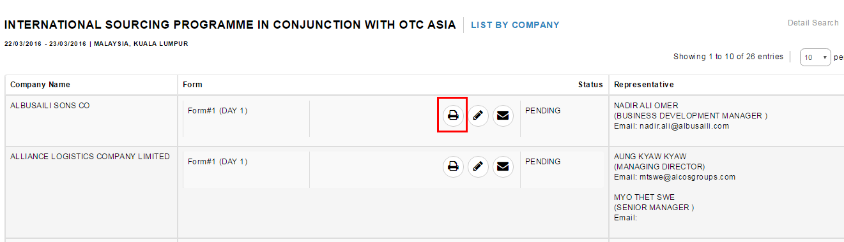

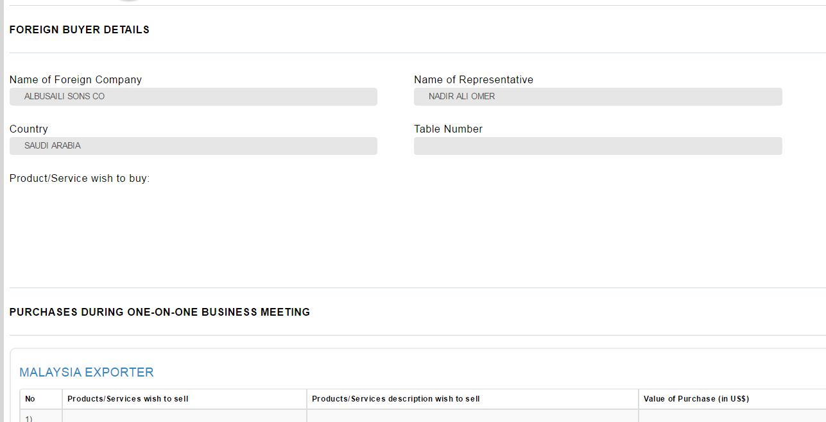

Feedback form -> when to print out, product/service wish to buy is empty and Malaysian exporter met is not display in the form. Should follow like the screen shot below when status is **REPLIED**

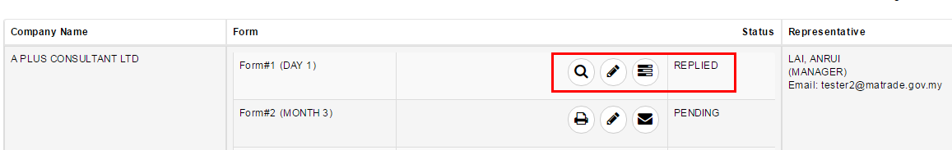

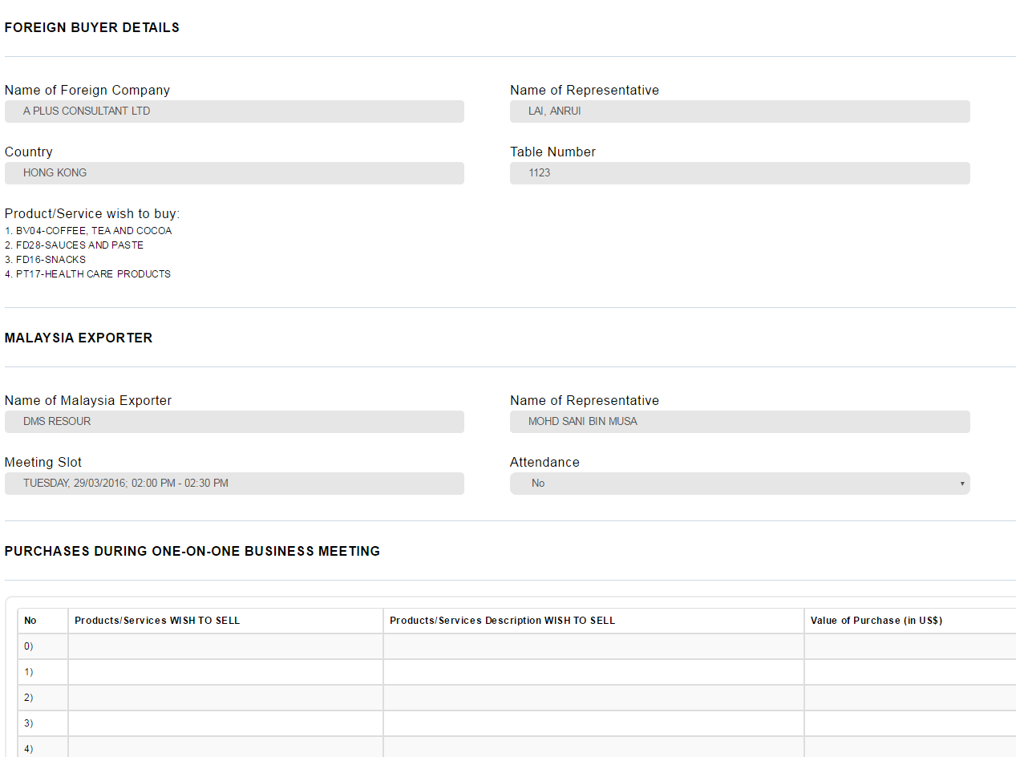

To print when in Edit mode:

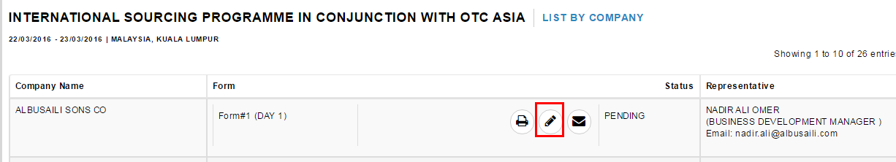

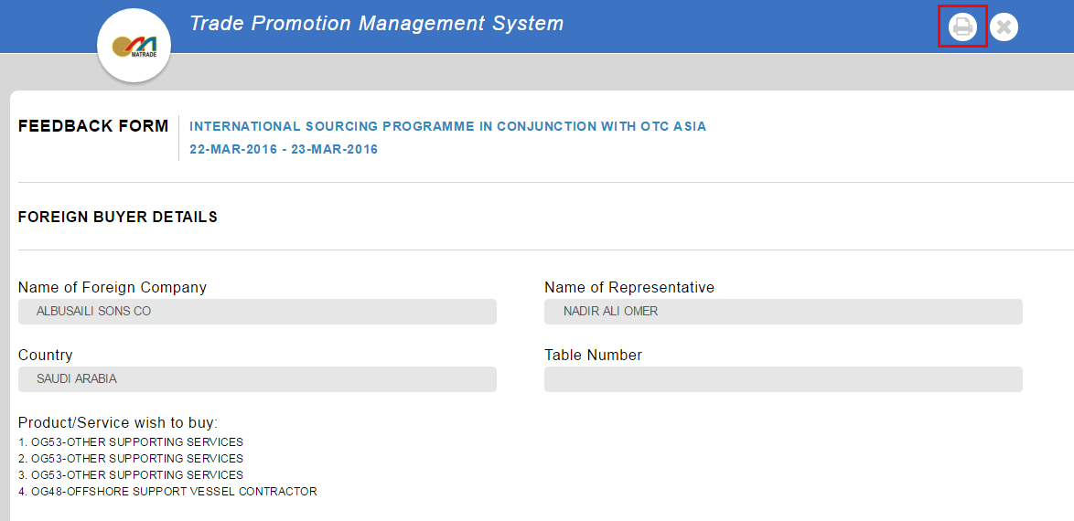

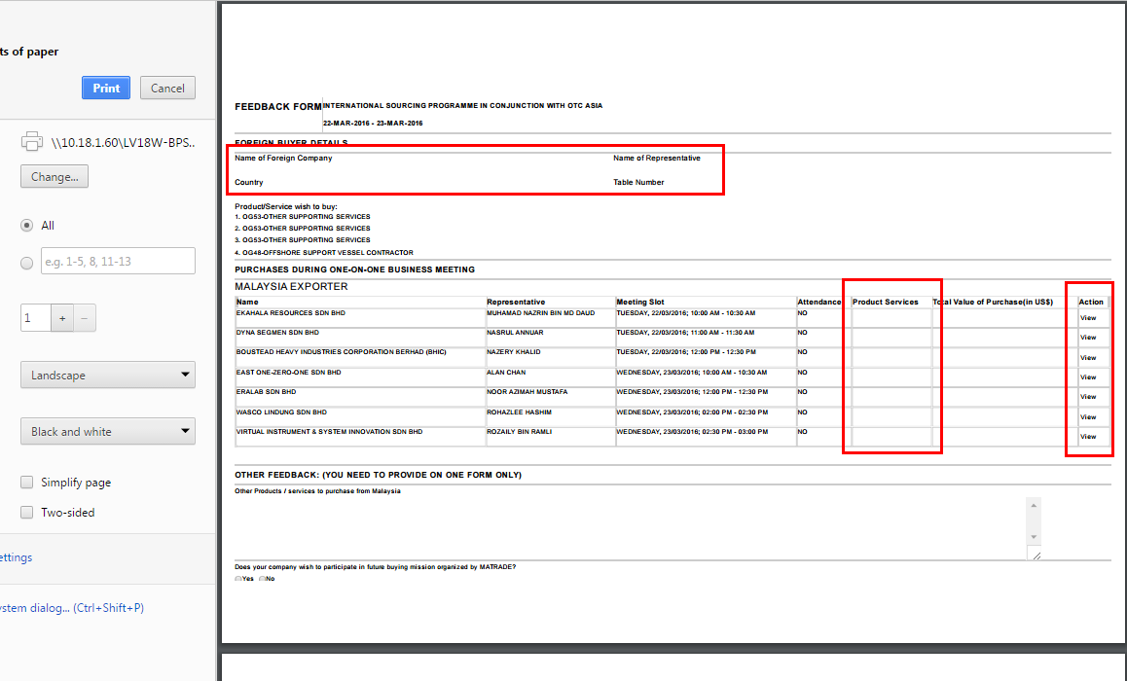

Foreign buyer name, name of representative and country empty when to print.

To add line for “Other Products/Service to purchase from Malaysia” and “General Comments”