Test Issue Log |  |  |  |  |  | Issue ID# : TPMS_Prod105
Project Name: | Trade Promotion Management System (TPMS)
Test Stage: | Unit Functionality Integration System Interface  Performance Regression Acceptance Pilot
Test Case Number: | Support # 6101 |  |  | Test Started Date: |  |  | 22/03/2016
Test Title: | Header for departure need to change from ETA to ETD.
Test Description: | To test on ETD header to be change at from ETA to ETD.
Test Functionality: | Promotion > Report > Logistics
Test Procedure: | Click on Promotion > Reports > Promotion Report > Logistic  Sort by:  - Company Name Alphabetical  - Country  - Hotel  - TC  - ETA  - ETD
Test Result: | Pass: Fail:  Conditional Pass: : |  | Tested by: |  | Siti Norahayu Binti Mohd Desa
Reason for Failure:
TEST DESCRIPTION
Issue:
To test on ETD header to be change at from ETA to ETD.

Sort by:
- Company Name Alphabetical
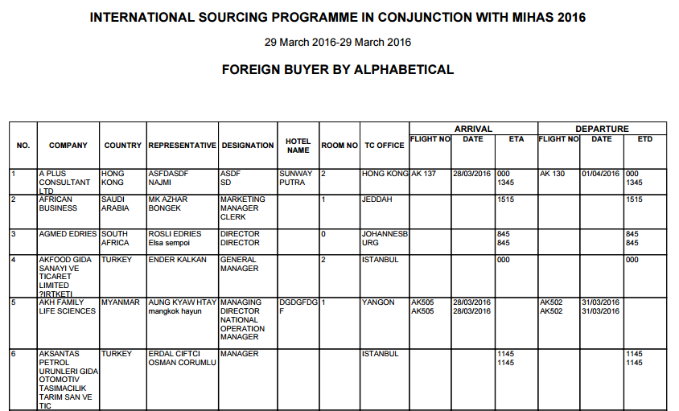

- Country
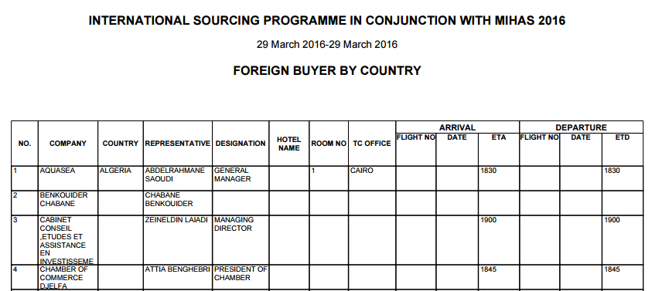

- Hotel

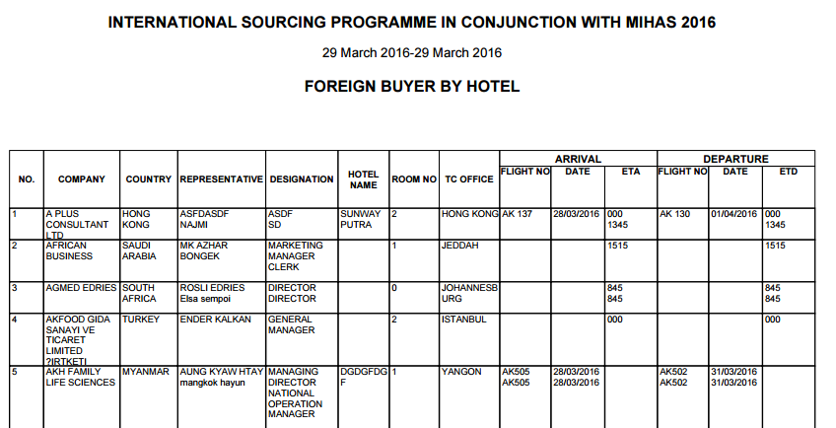

- TC
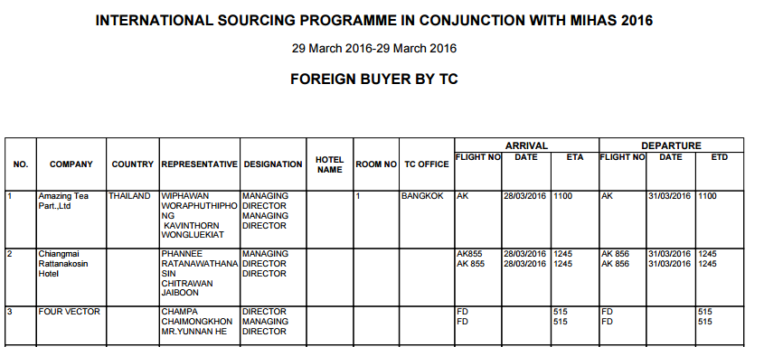

- ETA
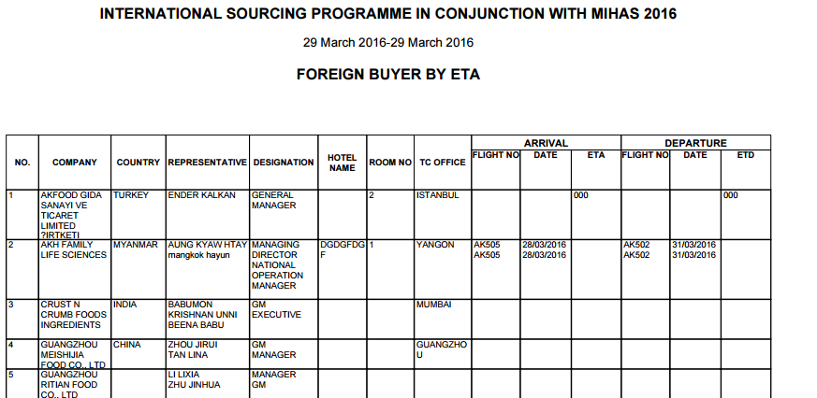

- ETD

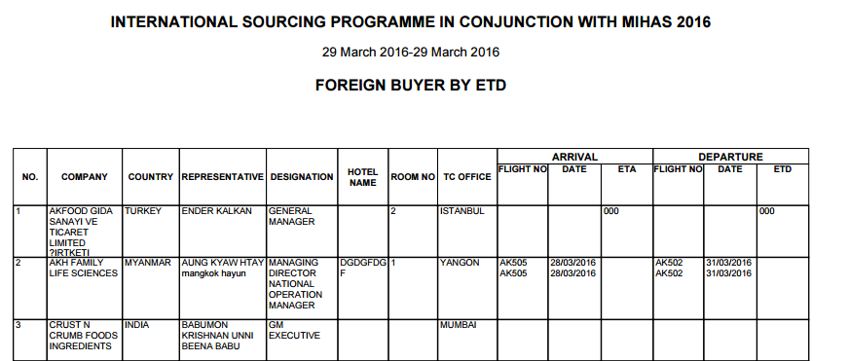

Reviewed By: (PMO)
 |  | Name/Position : Norhaidah Binti Md Dasuki / Senior Manager, Quality Assurance and Support  Date :22/03/2016

