Test Issue Log |  |  |  |  |  | Issue ID# : TPMS_Prod039
Project Name: | Trade Promotion Management System (TPMS)
Test Stage: | Unit Functionality Integration System Interface  Performance Regression Acceptance Pilot
Test Case Number: | Support #5931 |  |  | Test Started Date: |  |  | 23/03/2016
Test Title: | User got error “Request Entity Too Large” when updating the JPPPA impact of the activity.
Test Description: | To check and test on error occur upon creating new JPPPA activity
Test Functionality: | Planning > Planning JPPPA > Add New
Test Procedure: | - Click on Planning > Planning JPPPA>Add New
Test Result: | Pass: Fail:  Conditional Pass: : |  | Tested by: |  | Siti Aishah Binti Ibrahim
Reason for Failure:
TEST DESCRIPTION
Issue :

Login as External User



Select Planning
Select “Planning JPPPA” from the sub menu drop down list
Click on “Add New” button

Result :

TPMS successfully display Add New activity page without any error.
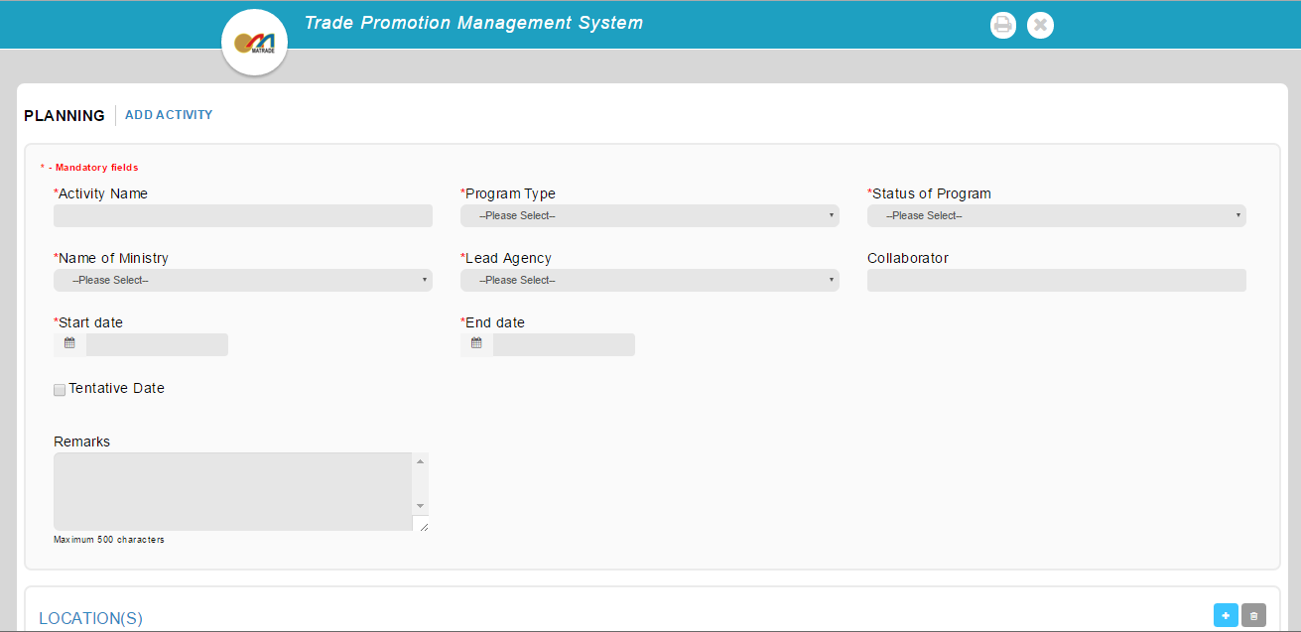

TPMS able and successfully save the new created activity information.

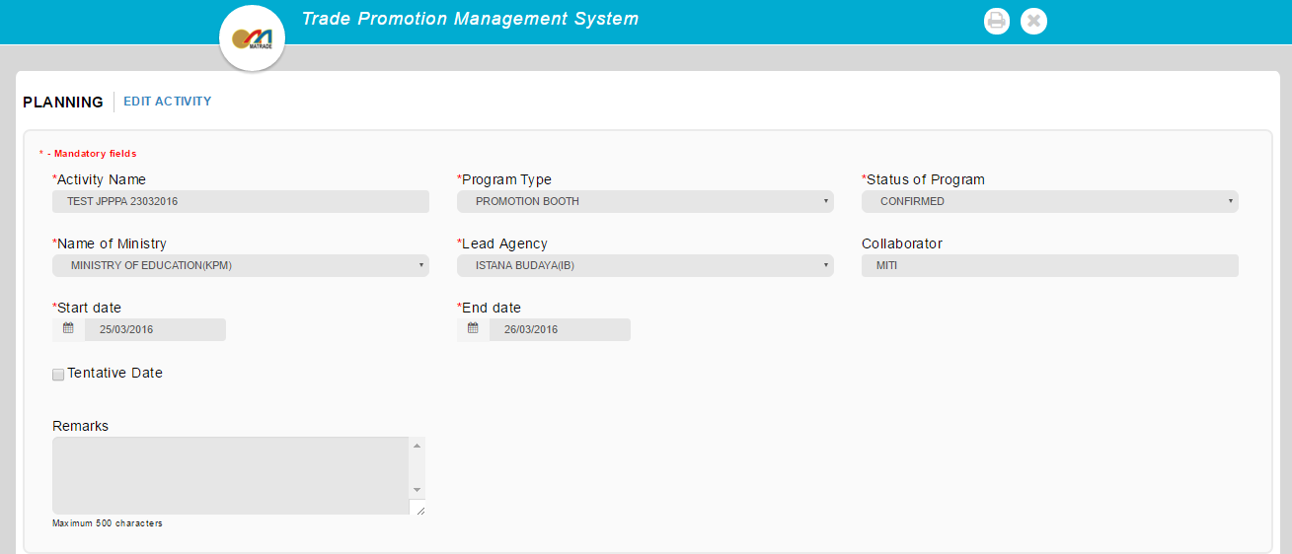

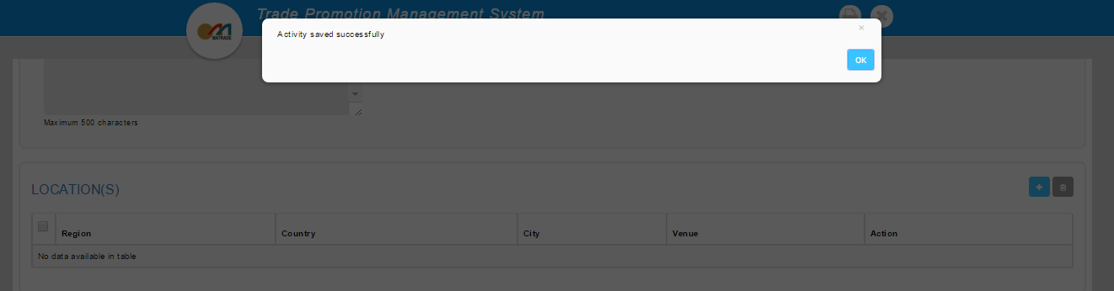

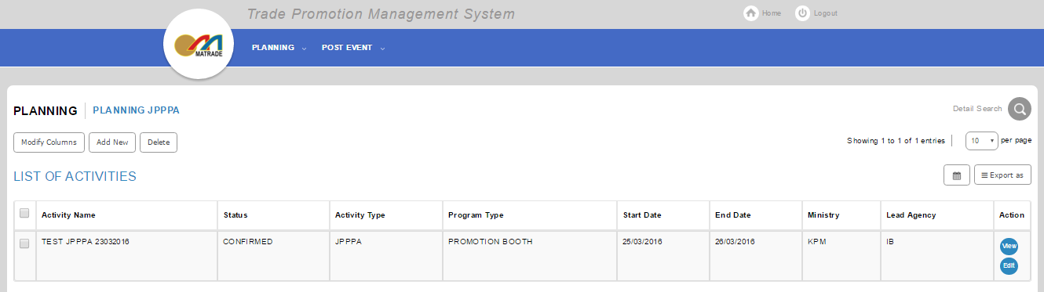

Reviewed By: (PMO)
 |  | Name/Position : Norhaidah Binti MdDasuki / Senior Manager, Quality Assurance and Support  Date :23/03/2016

