Test Issue Log |  |  |  |  |  | Issue ID# : TPMS_Prod073
Project Name: | Trade Promotion Management System (TPMS)
Test Stage: | Unit Functionality Integration System Interface  Performance Regression Acceptance Pilot
Test Case Number: | Support # 6002 |  |  | Test Started Date: |  |  | 24/03/2016
Test Title: | Details companies not display in the pop up window when user click button “view”.
Test Description: | System shall able to display details companies
Test Functionality: | TPMS>Promotion>Registration>View & Edit
Test Procedure: | Issue:  To display details companies
Test Result: | Pass: Fail:  Conditional Pass: : |  | Tested by: |  | Siti Aishah Ibrahim
Reason for Failure:
TEST DESCRIPTION
Issue :

Login as Administrator (Tester5)
Select Promotion
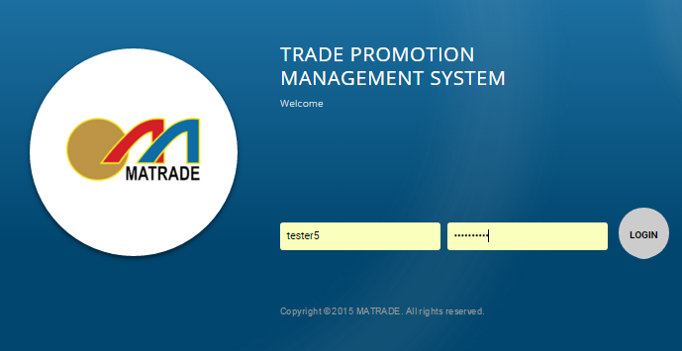

- Select “Promotion” from the sub menu drop down list
- Choose event “International Sourcing Programme In Conjunction With MIHAS 2016” and click on “View” button
- Select “Registration” from the sub navigation drop down list
- Choose “UNI ASIAN FOOD” company and click on “View” & “Edit” button

Result :

TPMS able to display details companies in View and Edit function.

- View Function
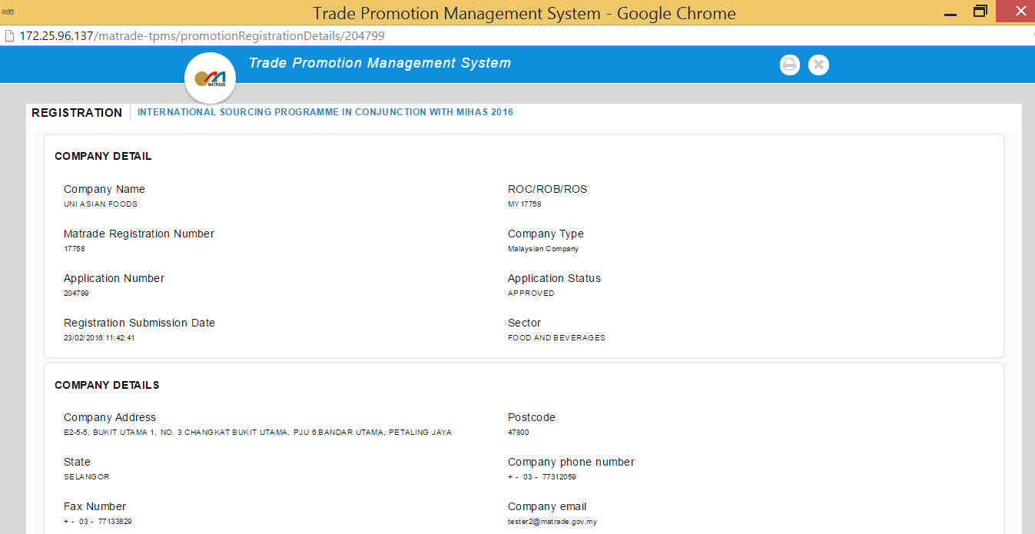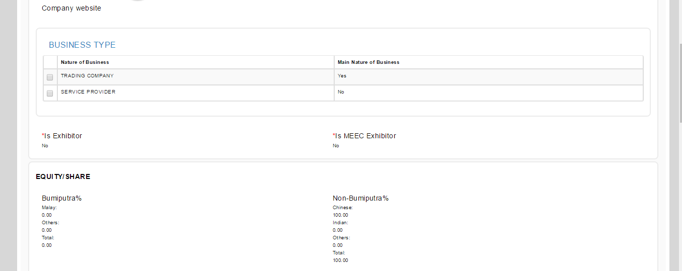
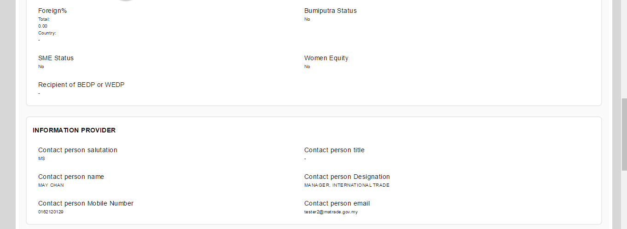
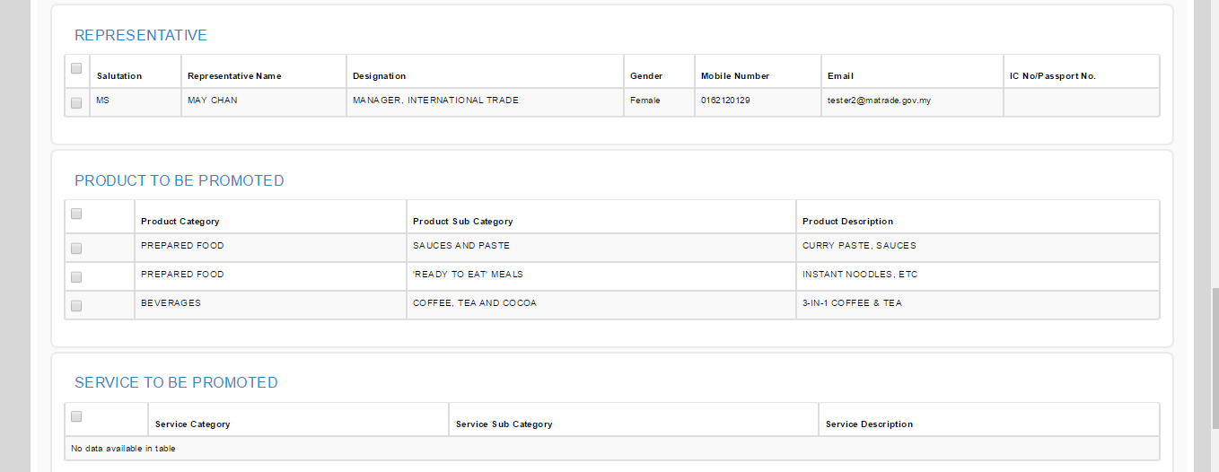
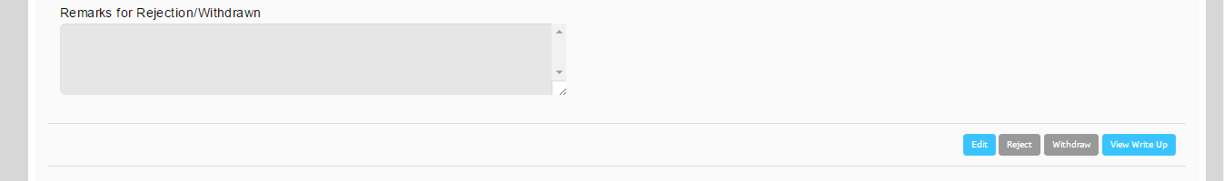

- Edit Function

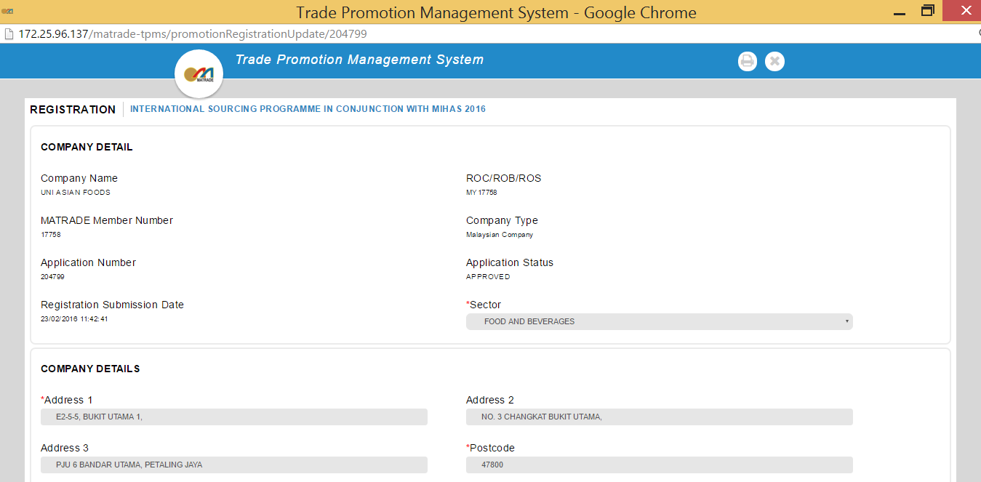
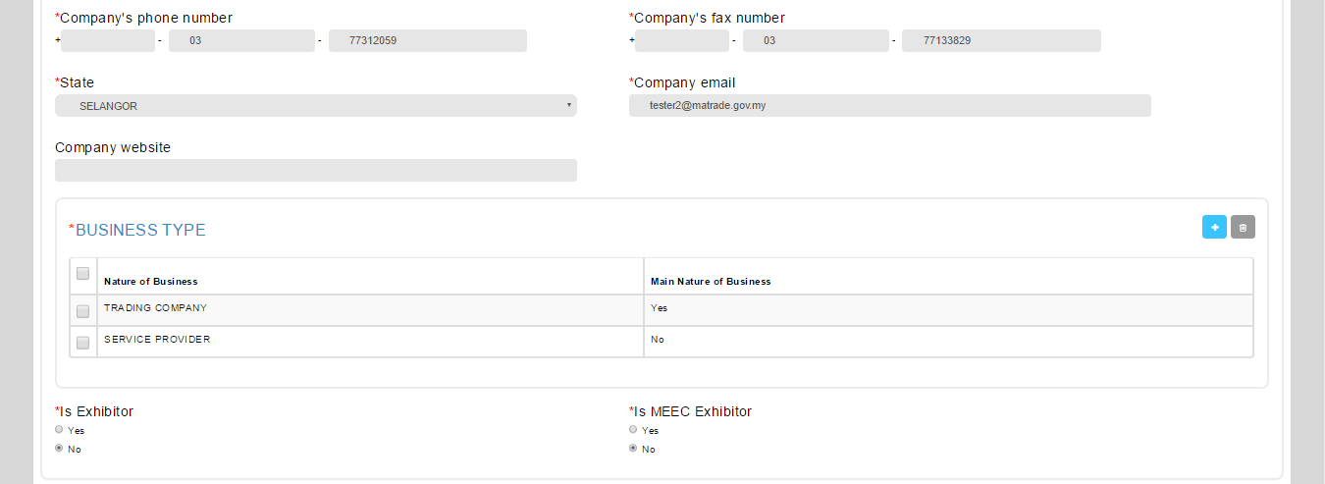
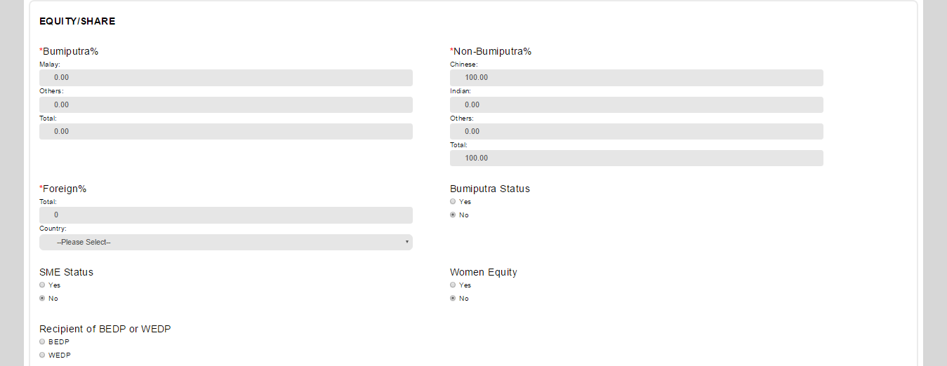
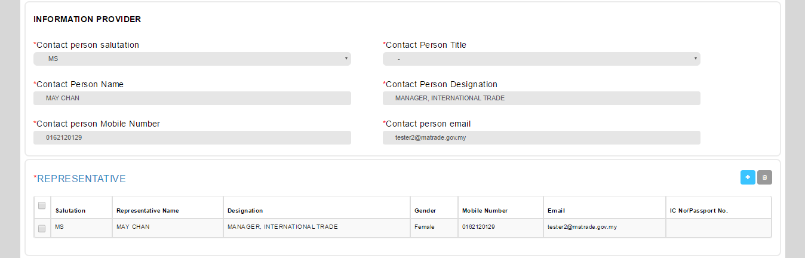
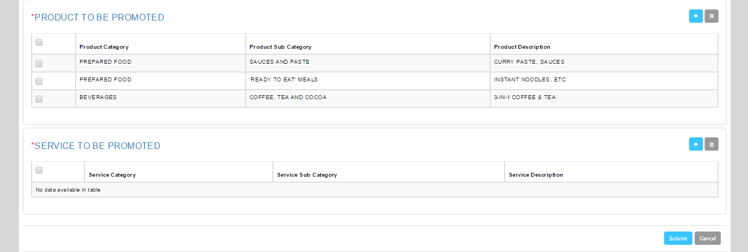

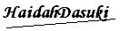 |  | Name/Position : Norhaidah Binti Md Dasuki / Senior Manager, Quality Assurance and Support  Date : 30/12/2015

