**2. Enhancement #5452 - Report >> Generate Word Report**

To generate word report with same PDF format.

~~Reports that are not supported by word due paper size more than A3:~~

~~Planning:~~

1. ~~Overall Summary > Details of work programme~~
2. ~~Master work compilation without kpi~~
3. ~~Master work compilation with kpi~~

~~Budget~~

1. ~~Ringkasan Perbelanjaan Peruntukan Promosi~~
2. ~~Ringkasan Perbelanjaan Peruntukan Promosi Berdasarkan Kelulusan BOD~~

**Generate Word**

**Planning Report> Summary of Work Programme**

1. Column title missing
2. Grand Total missing
3. Year did not display at summary title

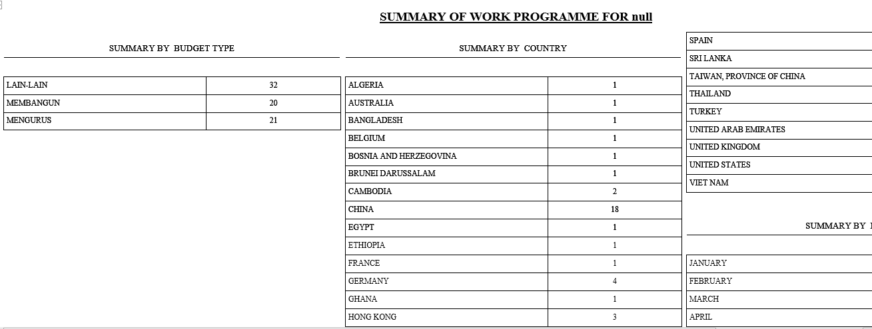

1. a) Add title Summary by Budget Type

b) Highlight column Grand Total

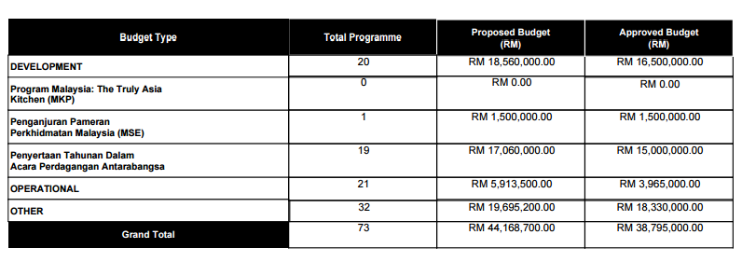

**Budget Report>Status of Trade Promotion Activity**

1. Column header did not highlighted as pdf
2. Column Total Budget did not highlighted as pdf
3. To display date of borang P received in properly format

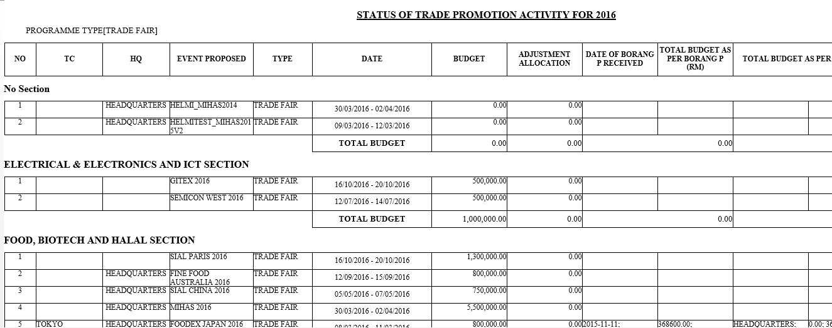

**Budget Report>JKPA – Aktiviti Yang Telah Dijalankan**

1. No report display. Blank screen.

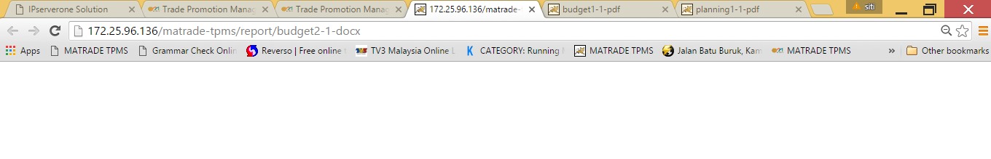

**Budget Report>JKPA – Aktiviti Yang Belum Dijalankan**

1. Column header did not highlighted as pdf
2. Column Jumlah did not highlighted as pdf

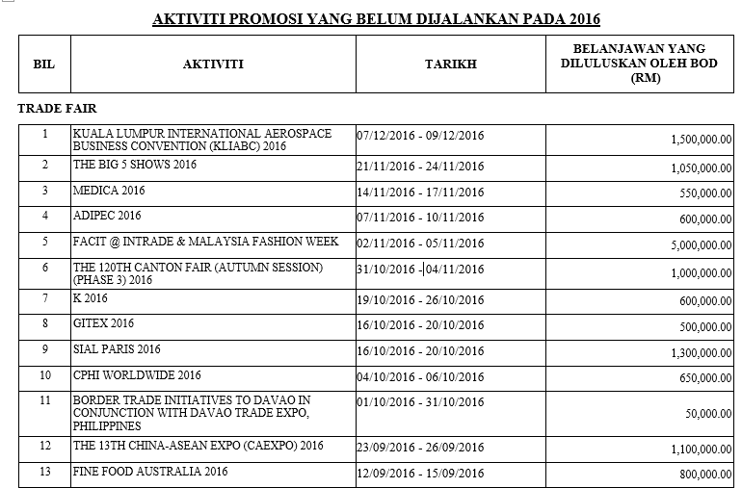

**Budget Report>JKPA – MATRADE WORK PROGRAMME**

1. Column header did not highlighted as pdf

