
Issue Form (PROD)
Originator's Name: Chooi So Fun  Project: Internet Banking  Project Manager: Malarvili / Chris Gunn  Module : IB  Date Raised: 24.11.10  Phase : Phase 2  Functional Area : Consumer | Issue ID Number: C011  Related Issue ID Number:  Classification:  Priority: Critical/High/Medium/Low  Assigned to: Vendor / IT / PMO SA / UPA  Actual Closed Date:
Status: Open/Assigned/Investigated/Resolved/Approved/Deferred/No Action (Circle one)
Description :
Successful transaction for SI Bill Payment (SI Ref# 69702) on 23.11.10 (RM1.00) does not reflect in
BVMC Daily Reports:
- Bill Payment Report
- Conso Trx Report
- ePay Recon Report
- Internet Trx Report
- SI Execution Report
PHOENIX Report:
SI Transaction is reflected in daily Phoenix Report:
CORUS:
- In Schedule Execution Log shown SI successfully executed with 1 transaction however the transaction is not found in SI Transaction History as well as in Email Notification
KFHOnline:
- On 23.11.10 - Amount (RM1.00) & SI Charges (RM2.00) have been debited from account but transaction are not reflected in SI Transaction History.
- Unable to Delete & Edit SI Ref# 69702: Auto logout after clicked on Delete / Edit Button.

(Refer to below attachment for details)
Impact:
Findings/Root Caused (Description): |  | Resolution:
Estimated Impact :

Recommendation:

Accepted :  (Vendor / IT / PMO SA / UPA)  Date: | Accepted (KFHMB Tester):  Date:
BVMC Daily Reports:

Phoenix Report:
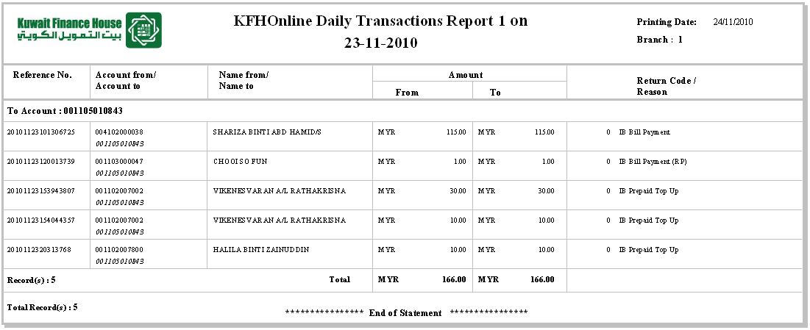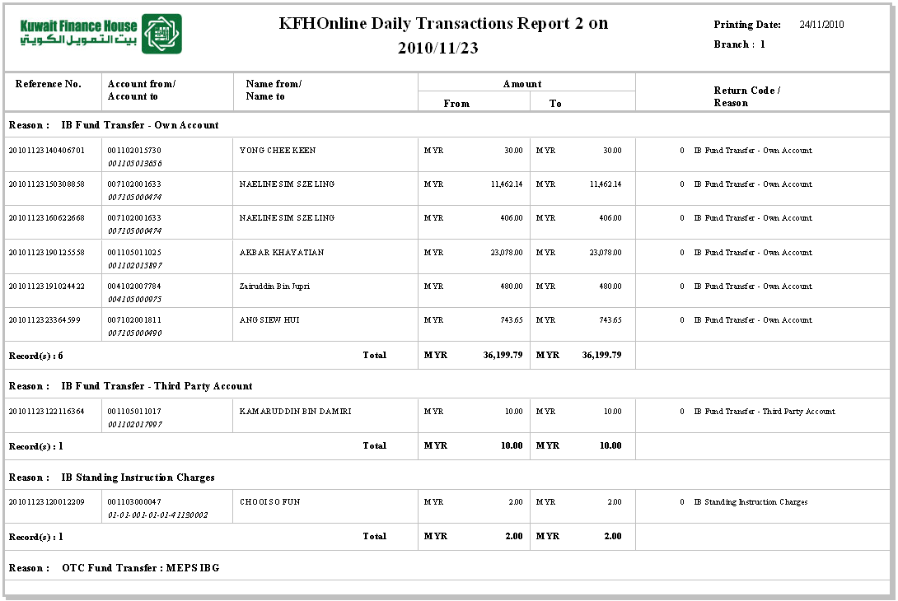

CORUS:

Schedule Execution Log:
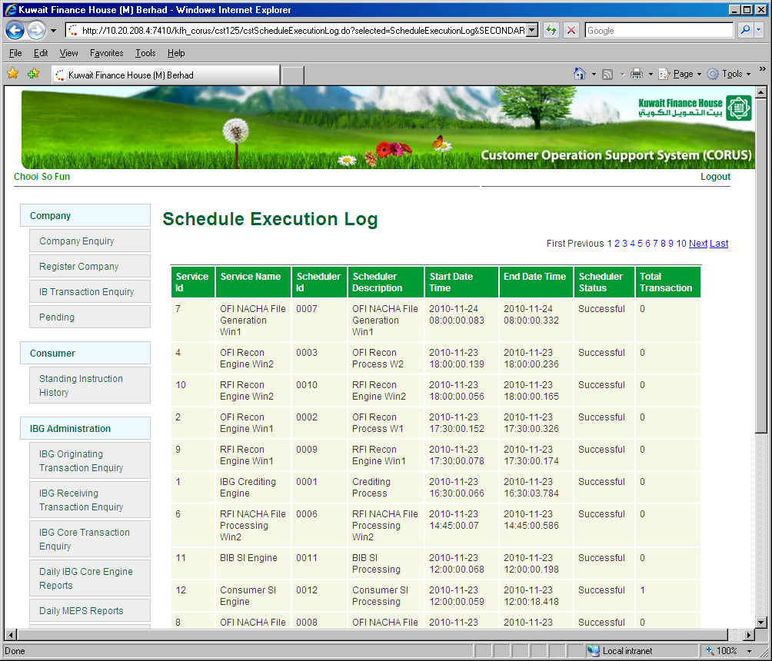
Email Notification:
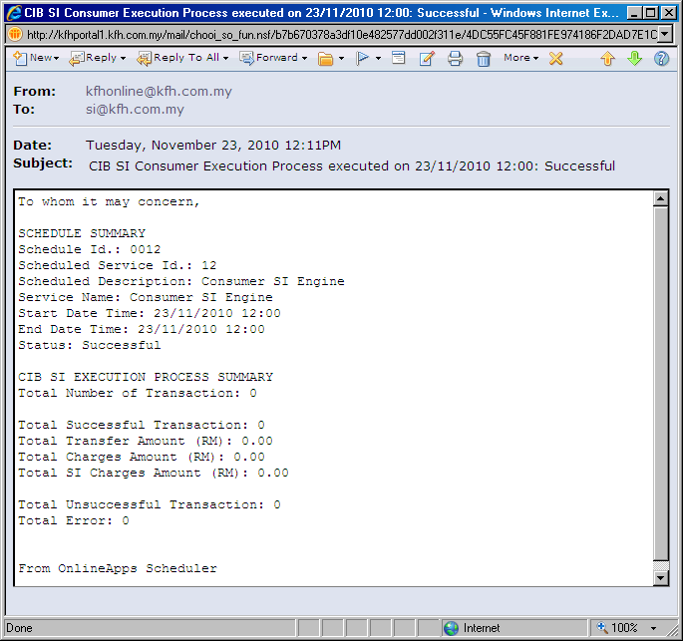
Shown “0” transaction

SI History:
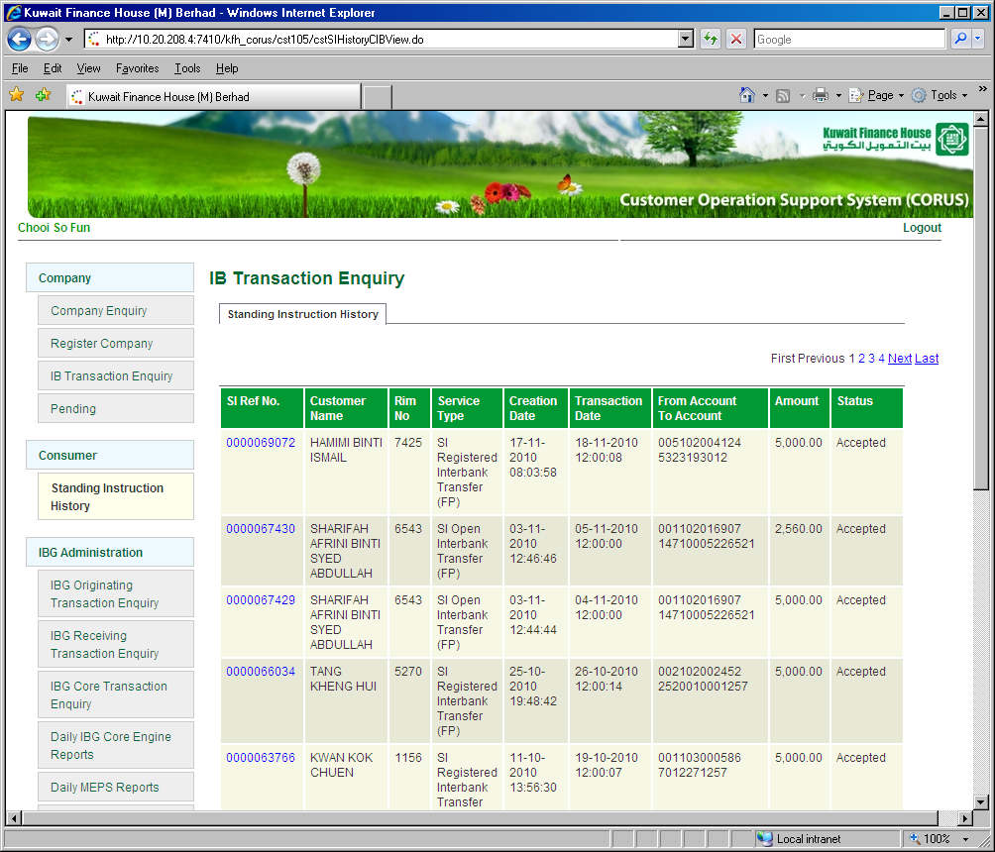
Record not found.

View Account Transaction History Page:
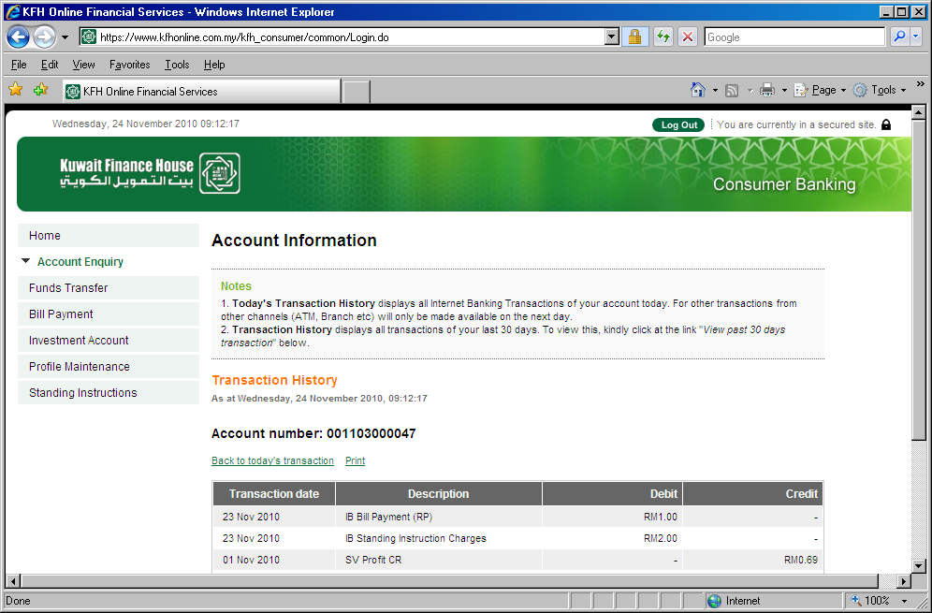
Amounts debited

View SI History Page:
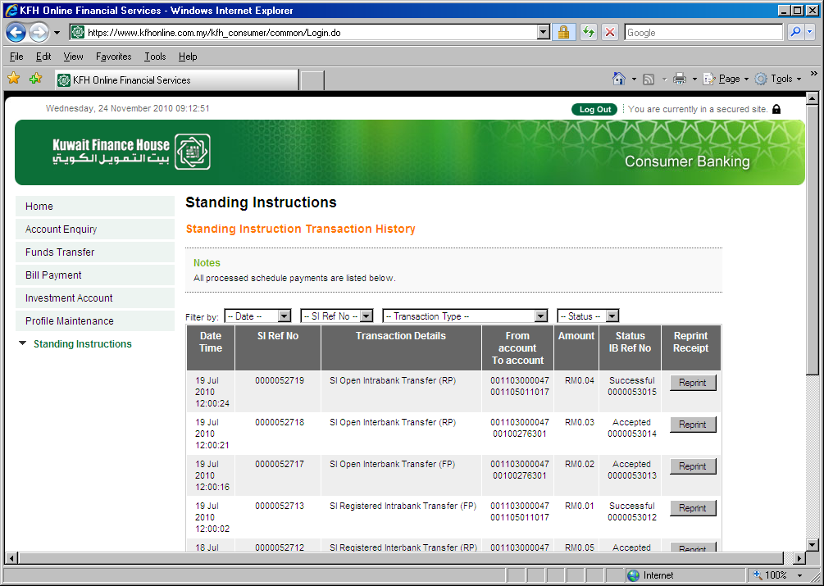
No SI trx found for 23.11.10

View SI Page:
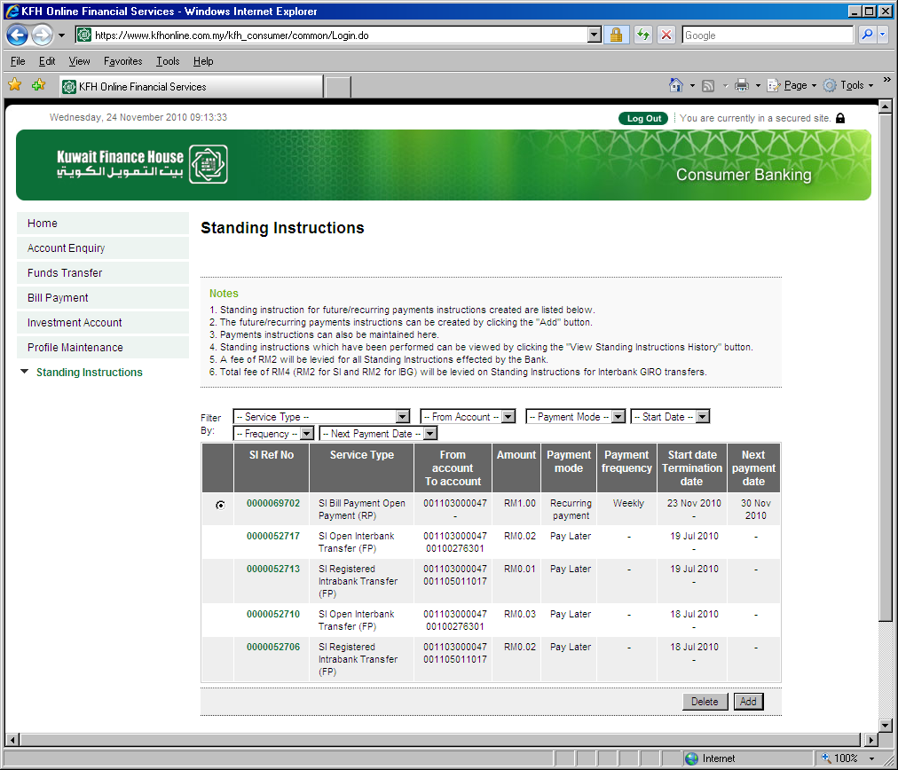
SI trx for 23.11.10

Unable to Delete & Edit:
