Test Issue Log |  |  |  |  | Issue ID#:
Project Name: | Trade Promotion Management System (TPMS)
Test Stage: | Unit Functionality Integration System Interface  Performance Regression Acceptance Pilot
Test Case Number: | Support #6095 |  |  | Test Started Date: |  | 25/3/16
Test Title: | Post Event > Event Report > IBM Report
Test Description: | Report Type: Incoming Buying Mission  a. Sub Report: Feedbacks: Total Sales By Country  i. Missing data  b. Sub Report: Feedbacks: Total Sales By Product/Services  i. Duplicate  c. Sub Report: Feedbacks: Total Sales By Product/Services  ii. Country name issue  d. Sub Report: Feedbacks: Sales by products / services sectors for individual countries details  i. Duplicate
Test Functionality: | IBM Feedback Form and Report
Test Procedure: | - Access Event Report from Post Event Module  - Select IBM Programme Type  - Select Report,  - Select Event,  - Click on Generate PDF / Excel Report
Test Result: | Pass: Fail: Conditional Pass: |  | Tested by: |  | Leonard Lim
Reason for Failed / Conditional Pass:
TEST DESCRIPTION
Test Result:
Feedbacks: Total Sales By Country
PDF
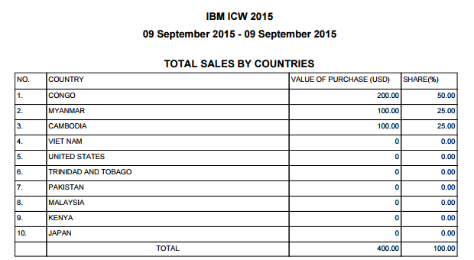
Excel
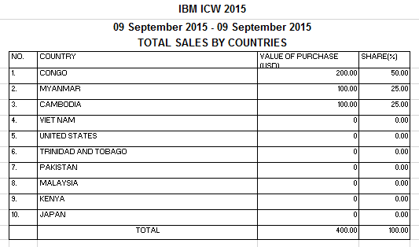
Feedbacks: Total Sales By Product/Services
PDF
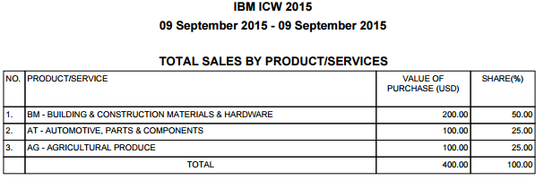
Excel
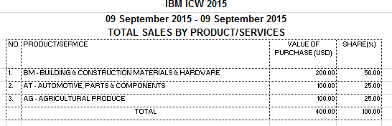
Feedbacks: Sales by products / services sectors for individual countries details
PDF
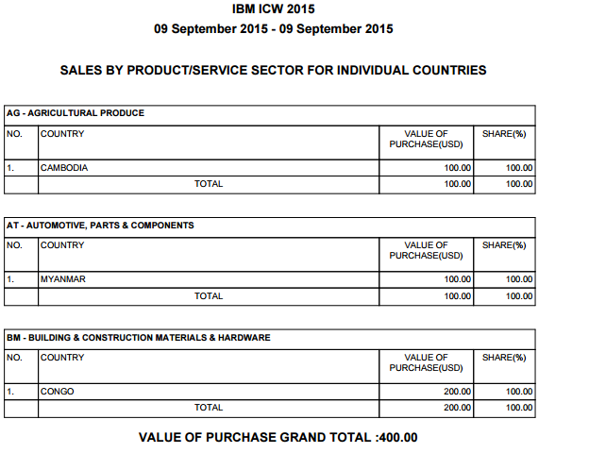
Excel
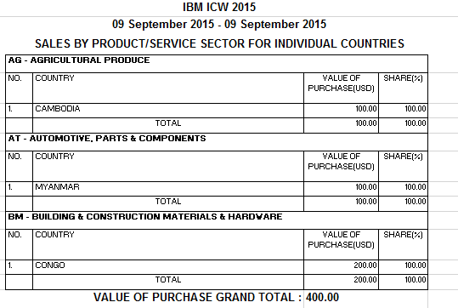

Reviewed By: (PMO)
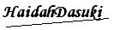 |  | Name/Position : NorhaidahBintiMdDasuki / Senior Manager, Quality Assurance and Support  Date : 15/1/2016

