***Issue Form (PROD)***

|  |  |
| --- | --- |
| **Originator's Name:** Nor FadzilahNawawi  **Project:** Trade Promotion Management System (TPMS)  **Project Manager:** NorharizalIshak  **Module :** Promotion  **Date Raised:** 25/03/2016  **Phase :** Module 3 - 8  **Functional Area:** Post Event>Event Reports > IBM | **Issue ID Number:** TPMS_Prod113  **Related Issue ID Number:** Redmine #6125  **Classification:**  **Priority:** Critical/High/Medium/Low  **Assigned to: Vendor / IT / PMO SA / UPA**  **Actual Closed Date:** |
| **Status:** Open/Assigned/Investigated/Resolved/Approved/Deferred/No Action  *(Circle one)* | |
| **Description :**   1. IBM>2010 > INTRADE 2009 in the 2010 listing 2. IBM > 2011 >Only display INTRADE and MIHAS for year 2011. IGEM 2011 and LIMA 2011 not in the list. 3. IBM > 2009 >Event for INTRADE 2009 not in the listing 4. Change **Incoming Buying Mission** to **International Sourcing Programme**   *Please refer to file attached for further details.* | **Impact:** |
| **Findings/Root Caused (Description):** | **Resolution:** |
| **Estimated Impact :** |  |
| **Recommendation:** | |
| **Accepted :**  **(Vendor / IT / PMO SA / UPA)**  **Date: 25/03/2016** | **Accepted (MATRADE Tester):**  **Date:** |

**No 1**

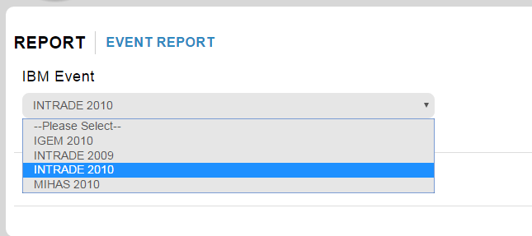

**No 2**

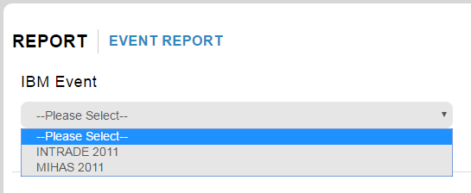

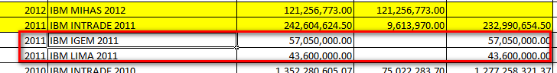

**No 3**

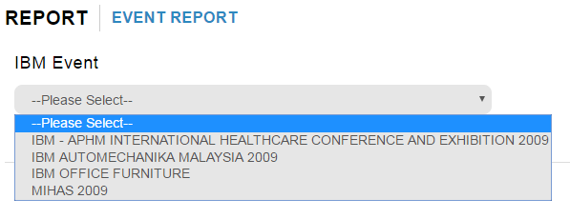



**No 4**

