***Issue Form (PROD)***

|  |  |
| --- | --- |
| **Originator's Name:** Mohd Helmi Bin Abdul Shukur  **Project:** Trade Promotion Management System (TPMS)  **Project Manager:** Norharizal b. Ishak  **Module :** Promotion  **Date Raised:** 26/3/2016  **Phase :** Phase 2_Module 3 - 9  **Functional Area : Post Event > Report** | **Issue ID Number:** TPMS_Prod114  **Related Issue ID Number:**  **Classification:**  **Priority:** Critical/High/Medium/Low  **Assigned to: Vendor / IT / PMO SA / UPA**  **Actual Closed Date:** |
| **Status:** Open/Assigned/Investigated/Resolved/Approved/Deferred/No Action  *(Circle one)* | |
| **Description :**   1. Typo at “Order Impact” – Should be “other impact”. 2. “Other Impact” is not displayed in “Other Impact” field.   Both issues is in pdf and excel file format. Outcome/Impact Report By Country(Detailed) - (2015) | **Impact:** |
| **Findings/Root Caused (Description):** | **Resolution:** |
| **Estimated Impact :** |  |
| **Recommendation:** | |
| **Accepted : (Vendor / IT / PMO SA / UPA)**  **Date: 28/3/2016** | **Accepted (MATRADE Tester):**  **Date:** |

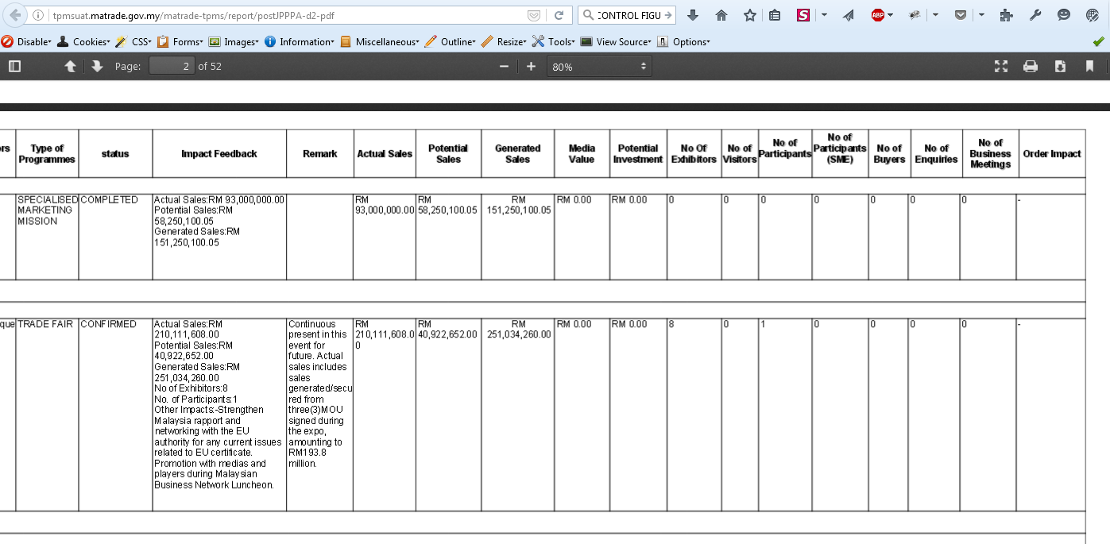

Copy “Other impact value” to “other impact” field. “other impact” will also displayed at impact/feedback if it has value.