Test Issue Log |  |  |  |  | Issue ID#: TPMS_Prod
Project Name: | Trade Promotion Management System (TPMS)
Test Stage: | Unit Functionality Integration System Interface  Performance Regression Acceptance Pilot
Test Case Number: | Support #6105 |  |  | Test Started Date: |  | 28/3/16
Test Title: | Post Event > JPPPA Report > Outcome / Impact Report
Test Description: | to include above report with status confirmed, completed, cancelled & postponed.
Test Functionality: | JPPPA Report > Outcome / Impact Report
Test Procedure: | - Access JPPPA Report, under Post Event module  - Select Report  - Select Sub-Report  - Click generate PDF Report, and Excel Report
Test Result: | Pass: Fail: Conditional Pass: |  | Tested by: |  | Leonard Lim
Reason for Failed / Conditional Pass:
TEST DESCRIPTION
Test Result:
Search Filter
Result
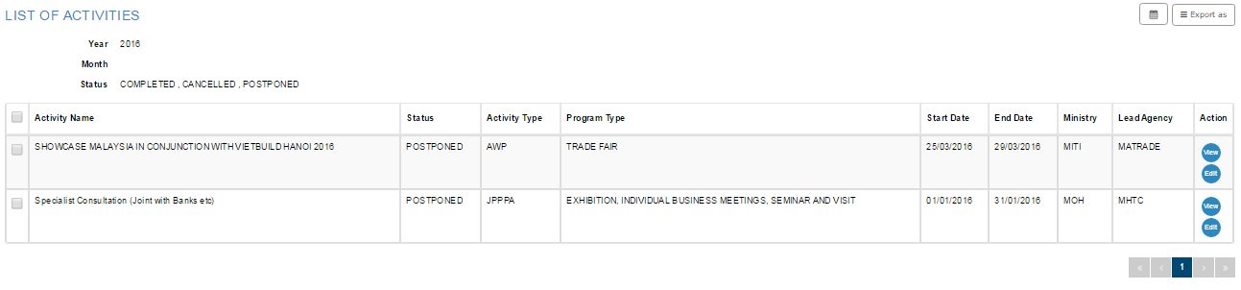
By Country
PDF
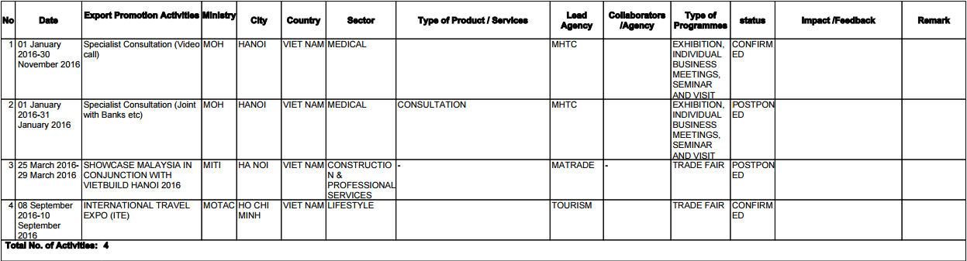
Excel
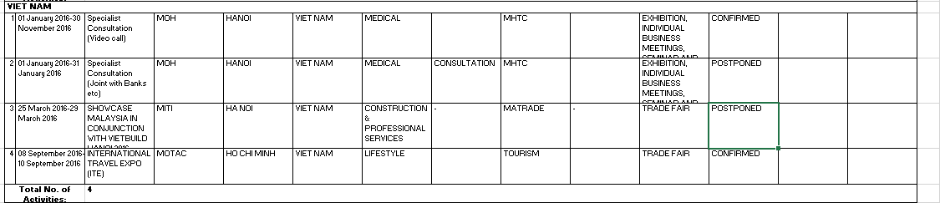
By Country (Detailed)
PDF
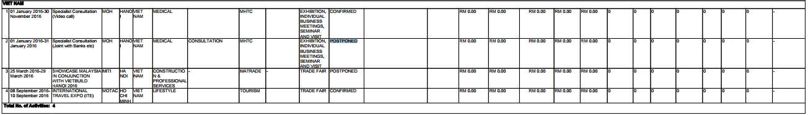
Excel
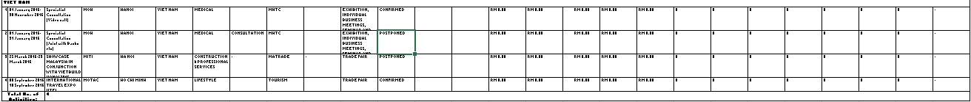
By Sector
PDF
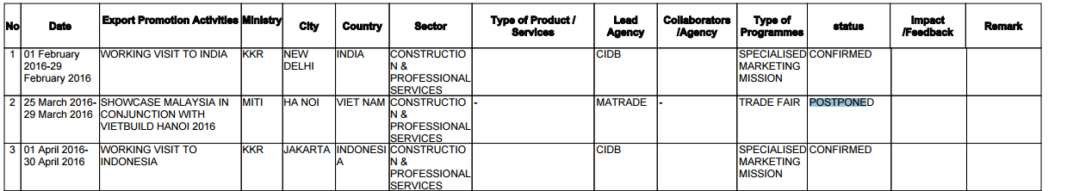
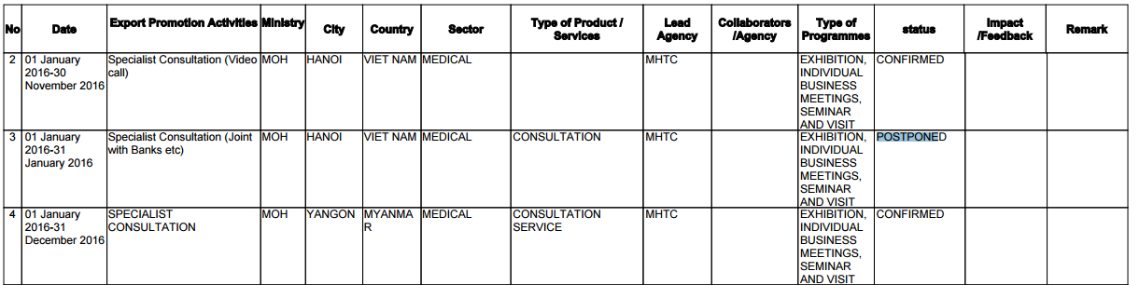
Excel
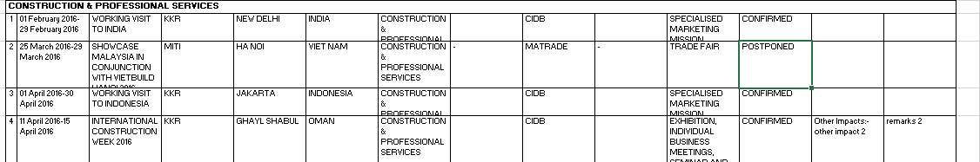
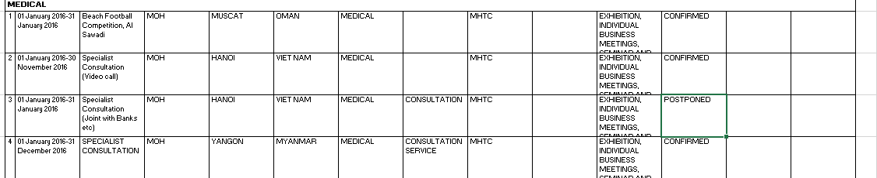
By Ministry
PDF
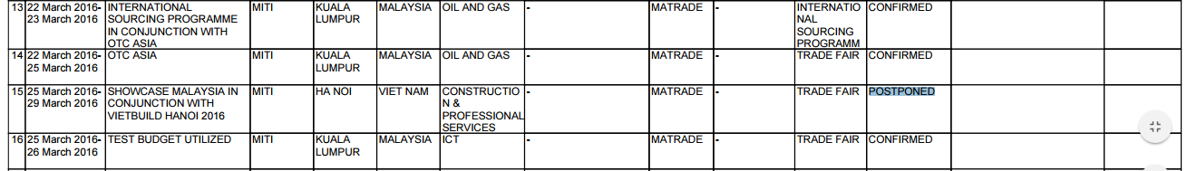
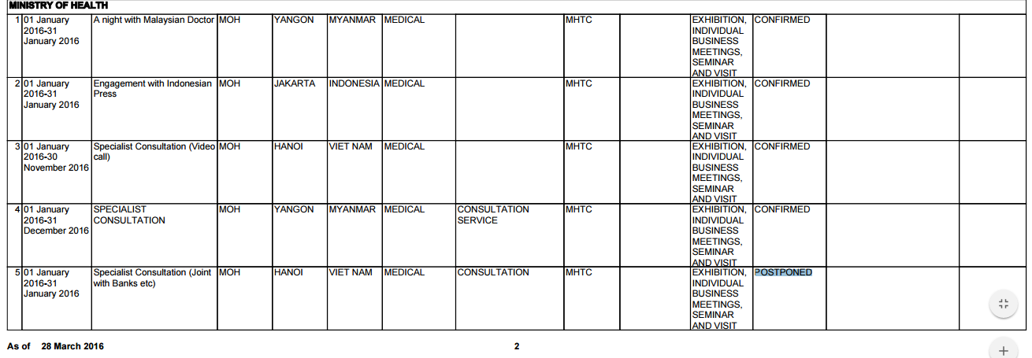
Excel
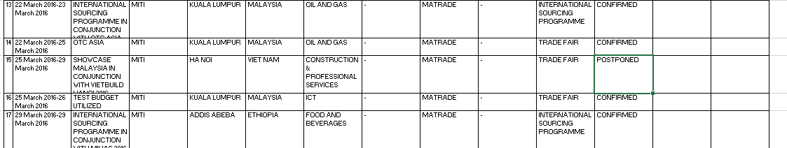
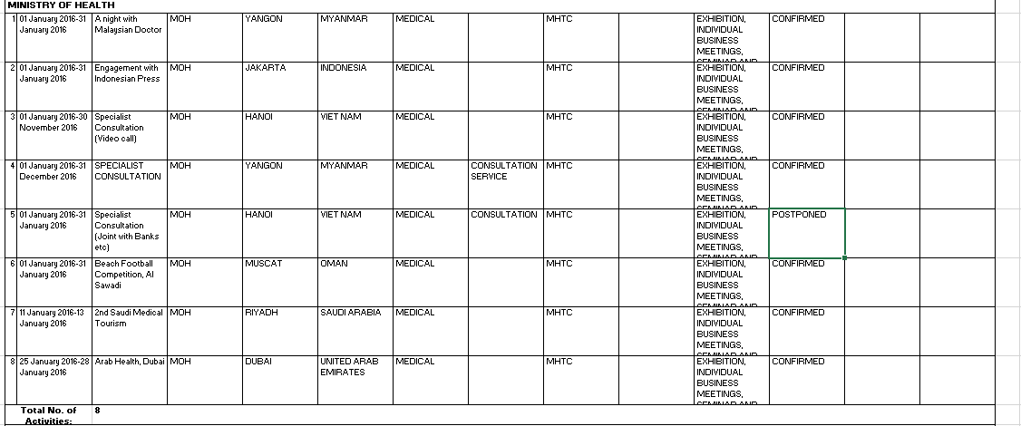
By Month
PDF
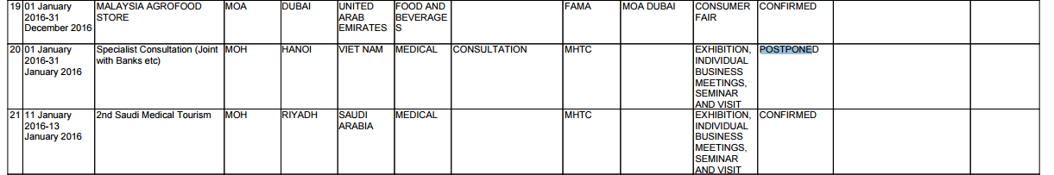
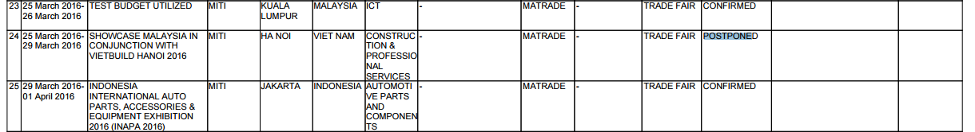
Excel
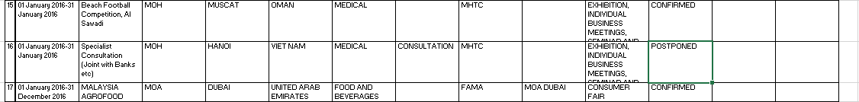
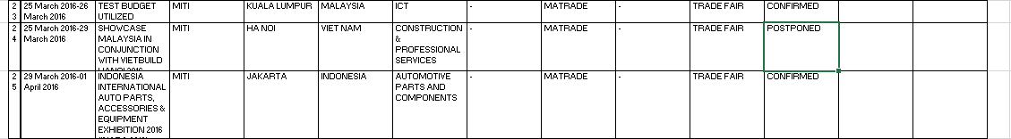
By Programme Type
PDF
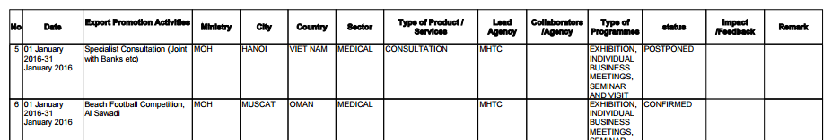
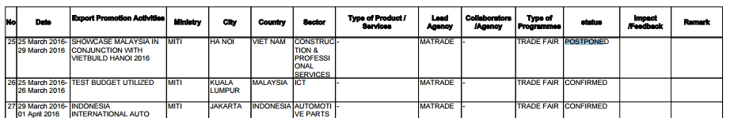
Excel
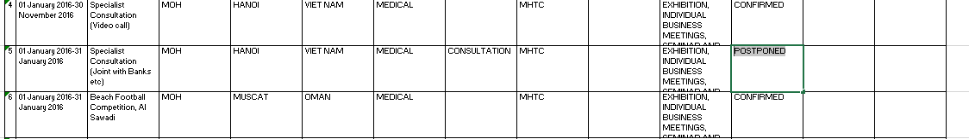
By Programme Type (Detailed)
PDF
Excel
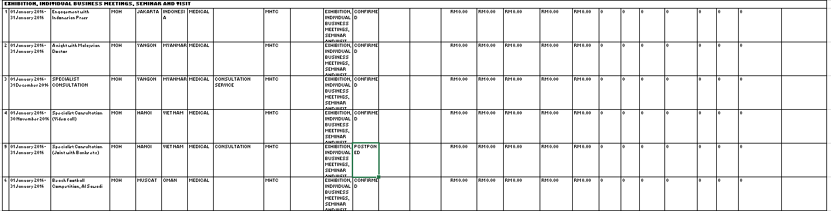
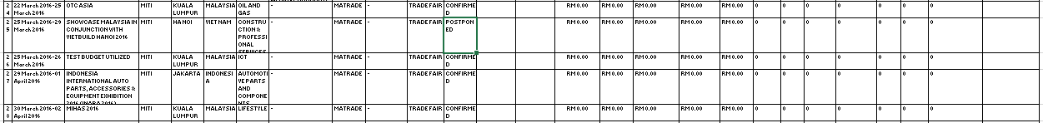
Search Filter Result
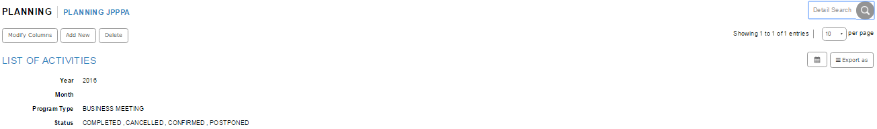

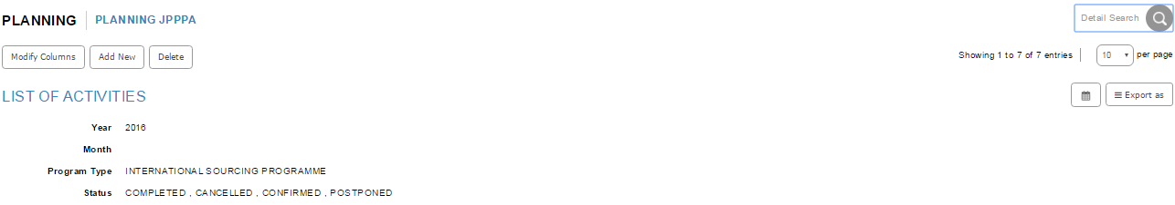

By Programme Type (Summary)
PDF
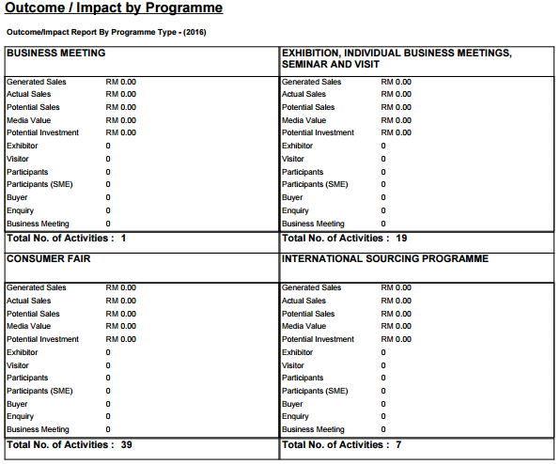
Excel
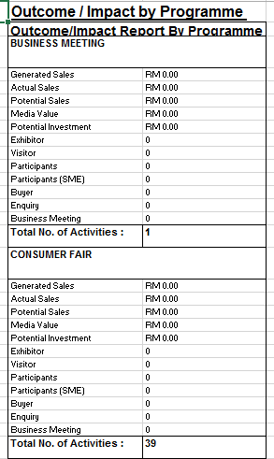
Reviewed By: (PMO)
 |  | Name/Position : NorhaidahBintiMdDasuki / Senior Manager, Quality Assurance and Support  Date : 15/1/2016

