Test Issue Log |  |  |  |  | Issue ID#: TPMS_Prod0107
Project Name: | Trade Promotion Management System (TPMS)
Test Stage: | Unit Functionality Integration System Interface  Performance Regression Acceptance Pilot
Test Case Number: | Support #6103 |  |  | Test Started Date: |  | 22/3/16
Test Title: | Post Event - Feedback  This issue is for IBM/INSP feedback form.
Test Description: | - Feedback form-> when to print product/service and Malaysian companies met not display in the form  - The Name of Representative display company name, not representative name.  - To widen the product/service column
Test Functionality: | Post Event> Feedback - Feedback form
Test Procedure: | - Access Programme, under Post Event module  - Click on Feedback  - Click on list by company  - Click print  - Click Edit
Test Result: | Pass: Fail: Conditional Pass: |  | Tested by: |  | Leonard Lim
Reason for Failed / Conditional Pass:
TEST DESCRIPTION
Test Result:
Based on discussion with En. Rizal and related to CR to add Product/Service Level 2 Category to Edit/Print Feedback Form screen. TPMS shall display as below:
- For Replied Status – the PURCHASES DURING ONE-ON-ONE BUSINESS MEETING column in Print Feedback page shall display the value input in Edit screen
- For Pending/Not Sent Status – the PURCHASES DURING ONE-ON-ONE BUSINESS MEETING column in Print Feedback page shall display the value from company Registration form

Issue #1
Status : Replied
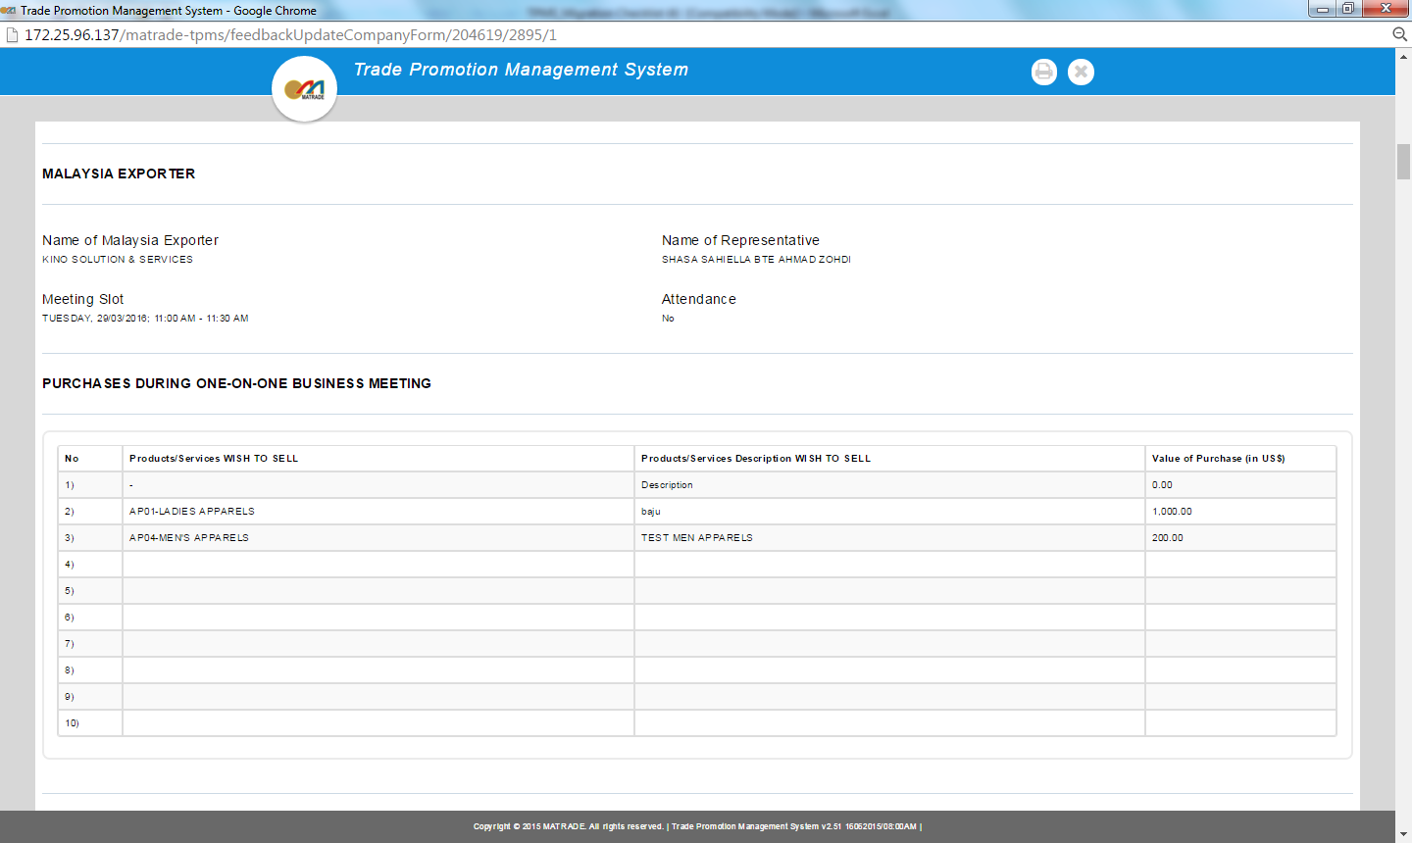

Status : Pending/Not Sent

Issue #2 & #3
Reviewed By: (PMO)
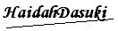 |  | Name/Position : NorhaidahBintiMdDasuki / Senior Manager, Quality Assurance and Support  Date : 28/3/2016

