Bug subject maintenance
- Add subject – subject field is required
- Add user - check box is untick when go to previous page
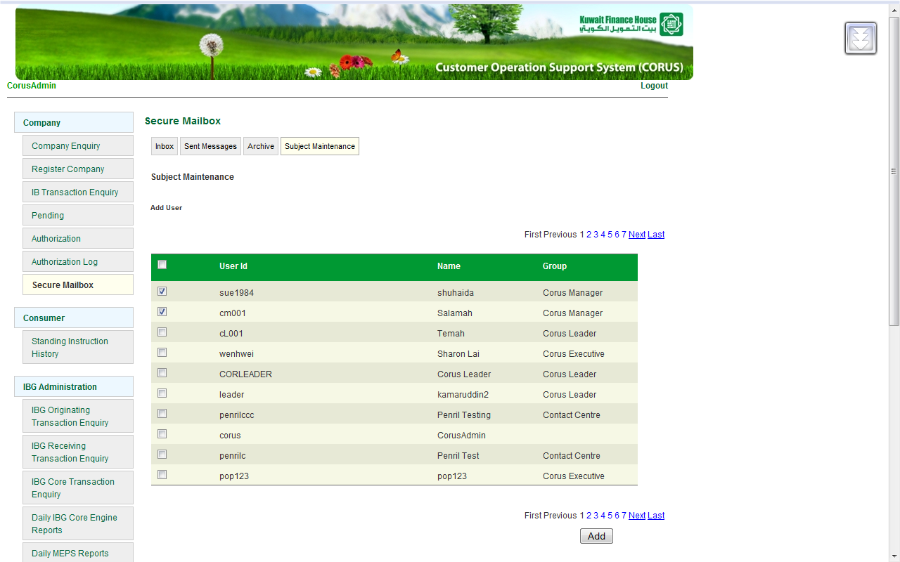

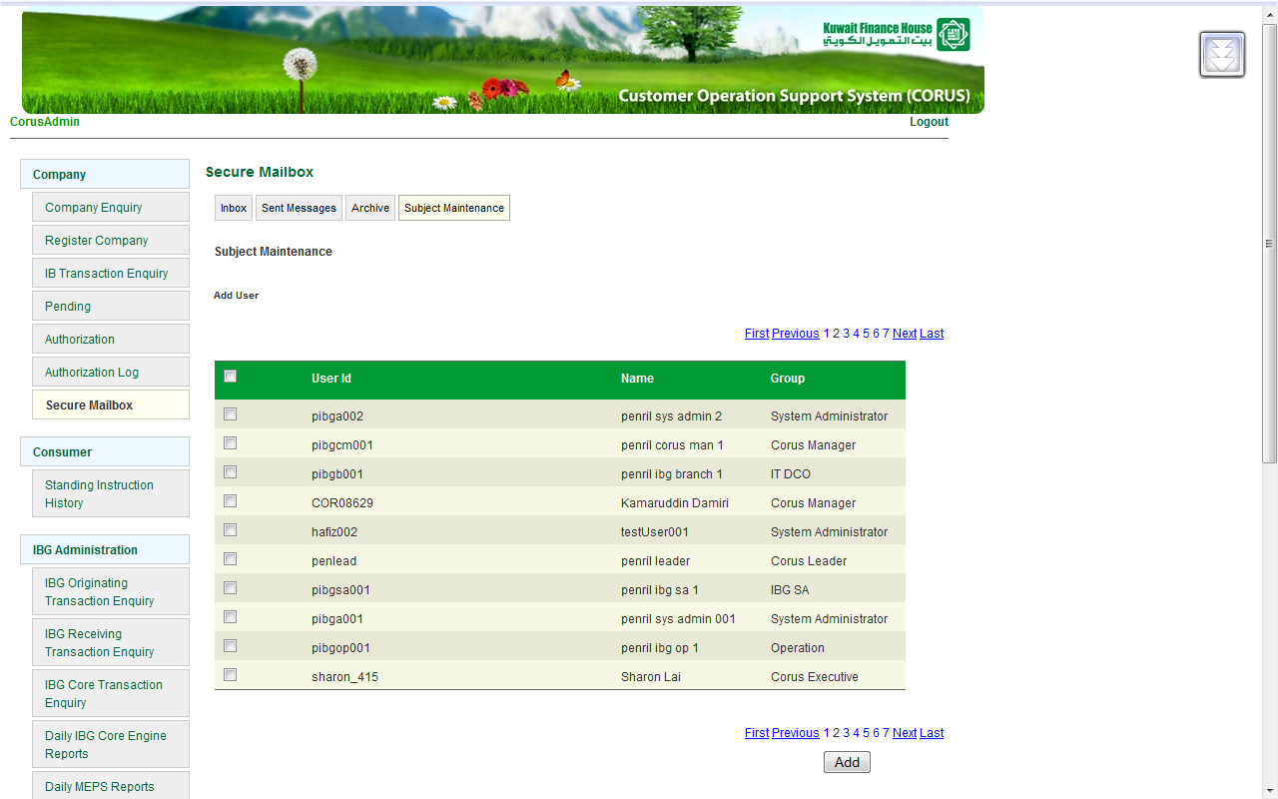

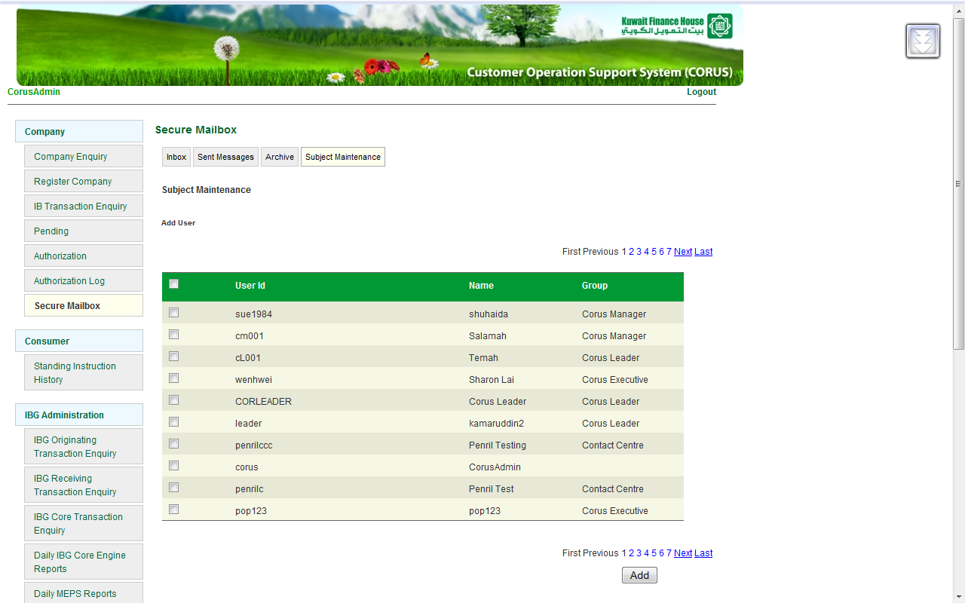

- Add user - Should not add same user
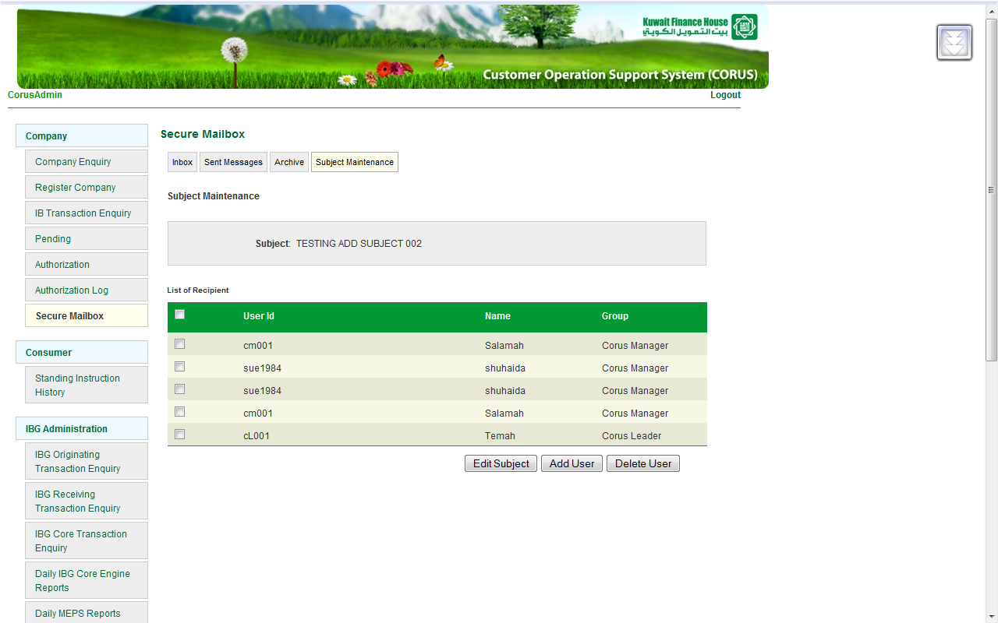
- Edit subject – not display user
** note:- edit, add, delete button need change to back , confirm button
Step :-
- Click edit subject button
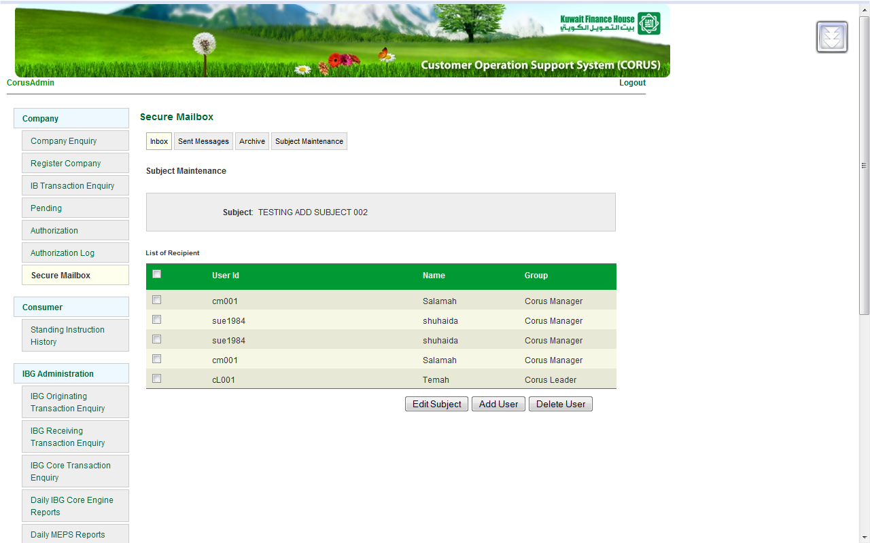

- Click add or delete button

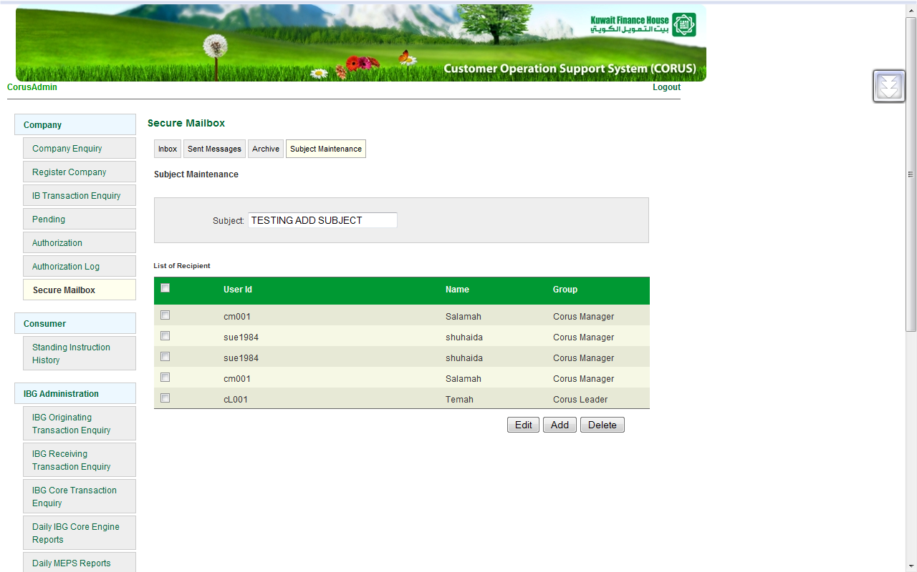

- Result for add button

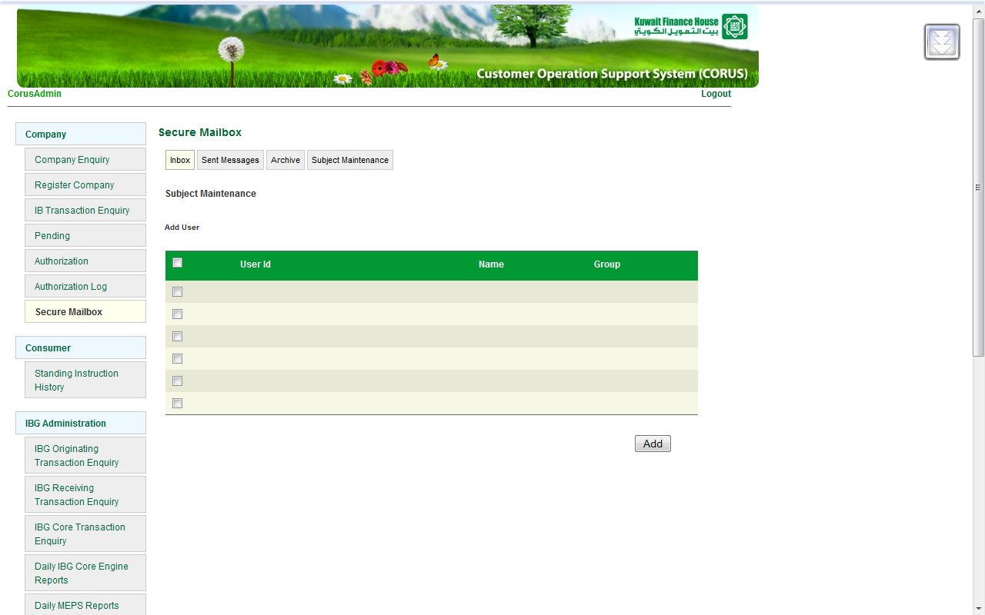
- Result for delete button
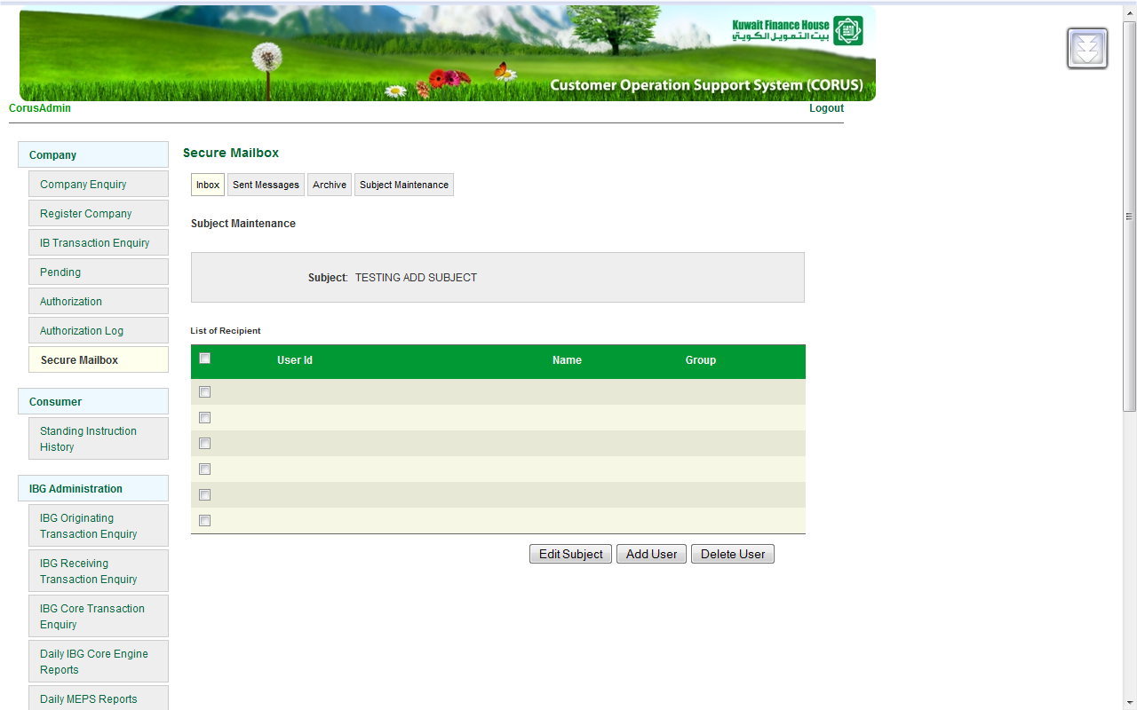

- Top link – change to inbox
Step :-
- add subject
- add user
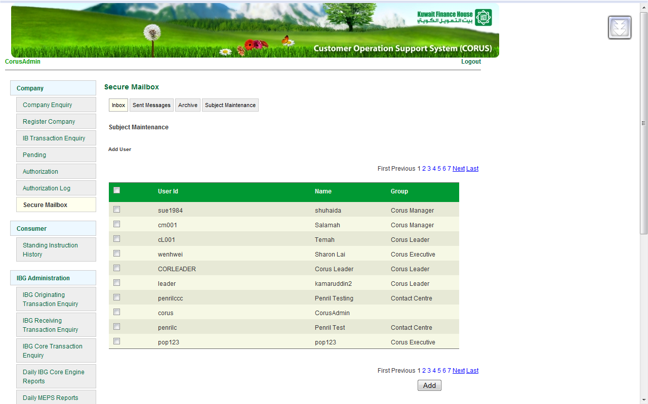

- edit subject – should required
- top link – change to inbox
Step :-
- edit subject
- click button edit

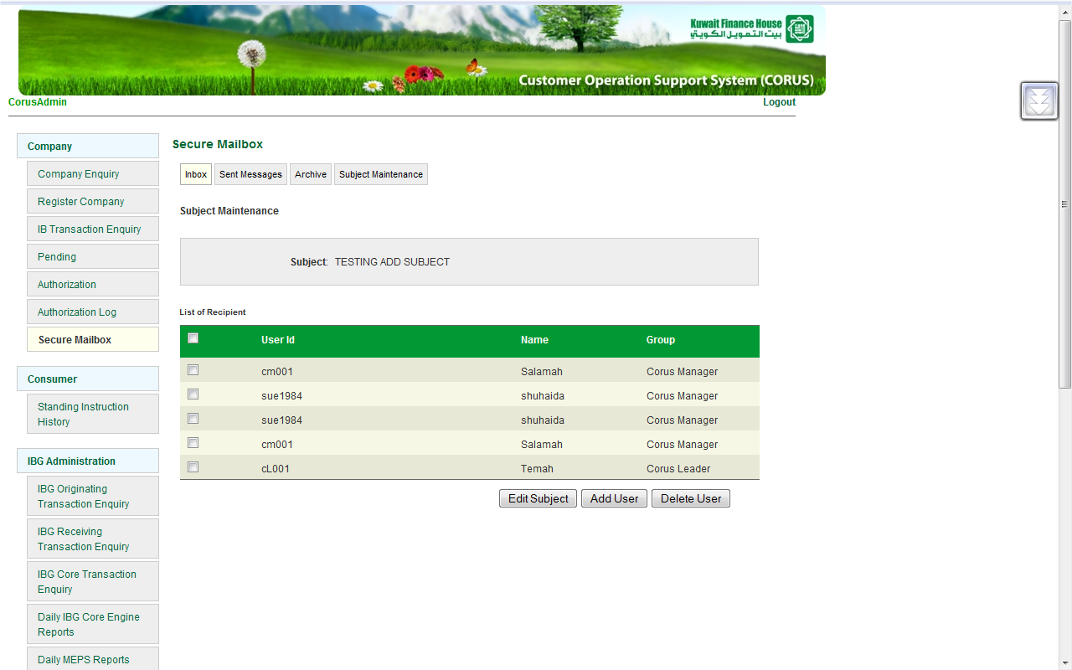
- cannot have more than 1 subject that have same name
Step :-
- add 2 subject that have different name
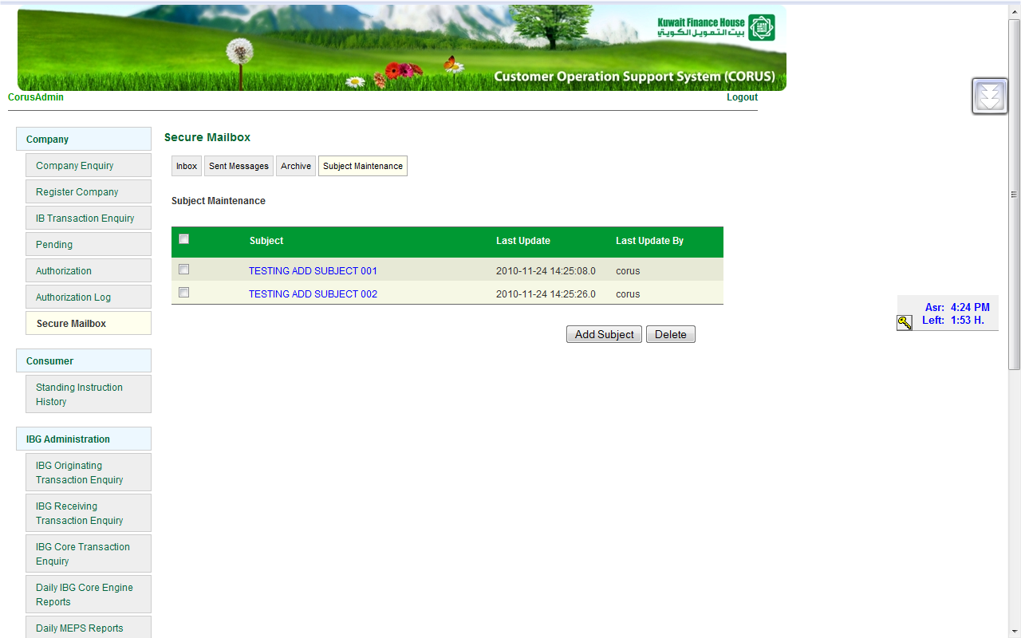
- edit 1 of these subject to other subject
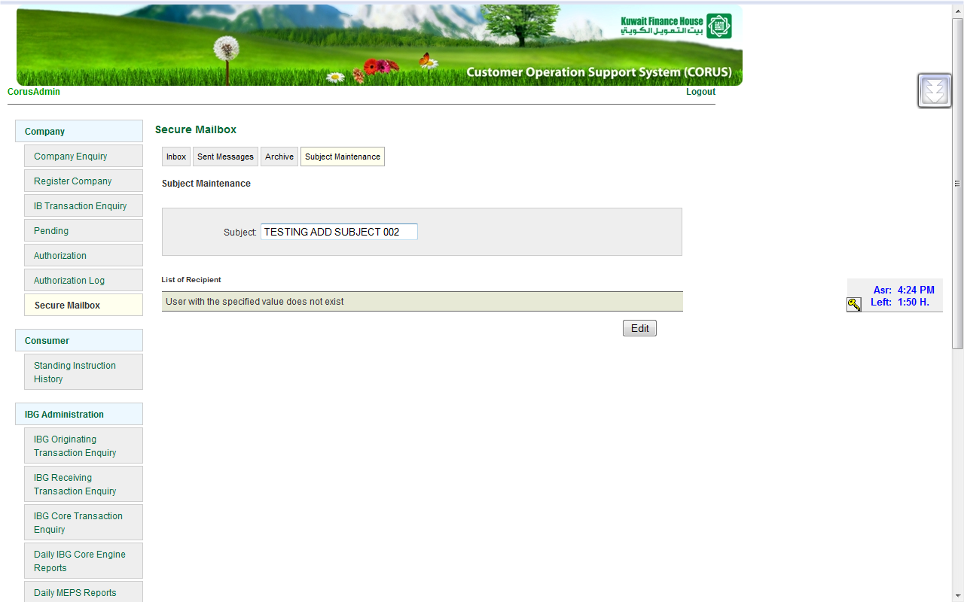

- now u have 2 subject that have same name

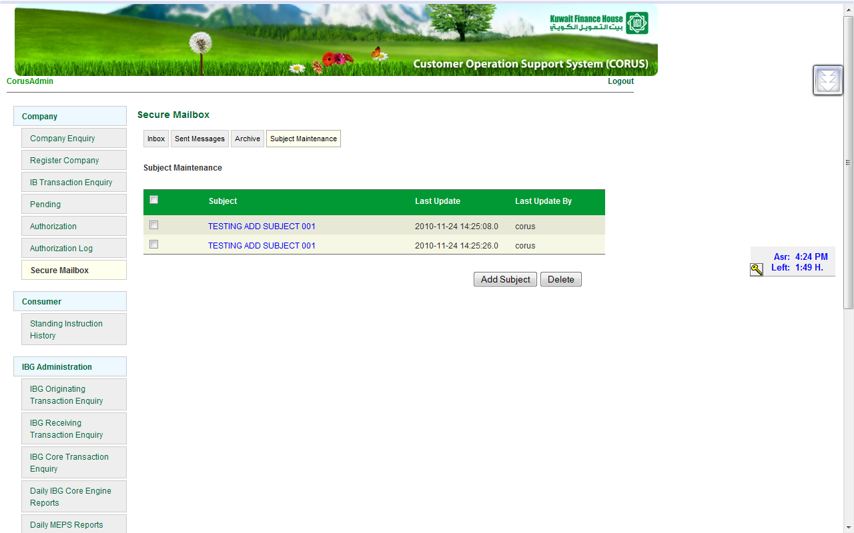
- cannot delete selected subject(2 subject have same name – follow bug 8)
Step :-
- have 2 subject have same name
- delete one by one
- the last subject cannot be delete
