Test Issue Log |  |  |  |  | Issue ID#: TPMS_Prod112
Project Name: | Trade Promotion Management System (TPMS)
Test Stage: | Unit Functionality Integration System Interface  Performance Regression Acceptance Pilot
Test Case Number: | Support #6124 |  |  | Test Started Date: |  | 30/3/2016
Test Title: | TPMS system not save the attendance after click submit button.
Test Description: | To test on saving attendance list.
Test Functionality: | Execution > Attendance Tracking
Test Procedure: | - Click on Execution > Attendance Tracking  - Tick any representative and click on Submit button.
Test Result: | Pass: Fail: Conditional Pass: |  | Tested by: |  | Siti Norahayu
Reason for Failed / Conditional Pass:
TEST DESCRIPTION
Click on Execution > Attendance Tracking
Result:
System display Attendance List Screen.

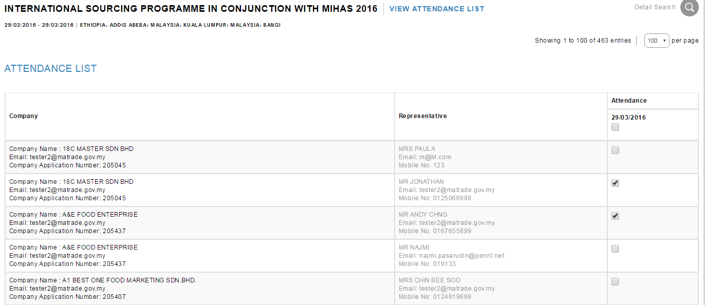

Tick any representative and click on Submit button.
Result:
System display selected Attendance List Screen.

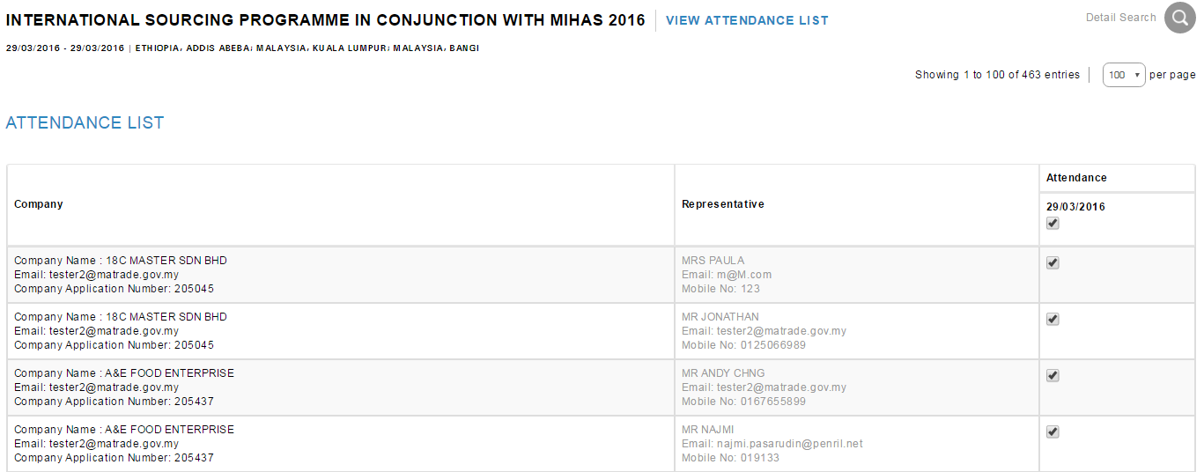

Reviewed By: (PMO)
 |  | Name/Position : NorhaidahBintiMdDasuki / Senior Manager, Quality Assurance and Support  Date : 30/3/2016

