Test Issue Log |  |  |  |  | Issue ID#: INSP_MIHAS2016
Project Name: | Trade Promotion Management System (TPMS)
Test Stage: | Unit Functionality Integration System Interface  Performance Regression Acceptance Pilot
Test Case Number: | Support #6126 |  |  | Test Started Date: |  | 30/3/2016
Test Title: | Remarks and feedback response is key in at day 1 form, but in report its displayed at day 3.
Test Description: | To test on remarks and feedback where is key in at day 1 form and display at day 1 in the report.
Test Functionality: | Post Event > Event Report > Local Trade Fair > General – Remarks / Comments
Test Procedure: | - Click on Post Event > Event Report > Local Trade Fair > General – Remarks / Comments
Test Result: | Pass: Fail: Conditional Pass: |  | Tested by: |  | Siti Norahayu
Reason for Failed / Conditional Pass:
TEST DESCRIPTION
Click on Post Event > Event Report > Local Trade Fair > General – Remarks / Comments
Result:
System display Remarks / Comment Report.

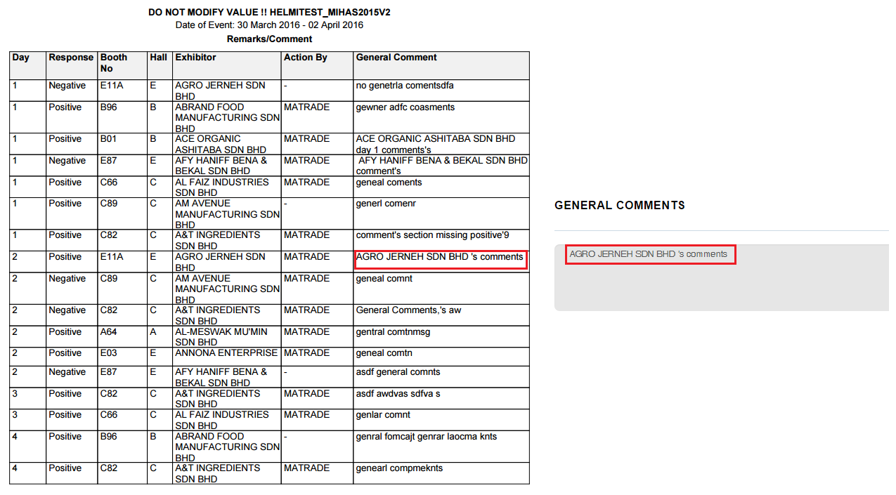

Reviewed By: (PMO)
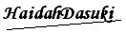 |  | Name/Position : NorhaidahBintiMdDasuki / Senior Manager, Quality Assurance and Support  Date : 30/3/2016

