**1. Enhancement #5452 - Report >> Generate Word Report**

To generate word report with same PDF format.

Reports that are not supported by word due paper size more than A3:

Planning:

1. Overall Summary > Details of work programme
2. Master work compilation without kpi
3. Master work compilation with kpi

Budget

1. Ringkasan Perbelanjaan Peruntukan Promosi
2. Ringkasan Perbelanjaan Peruntukan Promosi Berdasarkan Kelulusan BOD

**Generate Word**

**Planning Report> Summary of Work Programme**

1. Column title missing **– Test on 25032016 not fixed**
2. Grand Total missing **– Test on 25032016 not fixed**
3. Year did not display at summary title **– Test on 25032016 fixed**

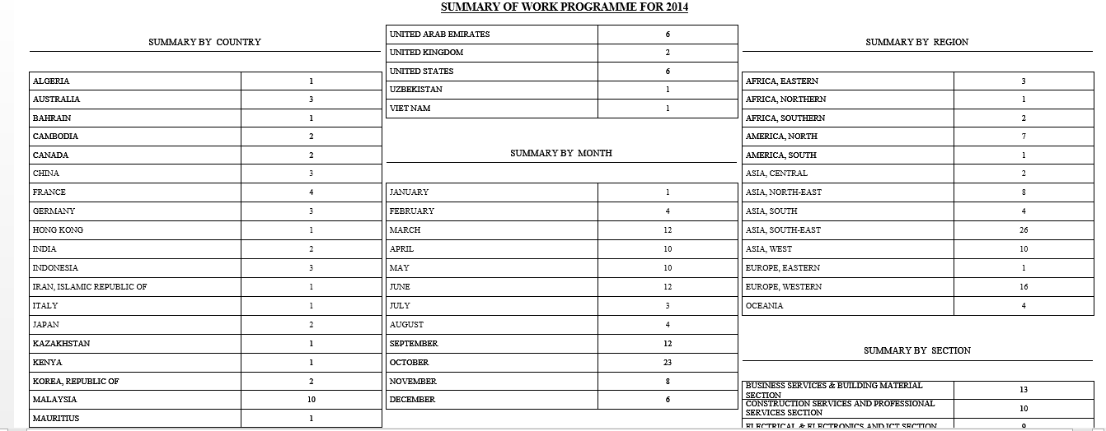

1. a) Add title Summary by Budget Type **– Test on 25032016 fixed**

b) Highlight column Grand Total **– Test on 25032016 fixed**

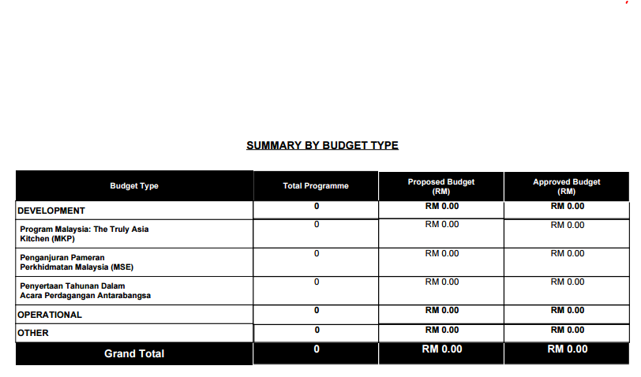

**Budget Report>Status of Trade Promotion Activity**

1. Column header did not highlighted as pdf **– Test on 25032016 not fixed**
2. Column Total Budget did not highlighted as pdf **– Test on 25032016 not fixed**
3. To display date of borang P received in properly format **– Test on 25032016 not fixed**
4. Remove semicolon (;)for single value amount
5. Alignment in proper display

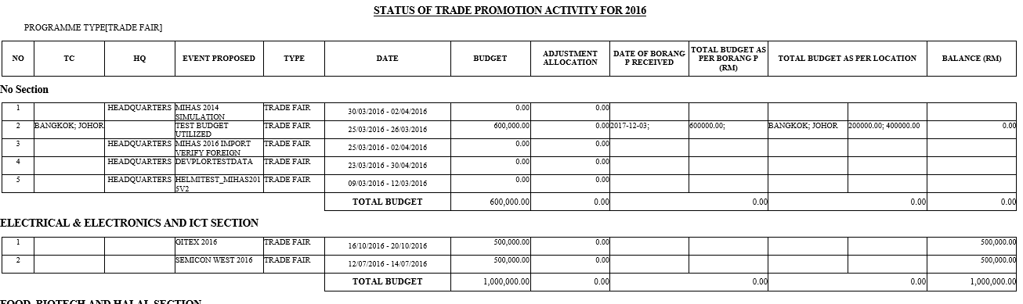

**Budget Report>JKPA – Aktiviti Yang Telah Dijalankan**

1. No report display. Blank screen. **– Test on 25032016 not fixed**

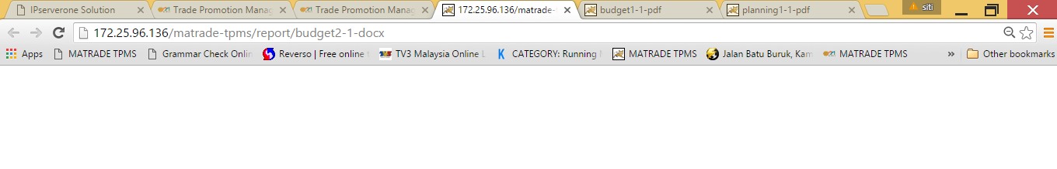

**Budget Report>JKPA – Aktiviti Yang Belum Dijalankan**

1. Column header did not highlighted as pdf **– Test on 25032016 not fixed**
2. Column Jumlah did not highlighted as pdf **– Test on 25032016 not fixed**

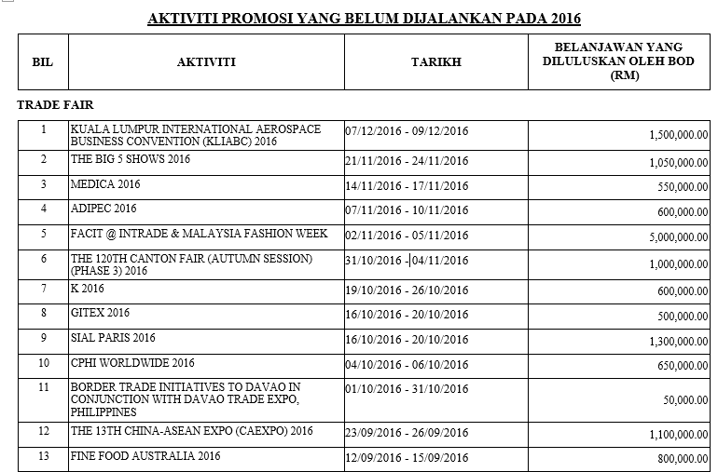

**Budget Report>JKPA – MATRADE WORK PROGRAMME**

1. Column header did not highlighted as pdf

