Test Result > Planning Report > Overall Summary > Summary of Work Programme

Test per summary checkbox – Approved by BOD

1. Status : Approved by BOD

Summary: Sector

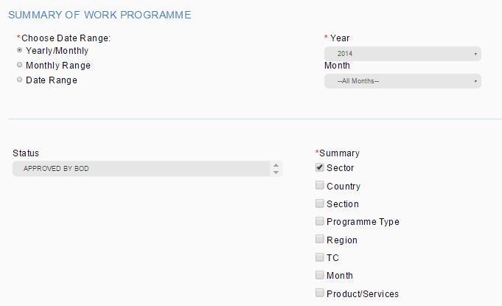

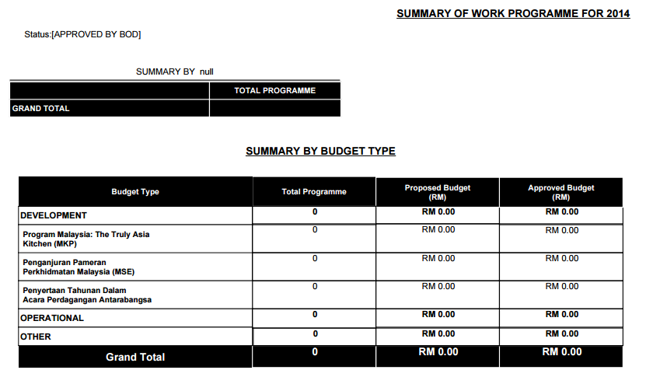

Shall display SUMMARY BY SECTOR

Error:

1. Shall display SUMMARY BY SECTOR instead of SUMMARY BY null
2. Summary by Budget Type shall not be display as we only tick sector report to be display
3. Status : Approved by BOD

Summary: Country

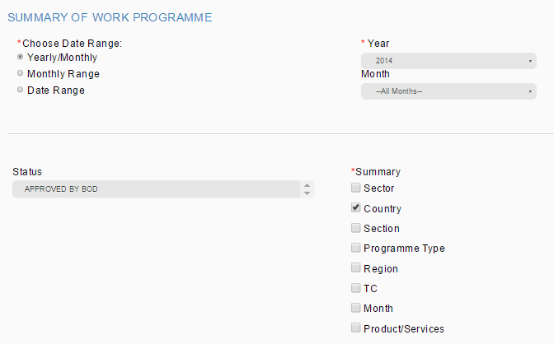



Shall display SUMMARY BY COUNTRY

Error:

1. Shall display SUMMARY BY COUNTRY instead of SUMMARY BY null
2. Summary by Budget Type shall not be display as we only tick country report to be display
3. Status : Approved by BOD

Summary: Section

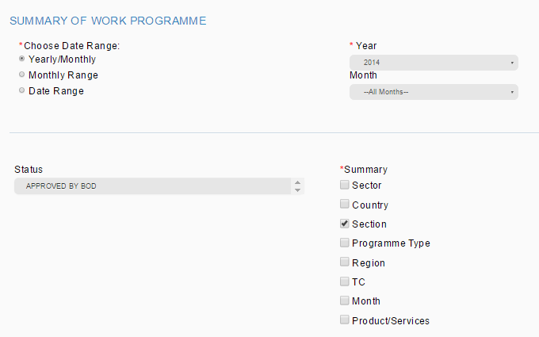



Shall display SUMMARY BY SECTION

Error:

1. Shall display SUMMARY BY SECTION instead of SUMMARY BY null
2. Summary by Budget Type shall not be display as we only tick section report to be display
3. Status : Approved by BOD

Summary: Programme Type

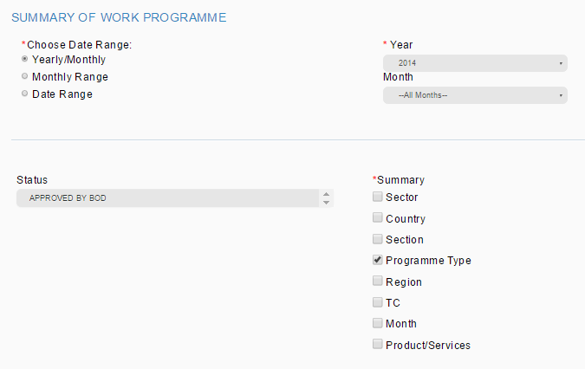



Shall display SUMMARY BY PROGRAMME TYPE

Error:

1. Shall display SUMMARY BY PROGRAMME TYPE instead of SUMMARY BY null
2. Summary by Budget Type shall not be display as we only tick programme type report to be display
3. Status : Approved by BOD

Summary: Region

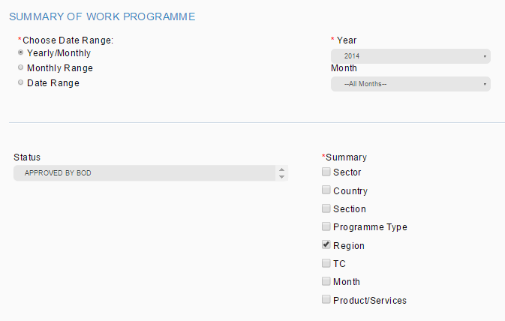



Shall display SUMMARY BY REGION

Error:

1. Shall display SUMMARY BY REGION instead of SUMMARY BY null
2. Summary by Budget Type shall not be display as we only tick region report to be display
3. Status : Approved by BOD

Summary: TC

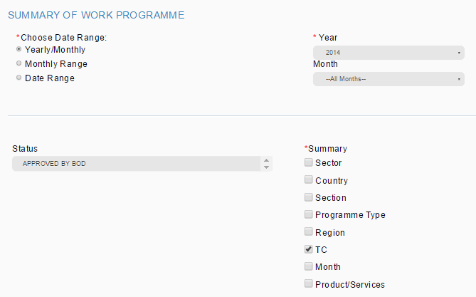



Shall display SUMMARY BY TC

Error:

1. Shall display SUMMARY BY TC instead of SUMMARY BY null
2. Summary by Budget Type shall not be display as we only tick TC report to be display
3. Status : Approved by BOD

Summary: Month

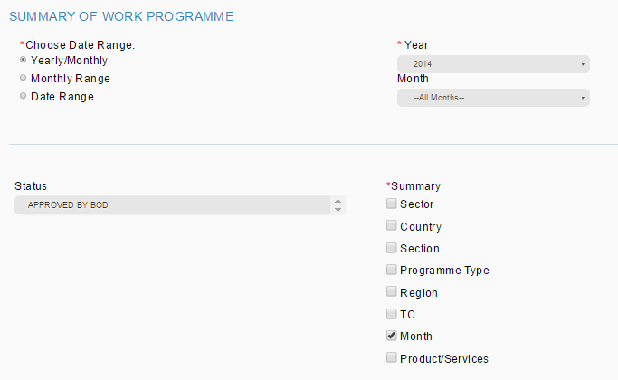



Shall display SUMMARY BY MONTH

Error:

1. Shall display SUMMARY BY MONTH instead of SUMMARY BY null
2. Summary by Budget Type shall not be display as we only tick month report to be display
3. Status : Approved by BOD

Summary: Product/Service

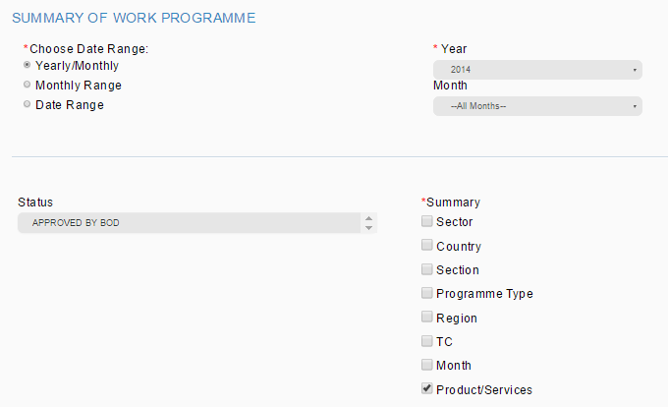



Shall display SUMMARY BY PRODUCT/SERVICE

Error:

1. Shall display SUMMARY BY PRODUCT/SERVICE instead of SUMMARY BY null
2. Summary by Budget Type shall not be display as we only tick product/service report to be display