Test Result > Planning Report > Overall Summary > Summary of Work Programme

Test per summary checkbox – Cancelled

1. Status : Cancelled

Summary: Sector

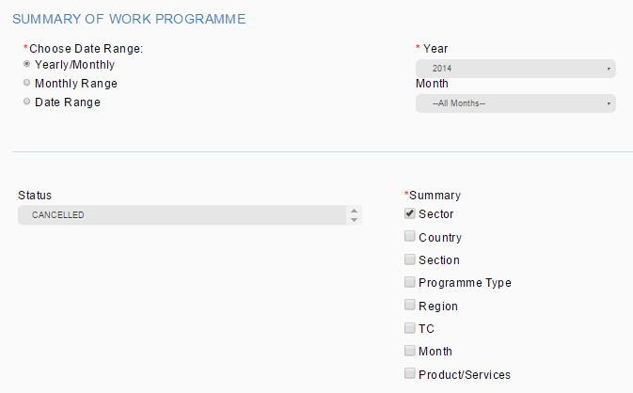

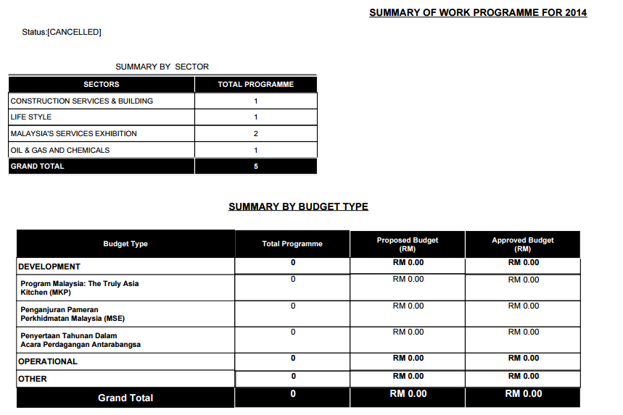

Error:

1. Summary by Budget Type shall not be display as we only tick sector report to be display
2. Status : Cancelled

Summary: Country

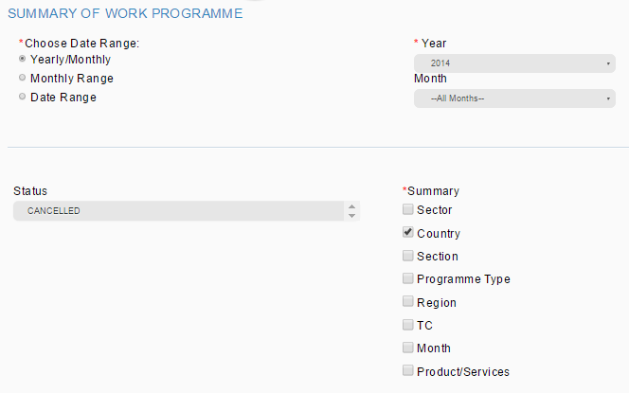

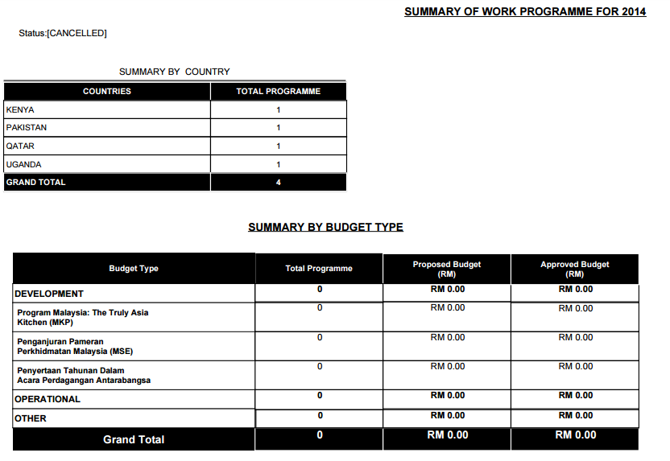

TPMS display 5 country

Error:

1. Summary by Budget Type shall not be display as we only tick country report to be display
2. Report display 4 country but in TPMS listing showing 5 country.

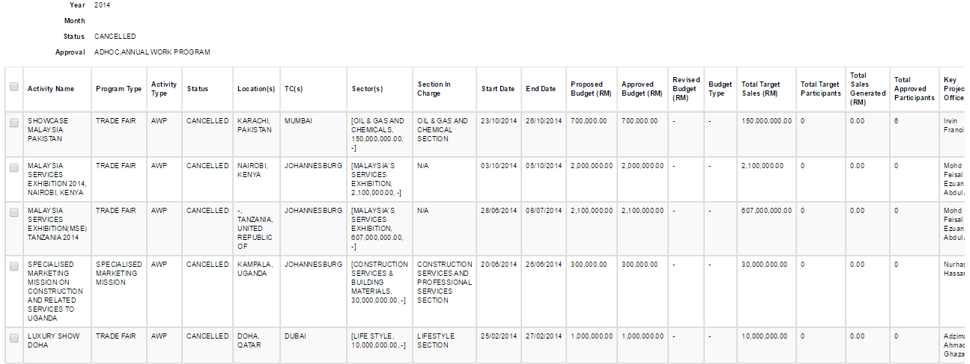

This event not cater in the report. Need double check at DB

1. Status : Cancelled

Summary: Section

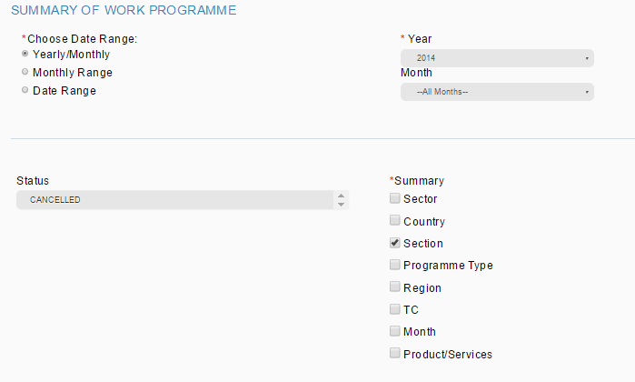

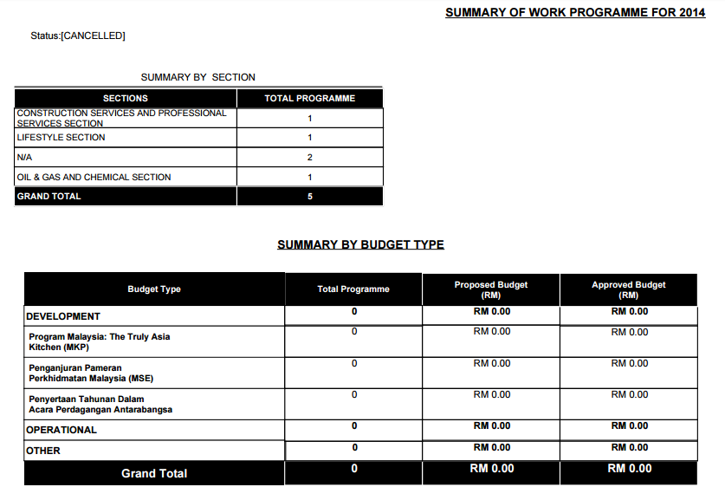

Error:

1. Summary by Budget Type shall not be display as we only tick section report to be display
2. Status : Cancelled

Summary: Programme Type

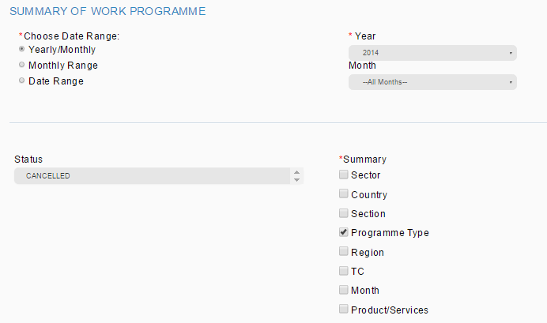

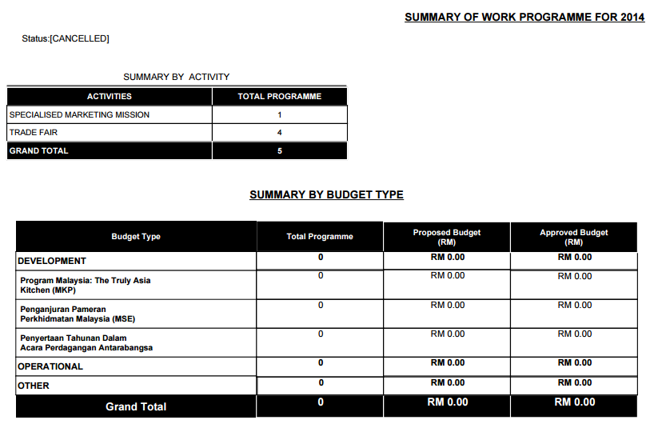

Error:

1. Summary by Budget Type shall not be display as we only tick programme type report to be display
2. Status : Cancelled

Summary: Region

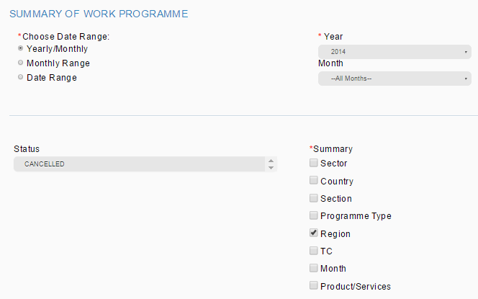

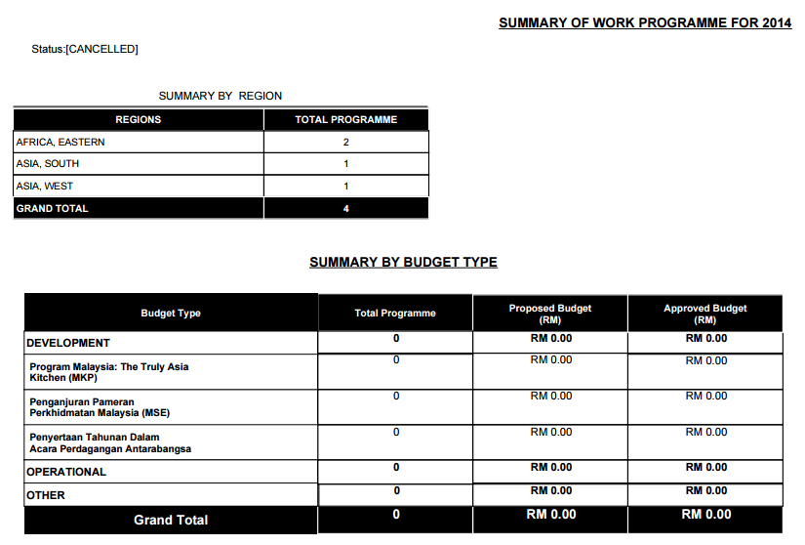

TPMS display total 5 region. 1 record from Africa, Eastern (Tanzania, United Republic of) not include in this report. Need to double check at DB.

Error:

1. Summary by Budget Type shall not be display as we only tick region report to be display

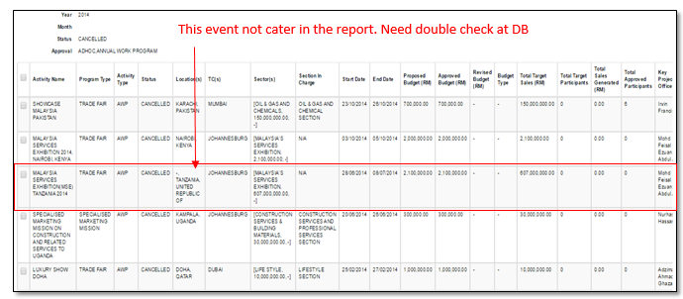

1. Status : Cancelled

Summary: TC

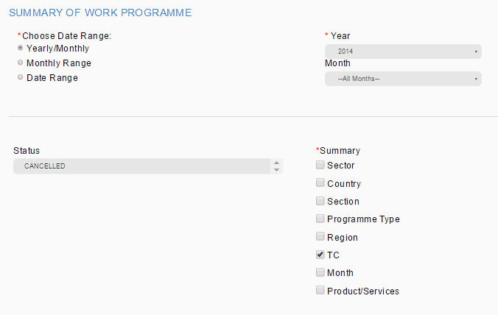

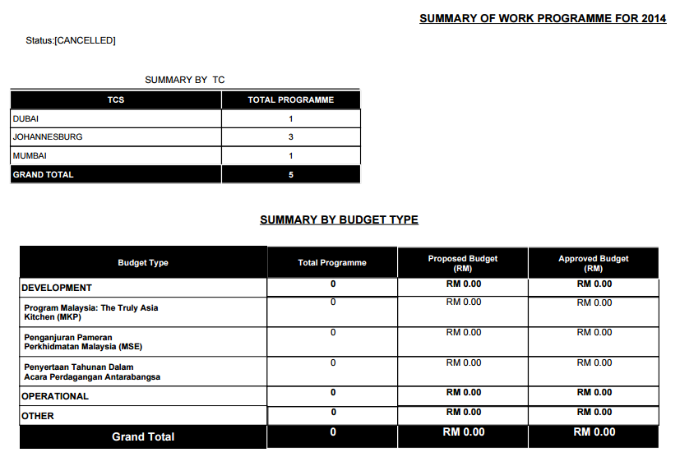

Error:

1. Summary by Budget Type shall not be display as we only tick TC report to be display
2. Status : Cancelled

Summary: Month

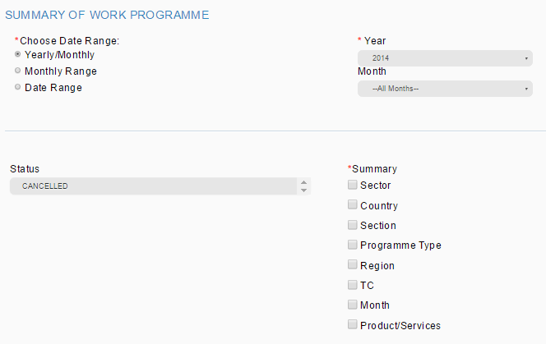

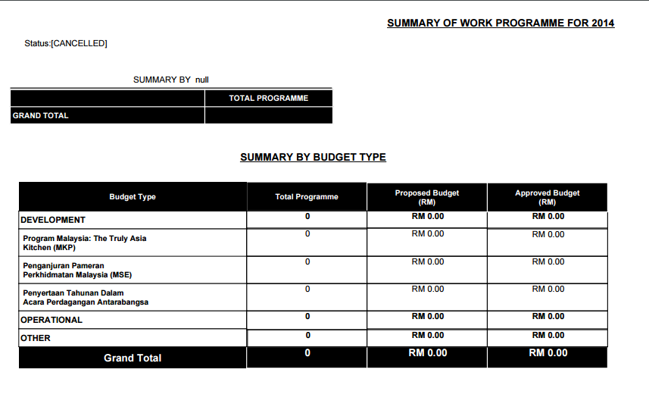

1. Shall display data
2. Shall display tittle SUMMARY BY MONTH

Error:

1. Shall display SUMMARY BY MONTH instead of SUMMARY BY null
2. Summary by Budget Type shall not be display as we only tick month report to be display

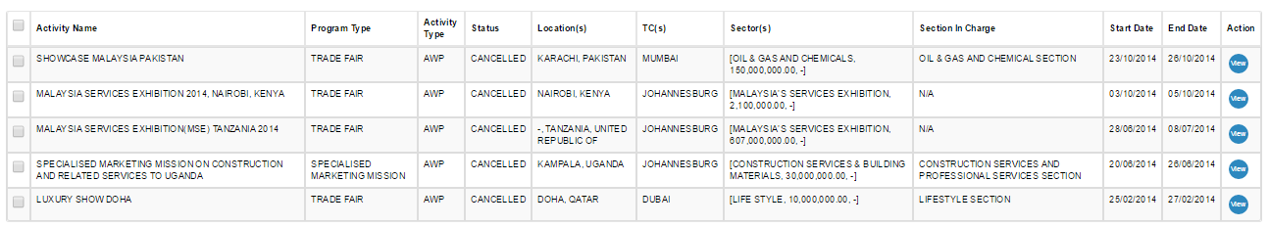

1. Status : Cancelled

Summary: Product/Service

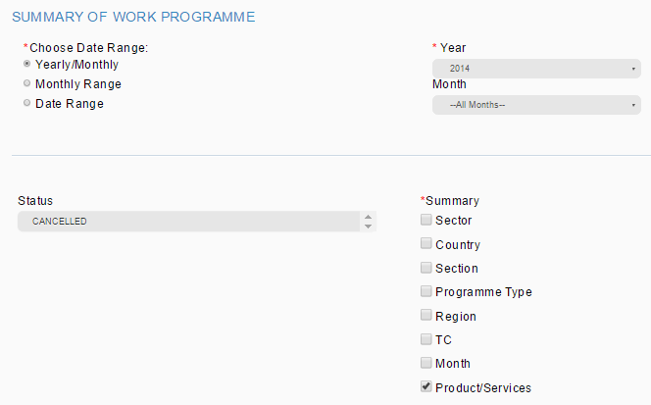

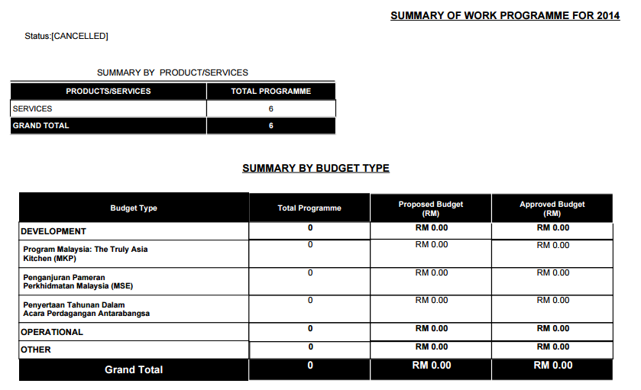

Only found 2 event instead of 6. Need to double check at DB

Error:

1. Summary by Budget Type shall not be display as we only tick product/service report to be display
2. Only found 2 event instead of 6. Need to double check at DB