Test Result > Planning Report > Overall Summary > Summary of Work Programme

Test per summary checkbox – Completed

1. Status : Completed

Summary: Sector

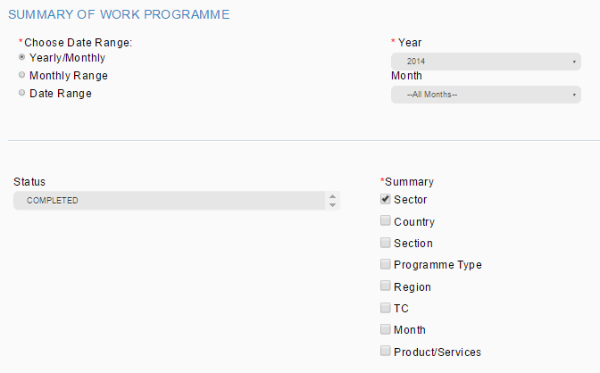

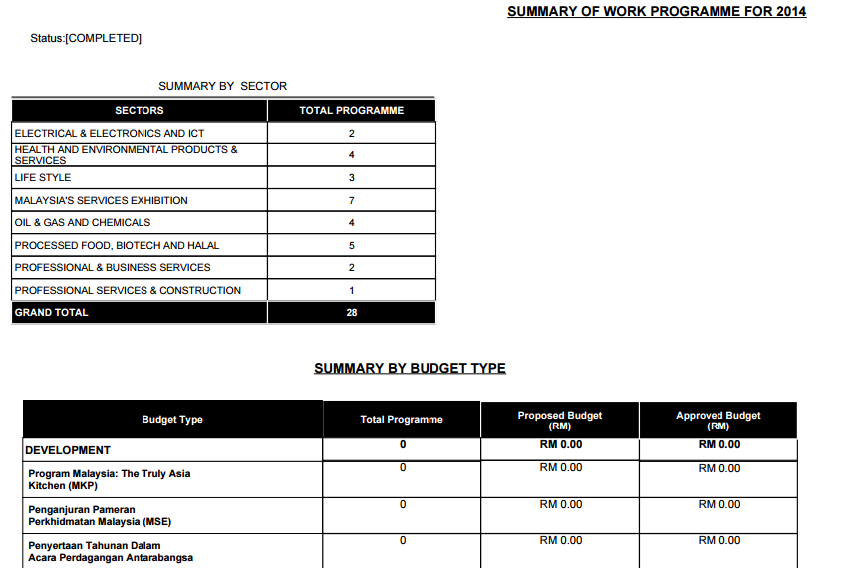

Error:

1. Summary by Budget Type shall not be display as we only tick sector report to be display
2. Status : Completed

Summary: Country

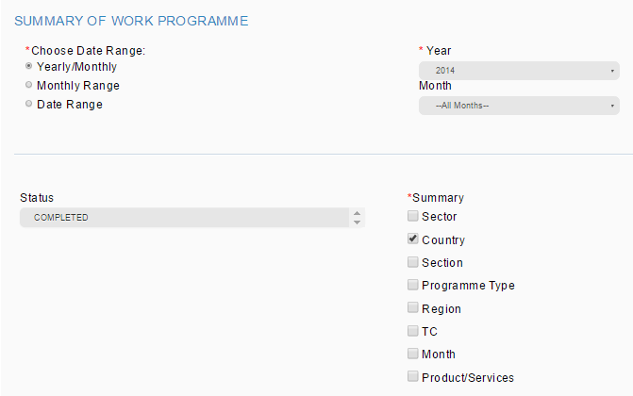

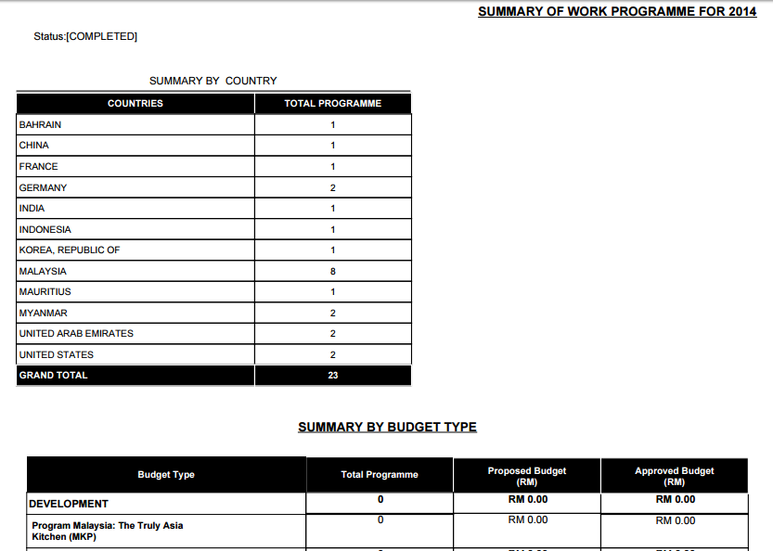

To check city condition. Record in report not tally with system.

Error:

1. To check city condition. Record in the report not tally with system.
2. Summary by Budget Type shall not be display as we only tick country report to be display
3. Status : Completed

Summary: Section

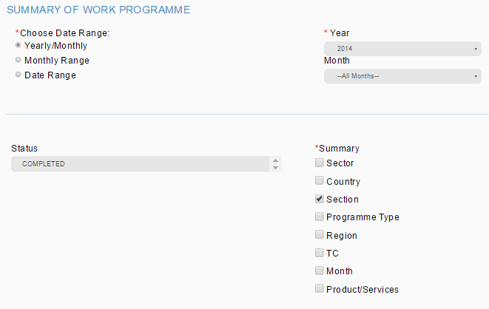

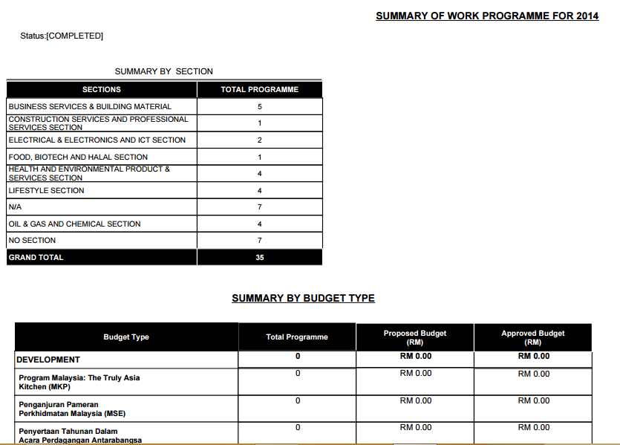

Error:

1. Summary by Budget Type shall not be display as we only tick section report to be display
2. Status : Completed

Summary: Programme Type

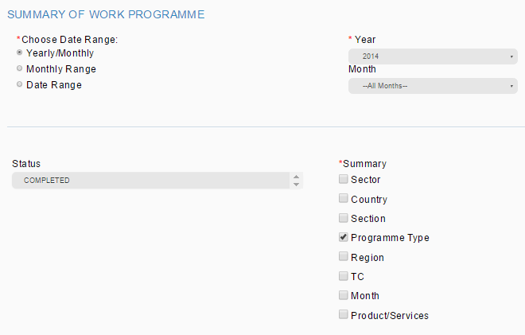

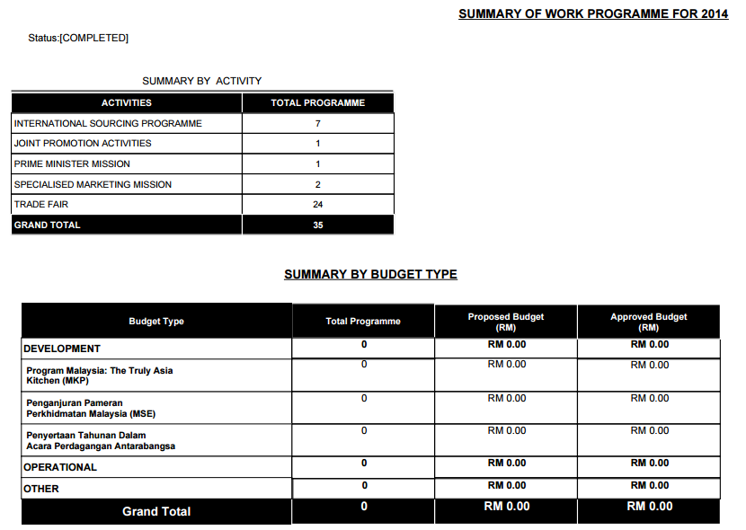

Error:

1. Summary by Budget Type shall not be display as we only tick programme type report to be display
2. Status : Completed

Summary: Region

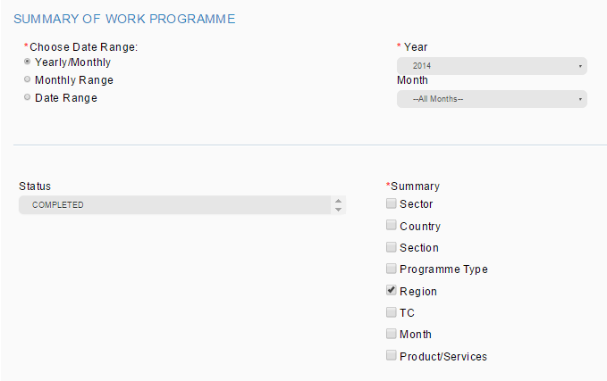

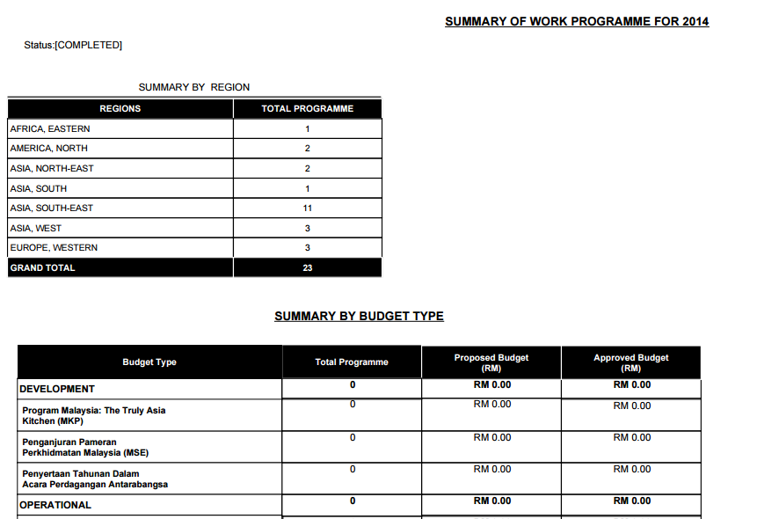

To check city condition. Region in report not tally with system.

Error:

1. To check city condition. Region in report not tally with system.
2. Summary by Budget Type shall not be display as we only tick region report to be display
3. Status : Completed

Summary: TC

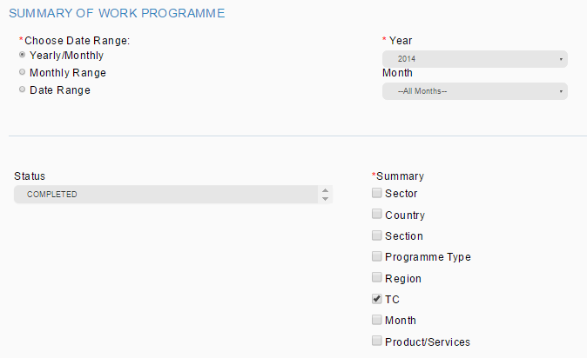

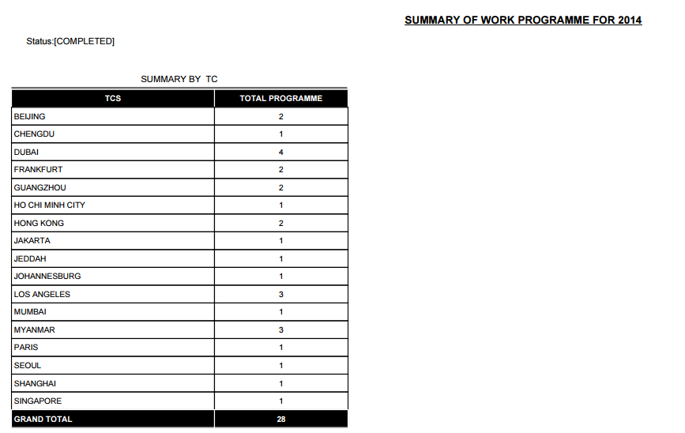

Need to double check with DB. TPMS listing showing 11 records with blank TC instead of 7.

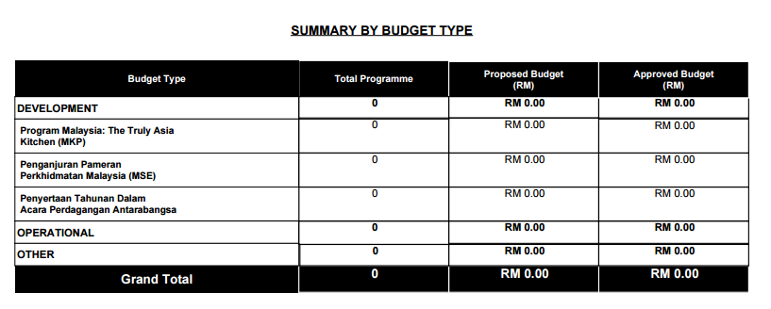

Error:

1. Summary by Budget Type shall not be display as we only tick TC report to be display
2. Need to double check with DB. TPMS listing showing 11 records with blank TC instead of 7.

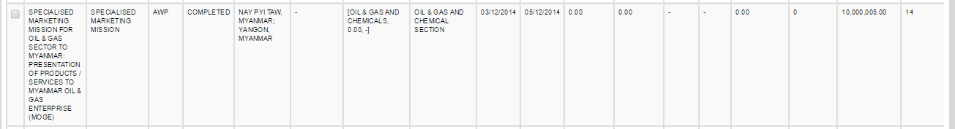

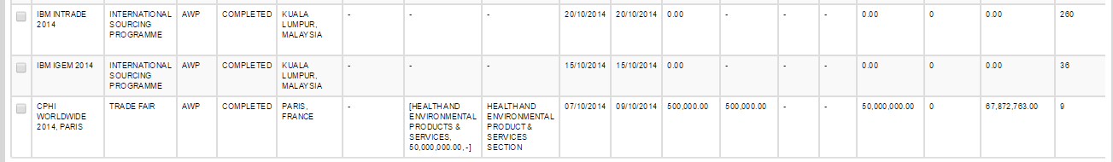













1. Status : Completed

Summary: Month

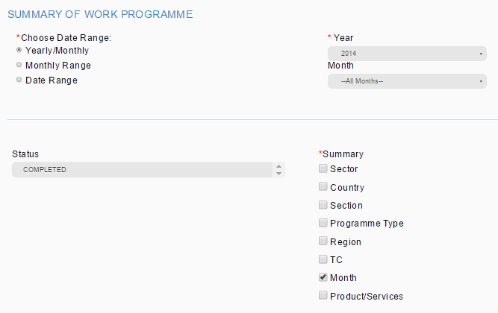

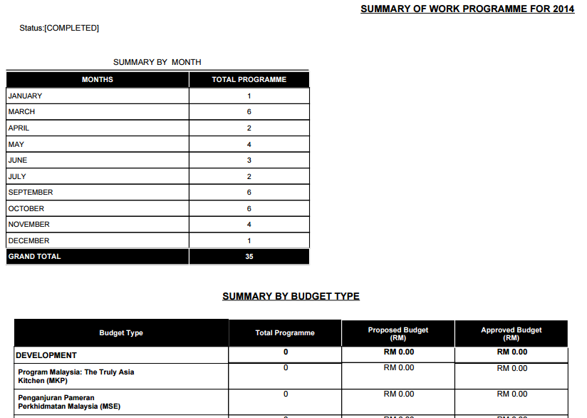

Error:

1. Summary by Budget Type shall not be display as we only tick month report to be display
2. Status : Completed

Summary: Product/Service

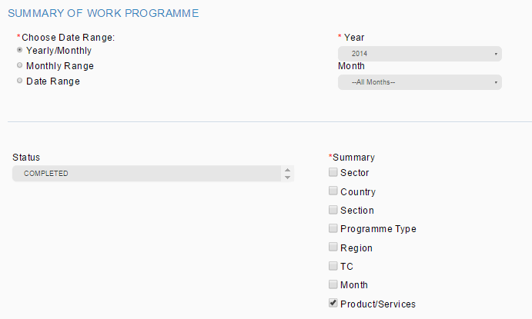

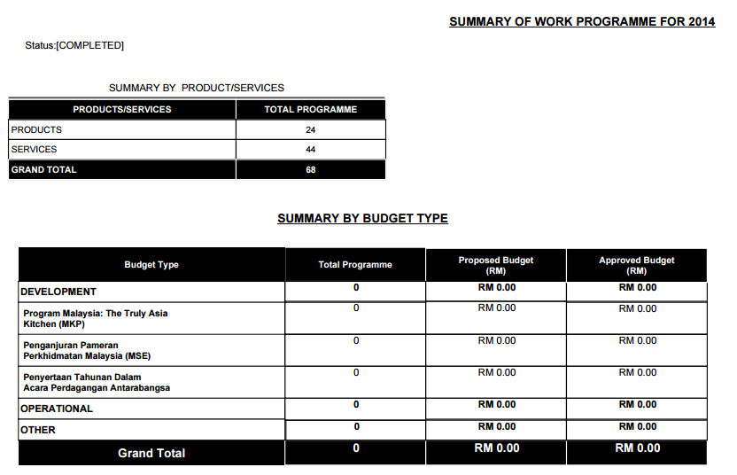

Record in the system not tally with report. Need to double check.

Error:

1. Summary by Budget Type shall not be display as we only tick product/service report to be display
2. Record in the system not tally with report. Need to double check.

