Test Result > Planning Report > Overall Summary > Summary of Work Programme

Test per summary checkbox – Confirmed

1. Status : Confirmed

Summary: Sector

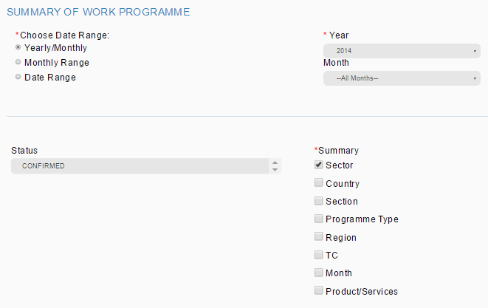

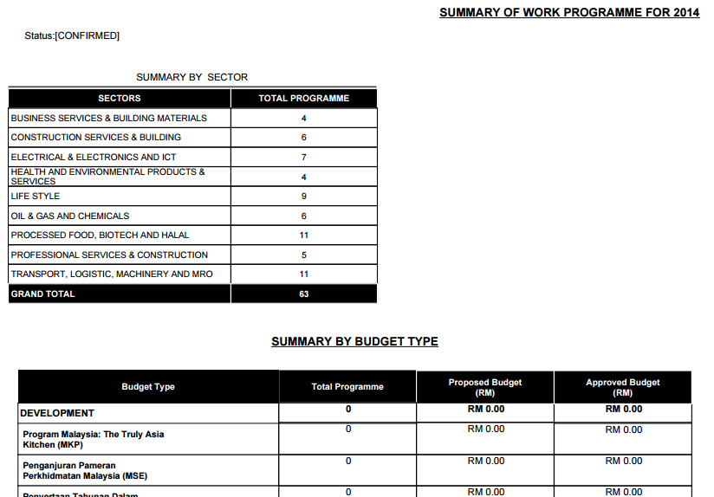

Error:

1. Summary by Budget Type shall not be display as we only tick sector report to be display
2. Status : Confirmed

Summary: Country

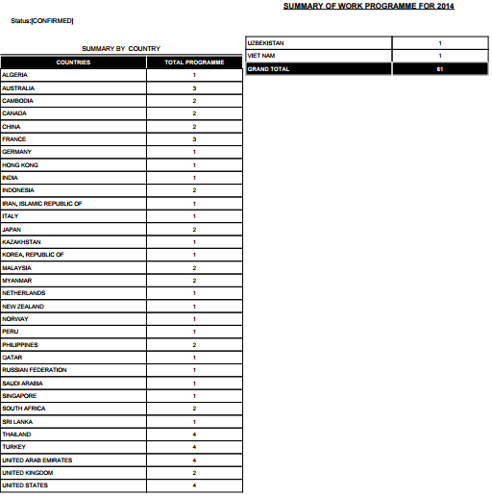

Report display 61 country but in TPMS listing showing 65 country. There is 8 event that doesn’t have city value. Need to check back with DB country condition (city).

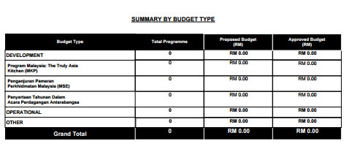

1. Summary by Budget Type shall not be display as we only tick country report to be display
2. Report display 61 country but in TPMS listing showing 65 country. There is 8 event that doesn’t have city value. Need to check back with DB country condition (city).

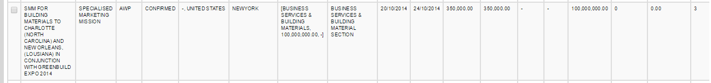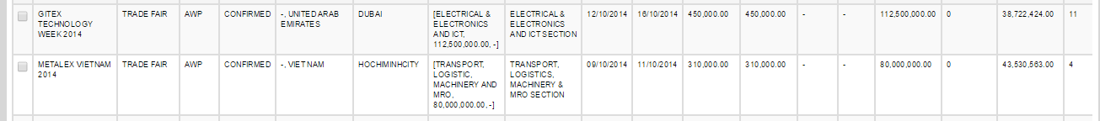

1. Status : Confirmed

Summary: Section

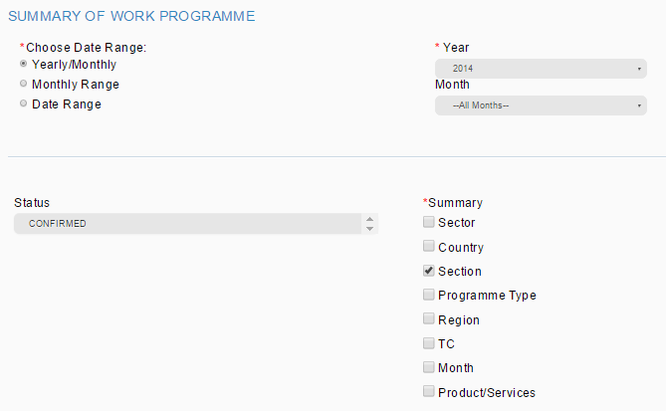

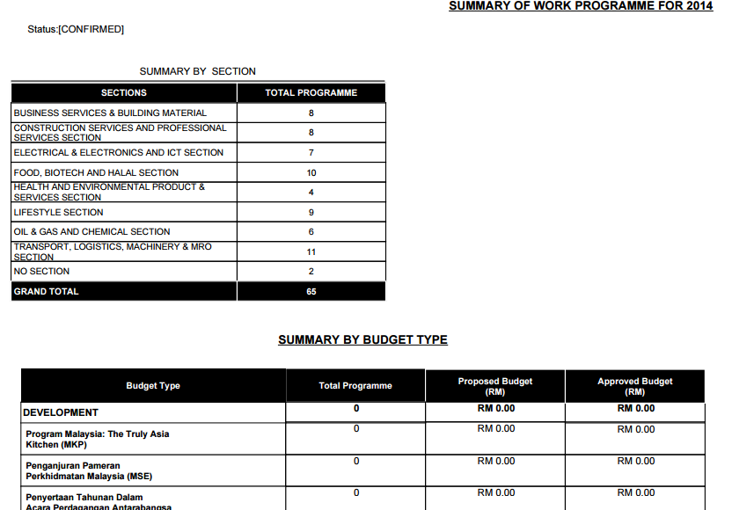

Error:

1. Summary by Budget Type shall not be display as we only tick section report to be display
2. Status : Confirmed

Summary: Programme Type

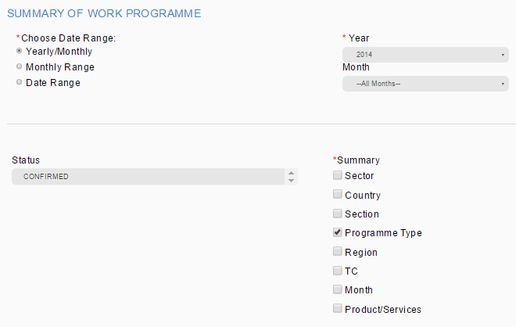

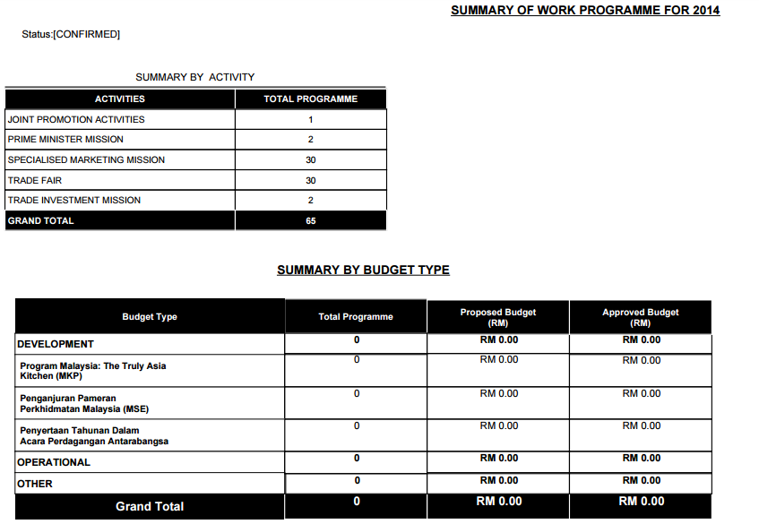

Error:

1. Summary by Budget Type shall not be display as we only tick programme type report to be display
2. Status : Confirmed

Summary: Region

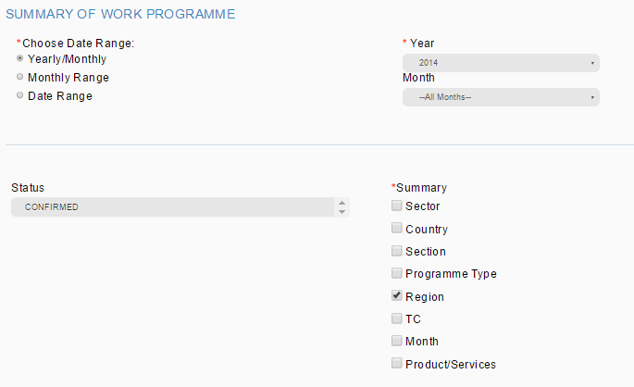

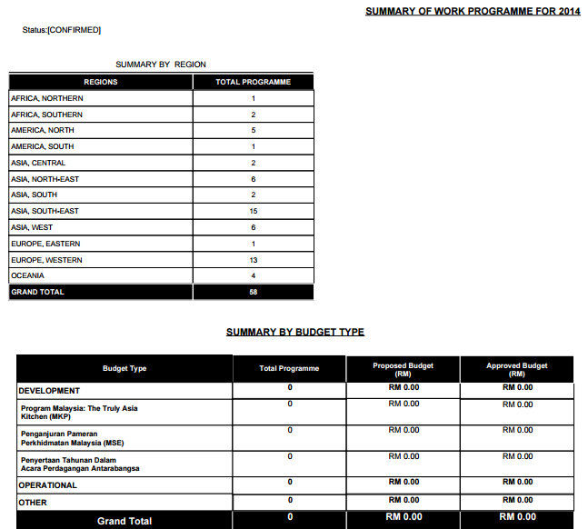

Report display 58 region but in TPMS listing showing 65 region. There is 7 event that doesn’t have region value. Need to check back with DB region condition (city).

Error:

1. Summary by Budget Type shall not be display as we only tick region report to be display
2. Report display 58 region but in TPMS listing showing 65 region. There is 7 event that doesn’t have region value. Need to check back with DB region condition (city).



1. Status : Confirmed

Summary: TC

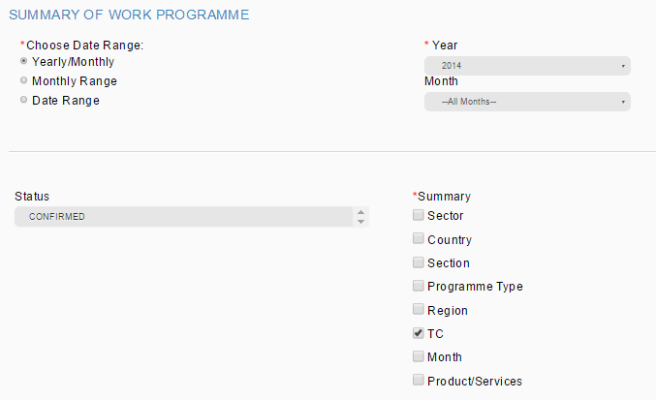

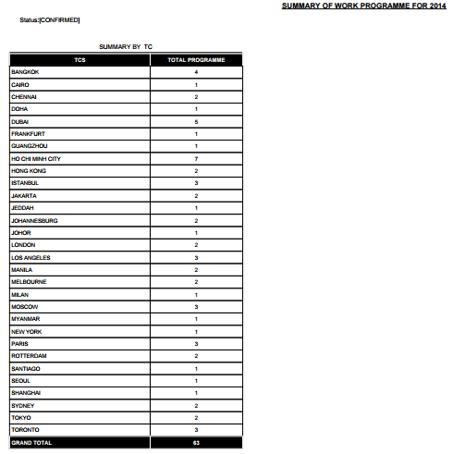

Report display 63 TC but in TPMS listing showing 65 event. There is 8 event that doesn’t have TC value. Need to check back with DB TC condition.

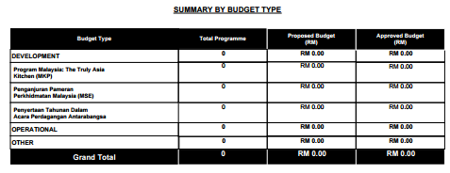

Error:

1. Summary by Budget Type shall not be display as we only tick TC report to be display
2. Report display 63 TC but in TPMS listing showing 65 event. There is 8 event that doesn’t have TC value. Need to check back with DB TC condition.



1. Status : Confirmed

Summary: Month

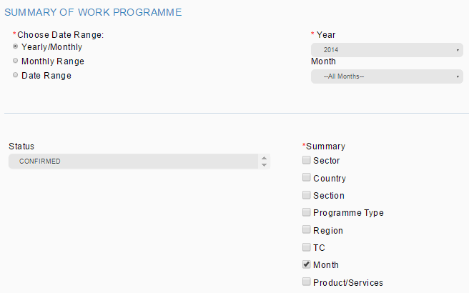

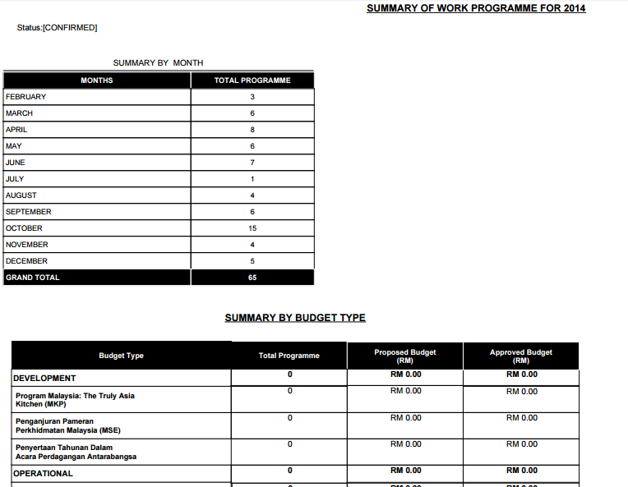

Error:

1. Summary by Budget Type shall not be display as we only tick month report to be display
2. Status : Confirmed

Summary: Product/Service

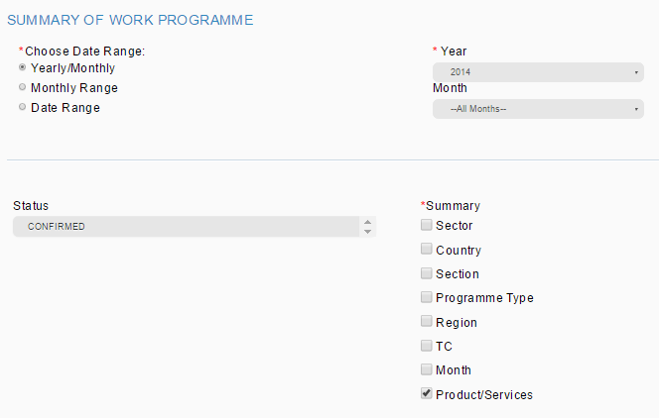

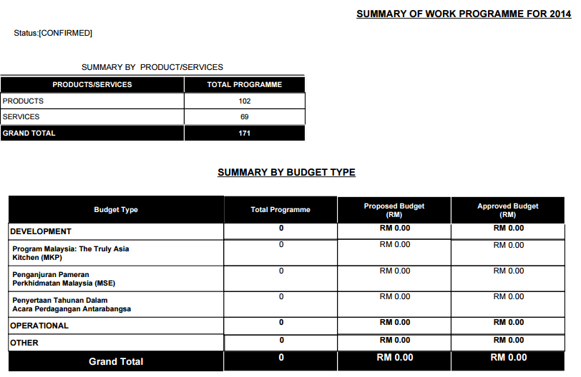

Need to double check at DB. Data not tally

Error:

1. Summary by Budget Type shall not be display as we only tick product/service report to be display
2. Need to double check at DB. Data not tally.