Test Issue Log |  |  |  |  | Issue ID#: [MIHAS2016_Local Trade Fair] - Issue 26/3/2016 (Exh016)
Project Name: | Trade Promotion Management System (TPMS)
Test Stage: | Unit Functionality Integration System Interface  Performance Regression Acceptance Pilot
Test Case Number: | Support #6134 |  |  | Test Started Date: |  | 31/3/2016
Test Title: | Report is not grouped by all hall followed by individual hall for each day.
Test Description: | To test on report is not grouped by all hall followed by individual hall for each day
Test Functionality: | Post Event > Event Report > Local Trade Fair  •By Hall - All Products/Service
Test Procedure: | - Click on Post Event > Event Report > Local Trade Fair > By Hall - All Products/Service
Test Result: | Pass: Fail: Conditional Pass: |  | Tested by: |  | Siti Norahayu
Reason for Failed / Conditional Pass:
TEST DESCRIPTION
Click on Post Event > Event Report > Local Trade Fair > By Hall - All Products/Service
Result:
System display All Products / Service by hall report.

By Hall – All Products/Service

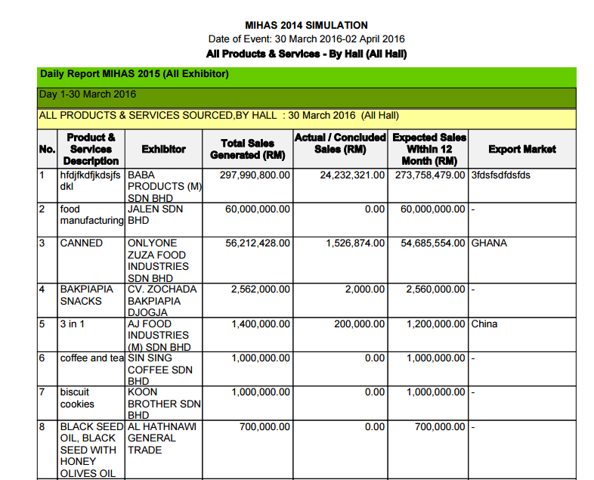

Reviewed By: (PMO)
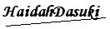 |  | Name/Position : NorhaidahBintiMdDasuki / Senior Manager, Quality Assurance and Support  Date : 31/3/2016

