Test Issue Log |  |  |  |  | Issue ID#: TPMS_Prod103
Project Name: | Trade Promotion Management System (TPMS)
Test Stage: | Unit Functionality Integration System Interface  Performance Regression Acceptance Pilot
Test Case Number: | Support #6096 |  |  | Test Started Date: |  | 01/04/2016
Test Title: | IBM MIHAS - problem when download Individual Master List in excel/PDF.
Test Description: | To test on export PDF & Excel data to display full value of Product & Services.
Test Functionality: | Promotion > Business Meeting > Individual Business Meeting > Foreign Buyer (Export as)
Test Procedure: | - Click on Promotion > Business Meeting > Individual Business Meeting > Foreign Buyer (Export as)
Test Result: | Pass: Fail: Conditional Pass: |  | Tested by: |  | Siti Norahayu
Reason for Failed / Conditional Pass:
TEST DESCRIPTION
Click on Promotion > Business Meeting > Individual Business Meeting > Foreign Buyer (Export as)
Result:
System display Individual Business Meeting PDF & Excel report

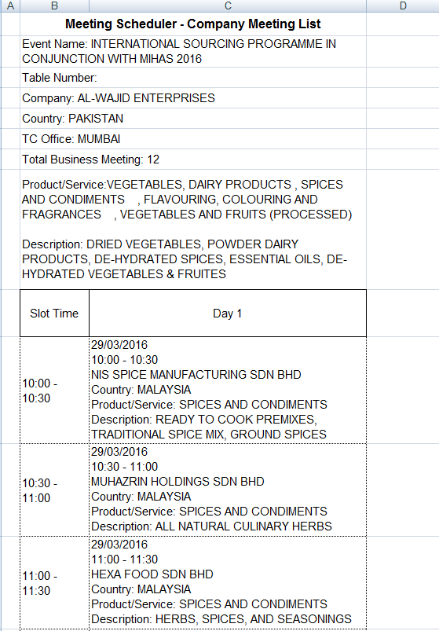
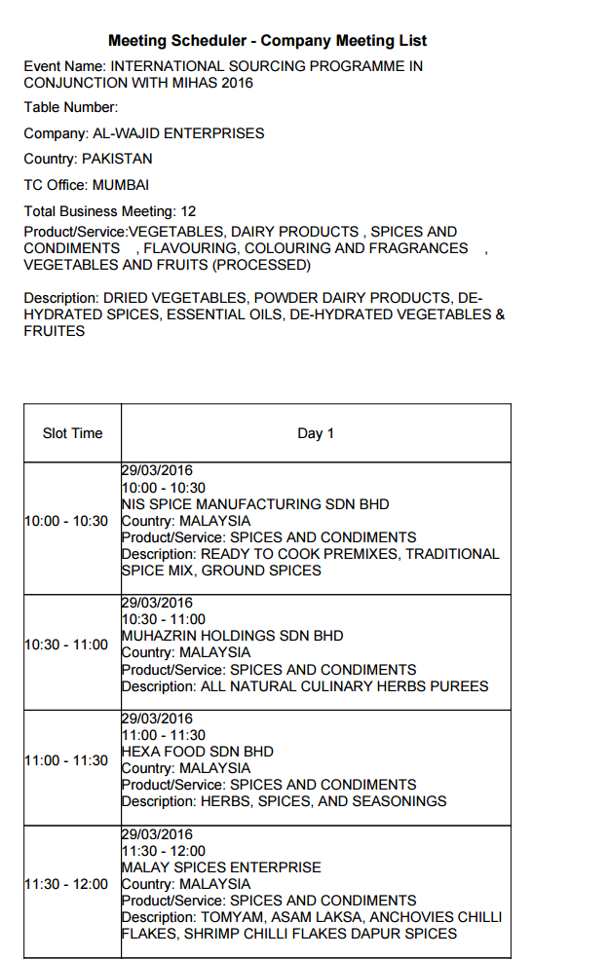

Reviewed By: (PMO)
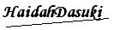 |  | Name/Position : NorhaidahBintiMdDasuki / Senior Manager, Quality Assurance and Support  Date : 30/3/2016

