Test Issue Log |  |  |  |  |  | SCP ID# : 5989
Project Name: | CMS Enhancement Dynamic Report
Test Stage: | Unit Functionality Integration System Interface  Performance Regression Acceptance Pilot
Test Case Number: |  |  |  | Test Started Date: |  |  | 01/04/2016
Test Title: | Dynamic Report
Test Description: | To ensure the search button on the Dynamic Report functioning well.
Test Functionality: | BIB  - Registration  -State
Test Procedure: | BIB  - Login to IBAM.  - Click on the BIB Dynamic Report.  - Choose on the Report Type drop down navigation.  - At the State dropdown navigation, choose on required state  - Click on Search.
Test Result: | Pass: Fail: | Tested by: |  |  | Erni Suhaireen binti Zulkifli
Reason for Failure: | Different state name between Dropdown List and Registration Report Table.
TEST DESCRIPTION

State (BUG)
Choose the required ‘State’. Then click on ‘Search’.
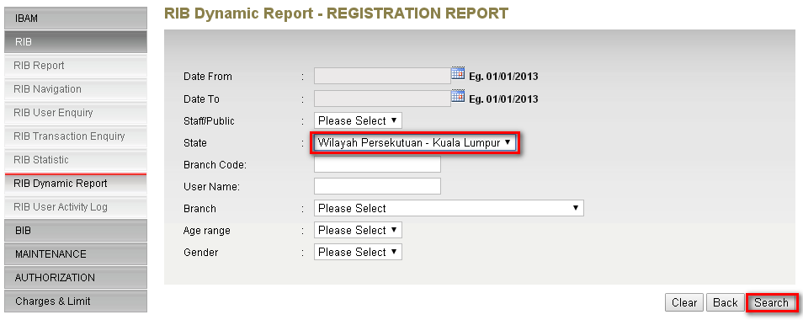
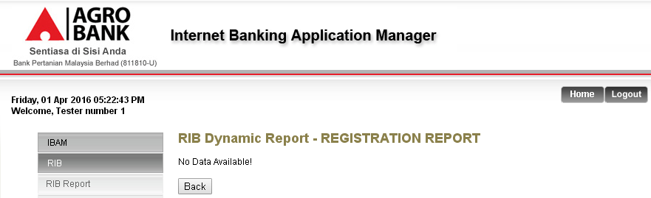
Different state name between Dropdown List and Registration Report Table.

For example:
Dropdown list: Wilayah Persekutuan – Kuala Lumpur
Registration Report table: Kuala Lumpur

That is why IBAM shows ‘No Data Available’ for State ‘Wilayah Persekutuan – Kuala Lumpur’.

Sample screen for dropdown list of state.
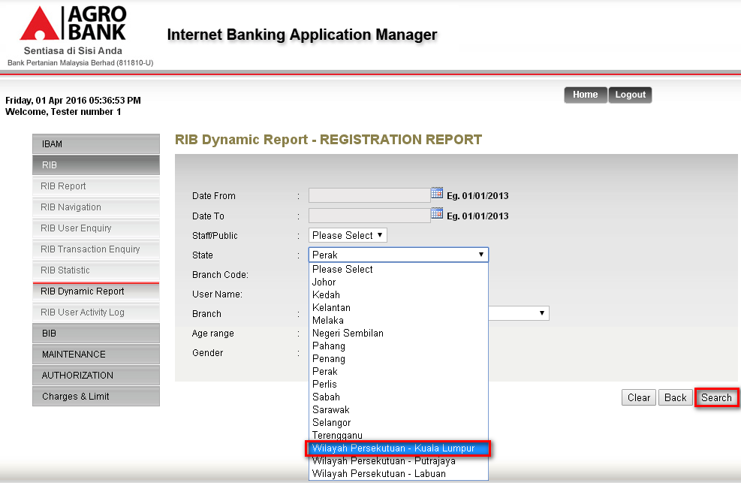
Sample screen of Registration Report table.
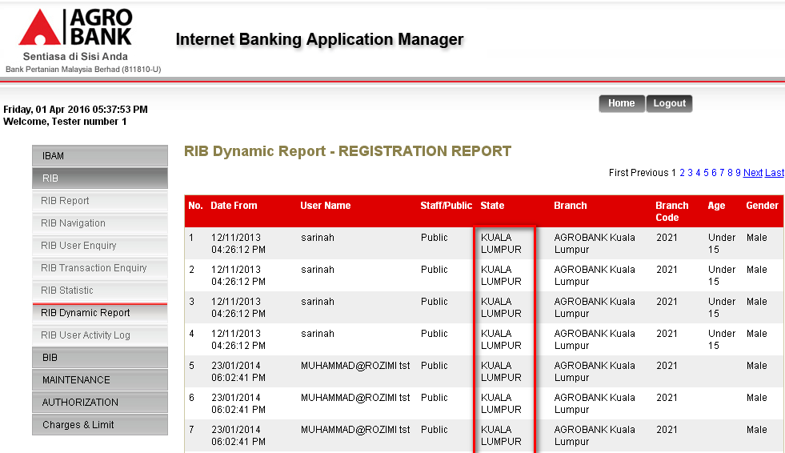

Reviewed By: (PMO)
Lizahwati |  |  | Name/Position : Lizahwati binti Basirun  Date :

