Test Issue Log |  |  |  |  | Issue ID#: TPMS_Prod089
Project Name: | Trade Promotion Management System (TPMS)
Test Stage: | Unit Functionality Integration System Interface  Performance Regression Acceptance Pilot
Test Case Number: | Support #6066 |  |  | Test Started Date: |  | 4/4/16
Test Title: | Post Event > Event Report > Local Trade fair
Test Description: | No option to delete sales feedback. If user can only remove the sales value, at report will display “0.00” if there are no product / service category
Test Functionality: | Local TF Feedback Form and Report
Test Procedure: | - Access Event Report from Post Event Module  - Select Local Trade Fair Programme Type  - Select Report,  - Select Event,  - Click on Generate PDF / Excel Report
Test Result: | Pass: Fail: Conditional Pass: |  | Tested by: |  | Leonard Lim
Reason for Failed / Conditional Pass:
TEST DESCRIPTION
Test Result:
General - All Sales By Hall
PDF
Excel
General – All Sales By Product/Service Category
PDF
Excel
General – Remarks/Comments
PDF
Excel
General – Enquiries
PDF
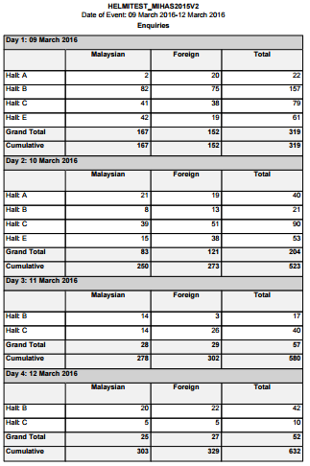
Excel
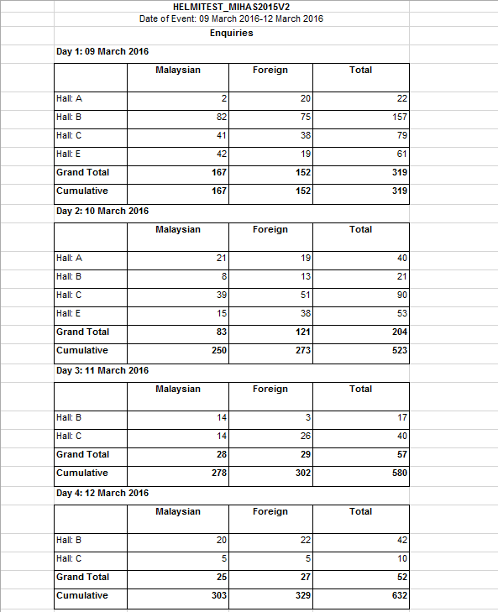
General – By Country
PDF
Excel
By Hall – Top 5 Product/Service
PDF
Excel
By Hall – Top 10 Product/Service
PDF
Excel
By Hall – All Product/Service
PDF
Excel
By Product/Services Category (Level 1) – Top 5 Product/Service
PDF
Excel
By Product/Services Category (Level 1) – Top 10 Product/Service
PDF
Excel
By Product/Services Category (Level 1) – All Product/Service
PDF
Excel
Reviewed By: (PMO)
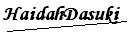 |  | Name/Position : NorhaidahBintiMdDasuki / Senior Manager, Quality Assurance and Support  Date : 15/1/2016

