Test Issue Log |  |  |  |  | Issue ID#: TPMS_Prod056
Project Name: | Trade Promotion Management System (TPMS)
Test Stage: | Unit Functionality Integration System Interface  Performance Regression Acceptance Pilot
Test Case Number: | Support #5970 |  |  | Test Started Date: |  | 05/04/2016
Test Title: | Date range for calendar at “Details search” function not working in Mozilla Firefox 45.0.1
Test Description: | To test on date picker in Calendar date range for details search function.
Test Functionality: | Planning>Planning JPPPA > List of Activities - Detail Search
Test Procedure: | - Click on Planning > Planning JPPPA > List of Activities – Details Search
Test Result: | Pass: Fail: Conditional Pass: |  | Tested by: |  | Siti Norahayu
Reason for Failed / Conditional Pass:
TEST DESCRIPTION
Click on Planning > Planning JPPPA > List of Activities – Details Search
Result:
System display List of Activities.

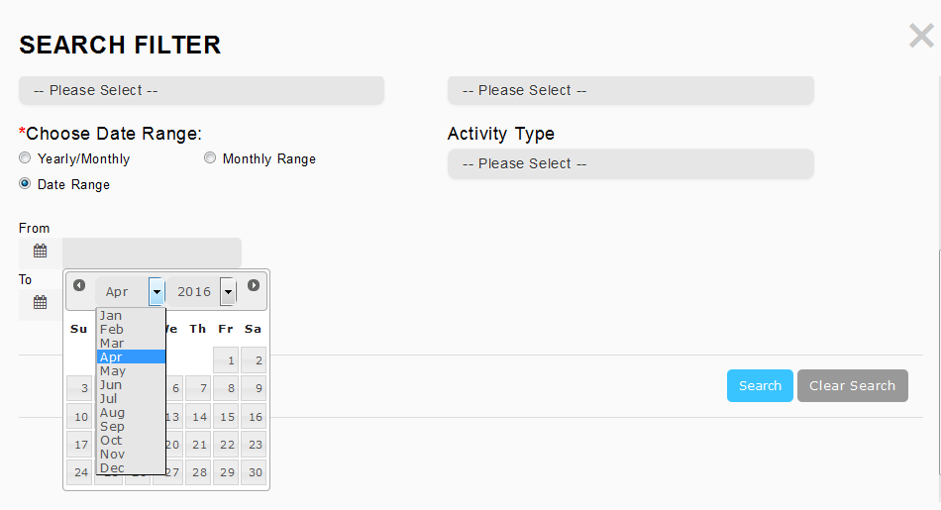
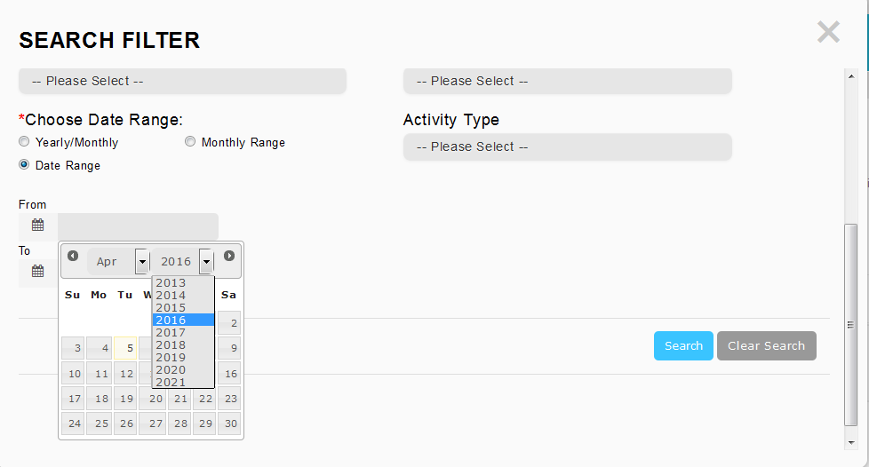
Reviewed By: (PMO)
 |  | Name/Position : NorhaidahBintiMdDasuki / Senior Manager, Quality Assurance and Support  Date : 5/4/2016

