# Overall

## Approved Budget – Overall by Budget Type

Tested in <http://172.25.96.136/matrade-tpms/>

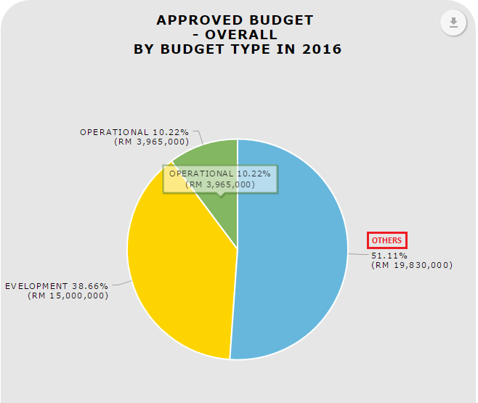

**OTHERS** – Label for Others not display. Please add at ‘Download as image’ (PNG, JPG, SVG, and PDF). Please hide SVG.

**Download data (CSV)**

Legend for Budget Type not display.

1. When “Download as Image”, “Download Data” and “Print Chart”, put the date and timestamp. (Comment by Pn.Raja)
2. Should highlight at the active tab. (Comment by Pn.Raja)

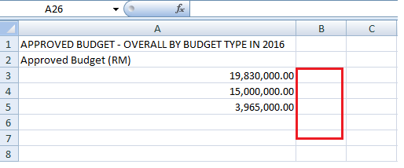

**Download data (XLSX)**

Legend for Budget Type not display.

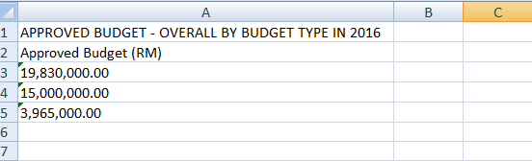

Budget Type: Total “OTHERS” not tally with the report.

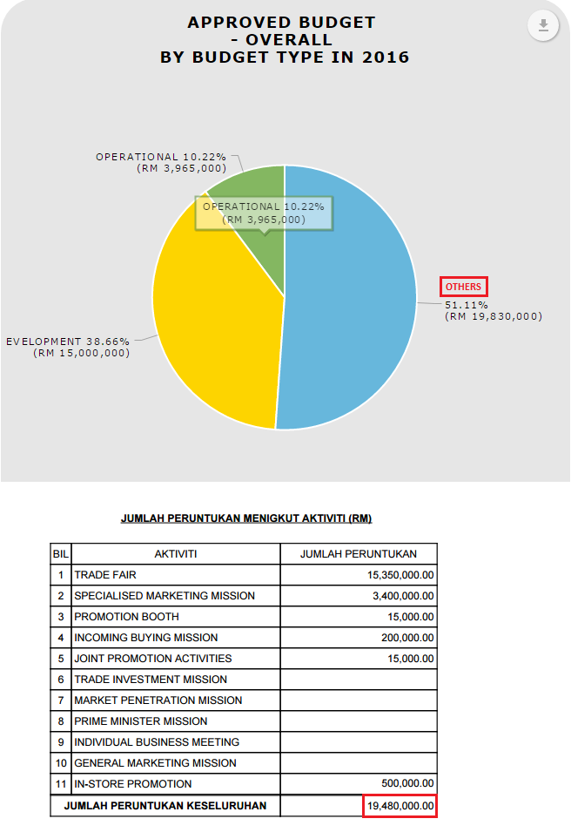

## Number of Approved Event by Programme Type

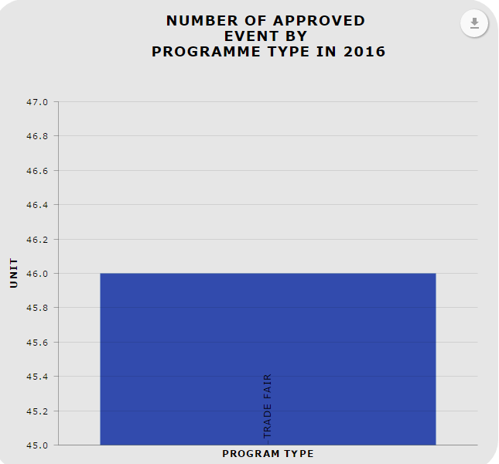

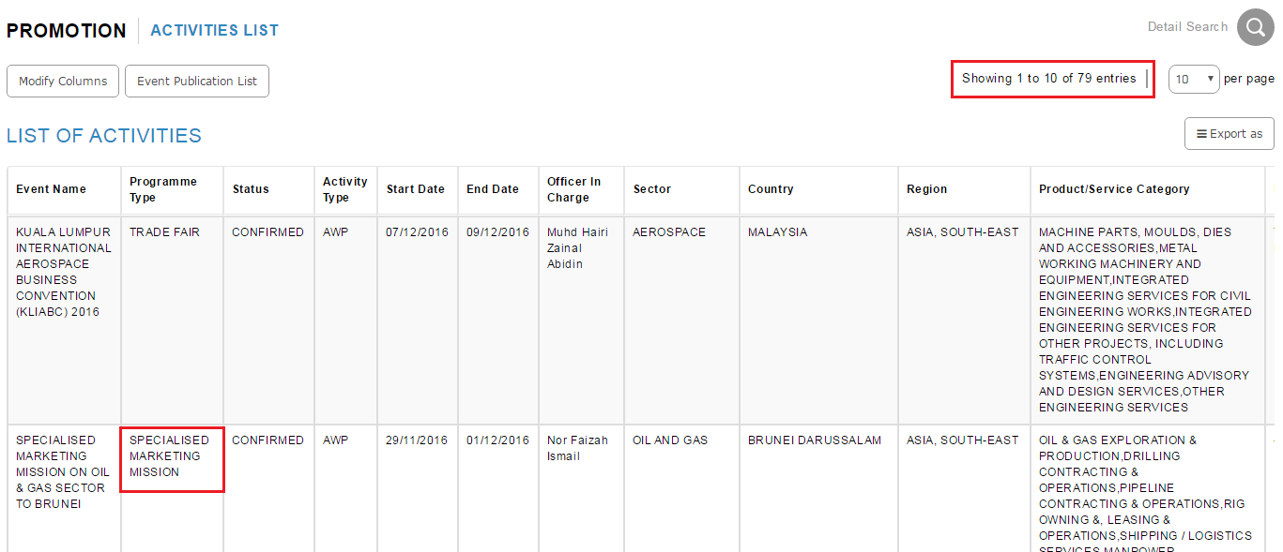

1. Dashboard display Programme Type for TRADE FAIR only but in the system there are many Programme Type with Approved status display.
2. Entries in the system show TRADE FAIR with status APPROVED (Confirmed/Completed/ Approved by BOD/ Approved by CEO) = 31 but in dashboard display 46
3. Change the bar chart from vertical to horizontal. To ease reading the label (Comment by Pn.Raja)
4. Change Program Type to Programme Type. (Comment by Pn.Raja)
5. The colour of the bar/pie of category should be the same in other chart. Example, Trade Fair use green and SMM use blue in chart 1, then other chart Trade Fair and SMM also should use the same colour green and blue. This to avoid misinterpretation. (Comment by Pn.Raja)

## Impact – Target Sales VS Sales Generated by Programme Type

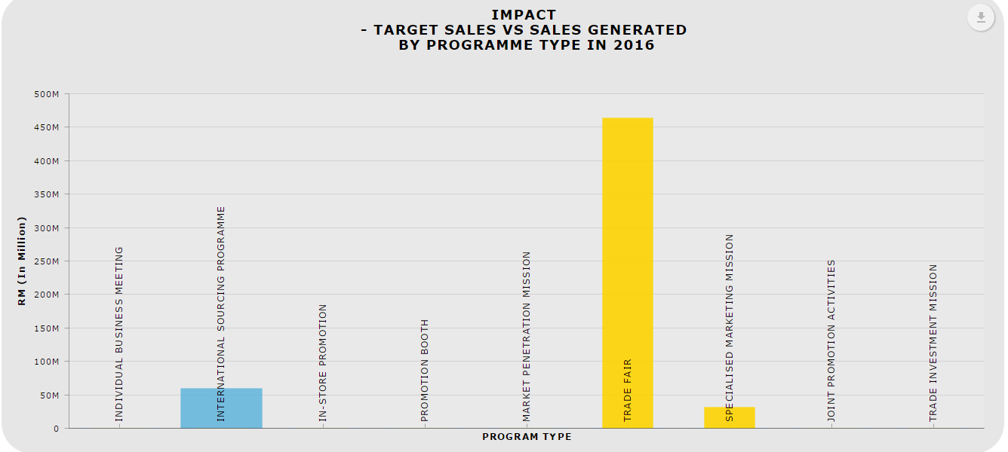

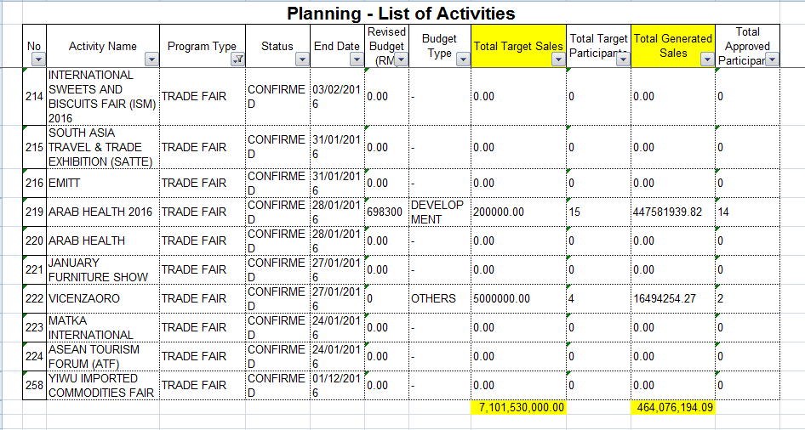

Target Sales(blue) vs Sales generated(yellow)

1. Do not display the category type if it has no value. (Comment by Pn.Raja)
2. The data not tally with the system

## Programme Type by Status & Section

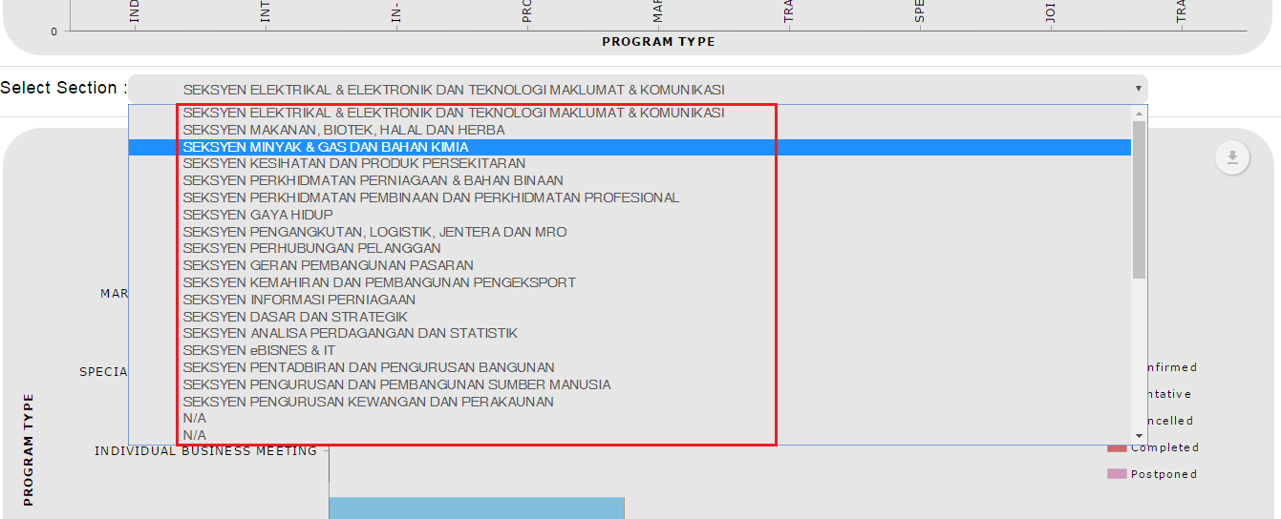

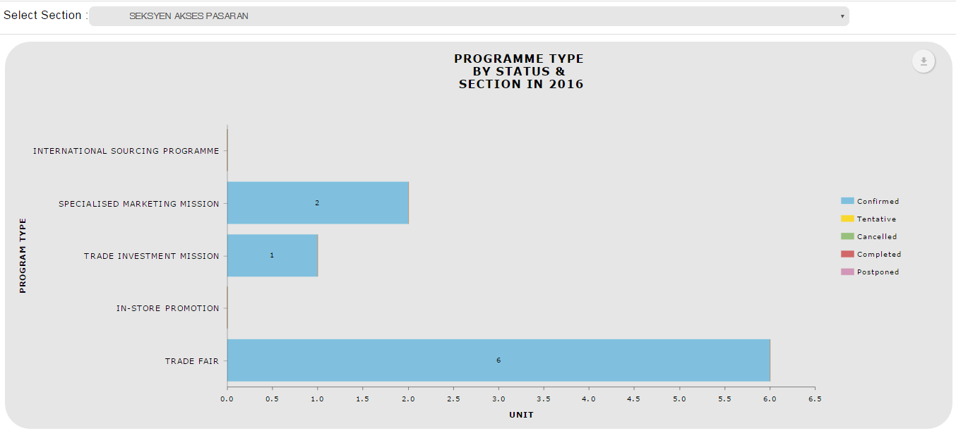

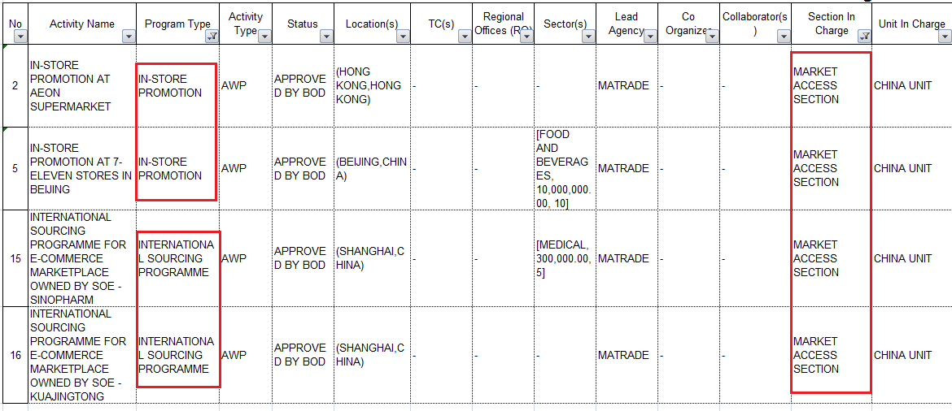

1. “Select Section” dropdown - Sort the list by alphabetical.
2. Data not tally :-
   1. In-store promotion should display 2 record
   2. INSP should display 2 record