Test Issue Log |  |  |  |  | Issue ID#: UAT1&2 - UAT_098
Project Name: | Trade Promotion Management System (TPMS)
Test Stage: | Unit Functionality Integration System Interface  Performance Regression Acceptance Pilot
Test Case Number: | Enhancement #5866 |  |  | Test Started Date: |  | 01/04/2016
Test Title: | Add summary of activity in the end of report
Test Description: | To test on summary of activity display and calculated accordingly
Test Functionality: | Planning > Reports > Planning Report > Overall Summary > Details of Work Programme
Test Procedure: | - Click Planning > Reports > Planning Report > Overall Summary > Details of Work Programme
Test Result: | Pass: Fail: Conditional Pass: |  | Tested by: |  | Siti Norahayu
Reason for Failed / Conditional Pass: | Conditional signoff due to limitation of Jasper report for Budget Type where need to show dynamic value for initiative.
TEST DESCRIPTION
Planning > Reports > Planning Report > Overall Summary > Details of Work Programme
Result:
System display Details of Work Programme Report.
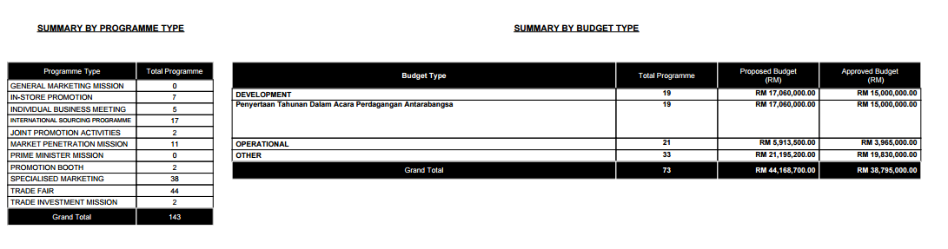

Reviewed By: (PMO)
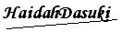 |  | Name/Position : NorhaidahBintiMdDasuki / Senior Manager, Quality Assurance and Support  Date : 08/04/2016

