Test Issue Log |  |  |  |  | Issue ID#: TPMS_Prod119
Project Name: | Trade Promotion Management System (TPMS)
Test Stage: | Unit Functionality Integration System Interface  Performance Regression Acceptance Pilot
Test Case Number: | Support #6167 |  |  | Test Started Date: |  | 11/4/16
Test Title: | Post Event > Programmes > Feedback - Change button naming
Test Description: | To change wording button from save to insert and wording button from submit to save.
Test Functionality: | IBM Feedback Form
Test Procedure: | - Go to programmes, under Post event module  - Select event with International sourcing programme type, and click on feedback,  - Go to list by company,  - Fill in feedback form
Test Result: | Pass: Fail: Conditional Pass: |  | Tested by: |  | Leonard Lim
Reason for Failed / Conditional Pass:
TEST DESCRIPTION
Test Result:
Save to Insert
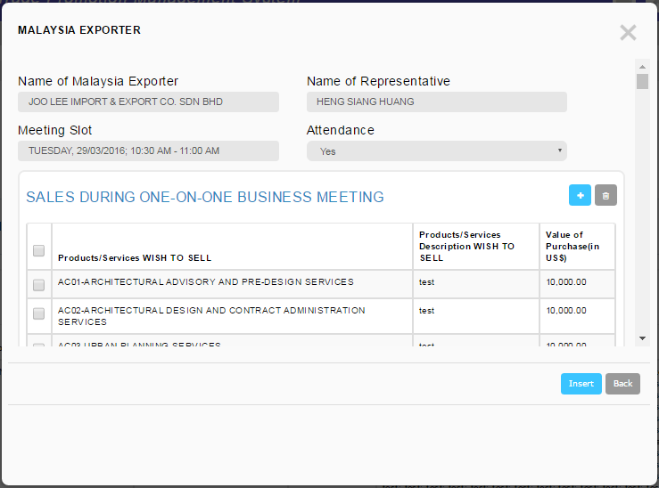
Submit to Save
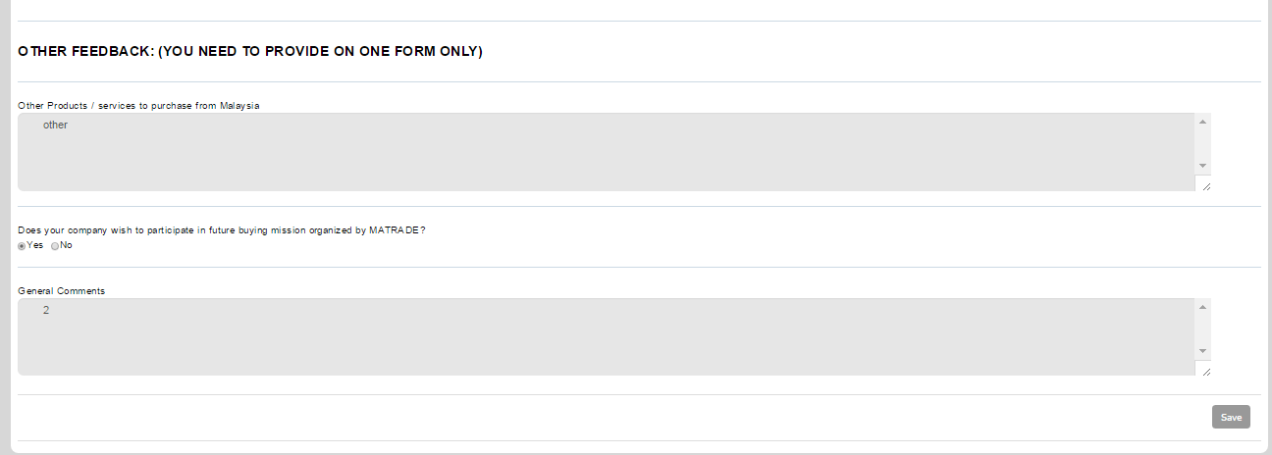

Reviewed By: (PMO)
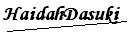 |  | Name/Position : NorhaidahBintiMdDasuki / Senior Manager, Quality Assurance and Support  Date : 15/1/2016

