Bugs: Notes is wrong description , must follow from BRS:

1. Actual Result from Consumer10 :

* Note 1 Remittance Enquiry

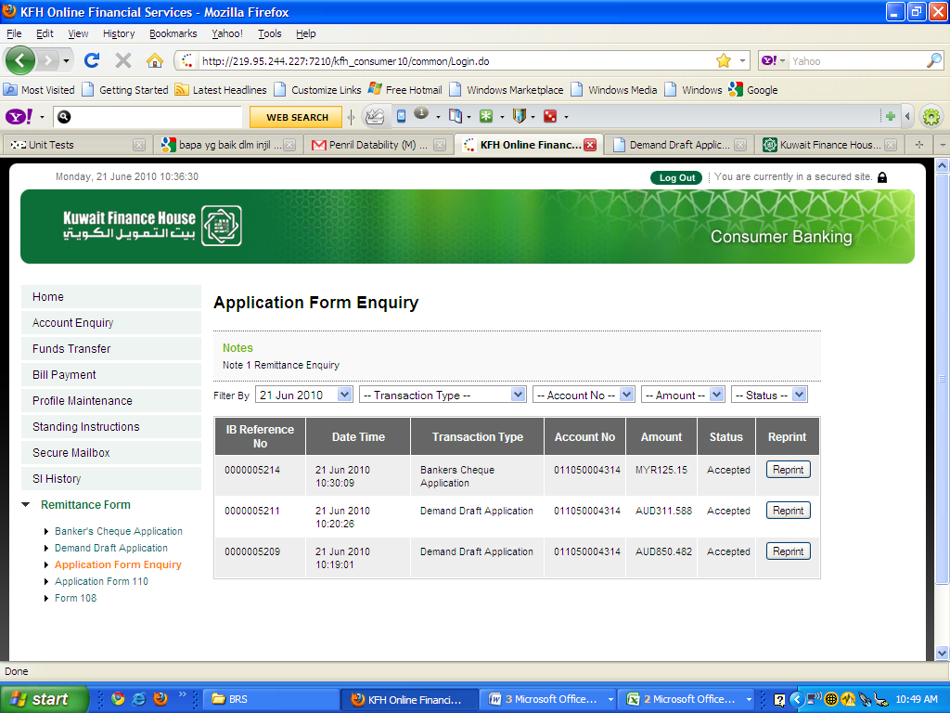

1. Expected Result from BRS:

* Notes: 1. Please read the Term and Conditions

