# Impact – Sales

## Target Sales vs Sales Generated – by Programme Type

1. Bar chart for Target Sales vs Sales Generated – by Programme Type not display even though data in the system is available and valid. Please refer image.

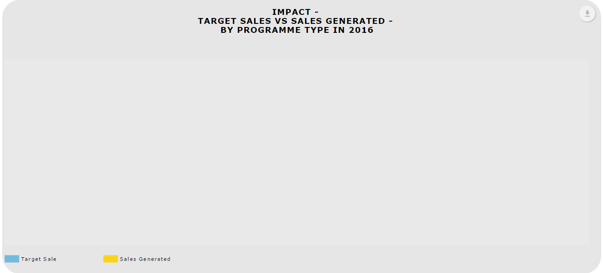

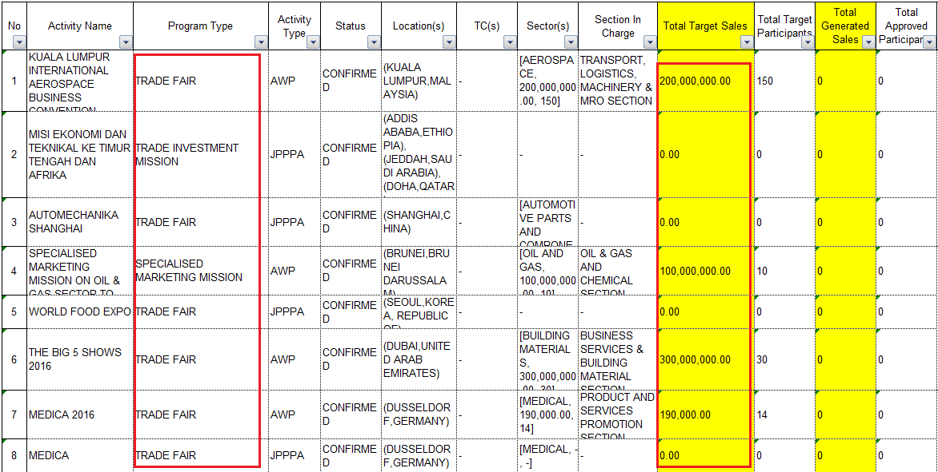

Target Sales vs Sales Generated – by Section

1. “Total Target Sales” not display at the bar graphs. System shows for ICT sector, “Total Target Sales” is equivalent

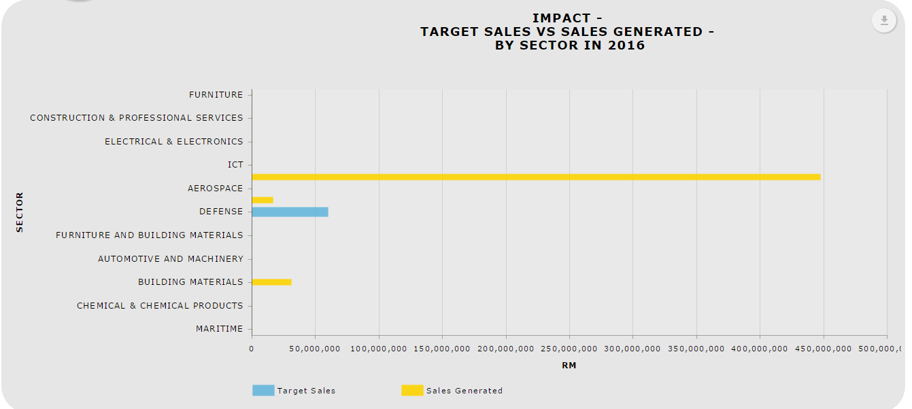

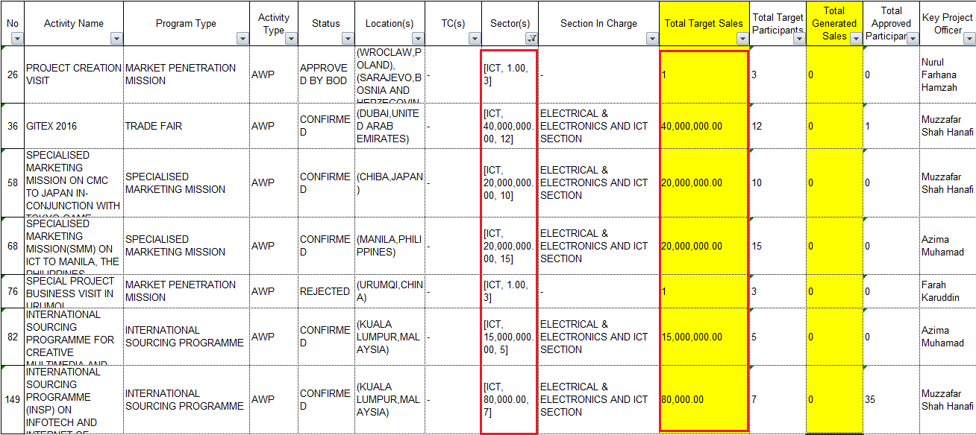

.

Target Sales vs Sales Generated – by Region

1. Bar chart not display “Total Target Sale” even though it has a value.

*Top Grossing Companies in 201 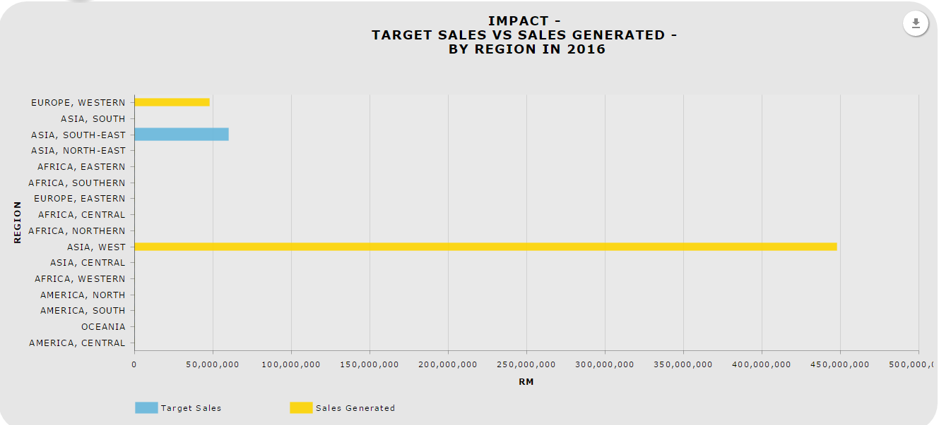

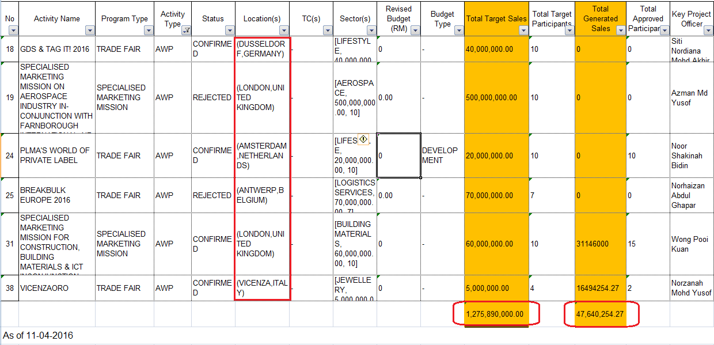

1. Top Grossing Companies should display per company name instead of event name

